

Navarātri

prayers, praises and hymns

A collection of praises and protocol for worship of Her Supreme Holiness Shri Mataji Nirmala Devi
as the Incarnation of the Supreme Goddess
during the Nine Nights of Navaratri

Researches in Sahaja Yoga Series. No. 6
A soft copy of this book and other ‘Researches in Sahaja Yoga‘
publications are available to download free on the symb-ol.org website

Compiled and edited by Chris Marlow and the RiSY team

First edition Sept 2016
Revised Oct 2019
There is no copyright on any of this material which is for the emancipation of humanity. However we request that no material is used in a way to substantially alter its meaning.
There is no copyright on any of this material. However we request that no part of it is used in such a manner to substantially alter its meaning.
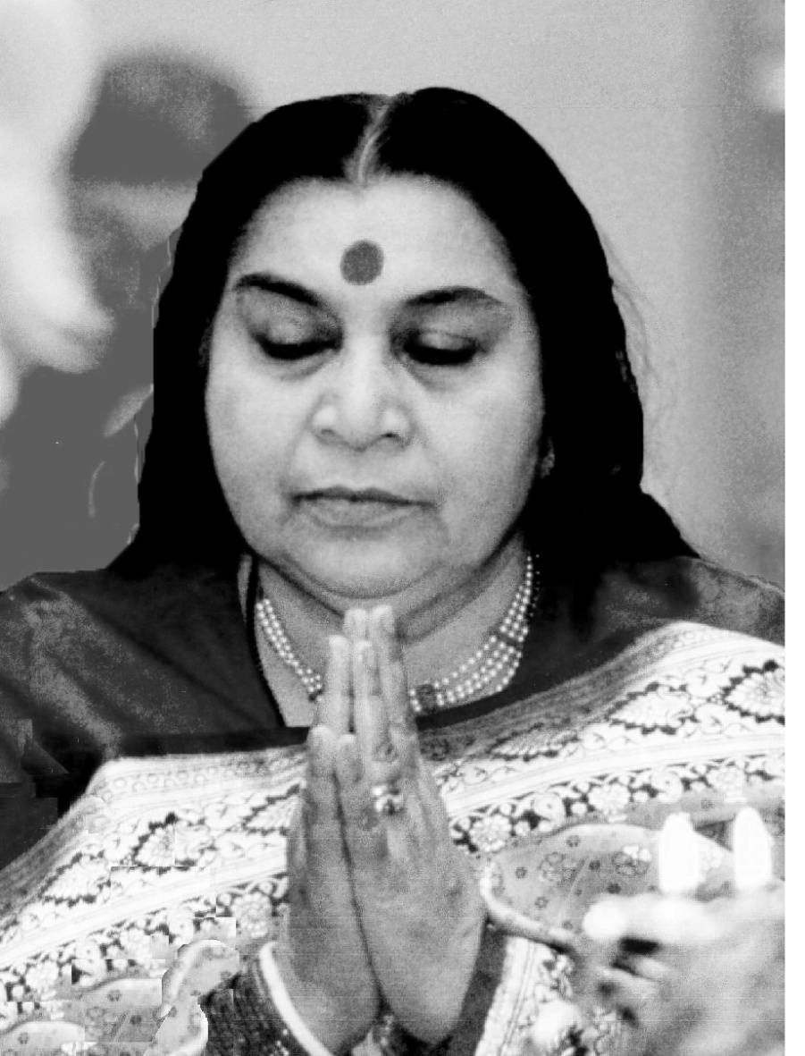

Salutations to that Supreme Goddess
who is the All-pervading Formless Consciousness
and the Mother of this whole creation;
who incarnated on this Earth as
Her Supreme Holiness Shri Mataji Nirmala Devi;
to Her we prostrate with complete reverence and surrender.
May our humble offerings be pleasing in Her sight.
Contents
Devi Mahatmyam (intro + Shri Mataji’s quotes) 5
List of Praises included 7
Navaratri – introduction 8
Astrological Timing 10
The Nine Nights – day by day instructions 11
Navaratri songs – a list from the songbook 23
Durga Saptashati – summary of the Devi Mahatmyam 24
Shri Mataji’s letter on Navaratri 26
The Navārna –‘nine-lettered’ Mantra 28
Sapta-śhloki – ‘Seven Most Auspicious Verses’ 30
108 Names of Śhrī Durga (list) 32
108 Names of Śhrī Durga (poem) 36
Kavach of the Devi 39
Argala Stotram 51
Kīlaka Stotram 54
Vedoktam Rātri-sūktam 57
Devi Māhātmyam (Durgā Sapta-śhati) 59
Chapter 1 60
Brahma Stuti 65
Chapter 2,3,4 69
Shakr’ādya Stuti 79
Chapter 5,6.......... Tantrika Devi Sūktam 89
Chapter 7, 8 98
Chapter 9, 10 106
Chapter 11........... Hymn to Nārāyanī 112
Chapter 12, 13 120
Notes on Devī Māhātmyam 126

Rigved’oktam Devi Sūktam 128
Shrī Lalitā Sahasra-nāma 130
Devi Atharva Sheersha 161
Mahish’āsura Mardini Stotram (20 verses) (Ayi Giri Nandini) 168
Śhrī Anna-pūrṇa Stotram (Ādi Shankarāchārya) 175
Mahālakshmī Stotram (Namaste-‘stu Mahāmāye...) 178
Aparadha-kshamāpana Stotram (prayer for forgiveness) 180
Kunjika Stotram 182
Sanskrit Notation and Pronunciation 186

Devī Māhātmyam

The Devī Māhātmyam is an ancient Sanskrit praise from the Mārkandeya Purāna also known as the Durgā Sapta-śhati –‘seven hundred verses to Śhrī Durgā’. It tells the story of the incarnations of the Goddess who were invoked to destroy the demons troubling the Devas –‘gods’ in Heaven and the saints and sages on this Earth; the chief demon being Mahiṣhāsura –‘buffalo demon’ who represents the lower animalistic side of our nature.
In the narrative are four great hymns of praise to the Goddess as Śhrī Mahākālī, Mahāsaraswatī and Mahālakshmī (Nārāyanī) which are included with the transliterated Sanskrit.
The original Sanskrit poem of the Devī Mahātmyam has wonderful sound, rhythm and vibrations; however in this edition only the English translation is given, so that the story can be recited and understood by westerners. The Sanskrit version can be downloaded from the symb-ol.org website.
See p.24 for a summary of the chapters of the Devī Mahātmyam.

Quotes by Shri Mataji about the Devi Mahatmyam

‘The greatest power belonging to the Mother is your protection. Protection from all kinds of things - all the Left Side protections are there. They are described in the Devî Mâhâtmyam - what a protections She gives you. So tremendous in Her protecting power. And this protecting power gives you understanding - how kind She is and how, I should say, how very, very protective, extremely protective.’
Navaratri, Los Angeles, 27-10-02.

‘Who is Vishnumâyâ? It's very important to know because in the Devî Mâhâtmyam She is only described as the Incarnation of the Goddess, ‘Vishnumāyeti shabditâ –‘She is called as Vishnumaya’. But let's see who is She, after all, this Vishnumâyâ? So Vishnumaya is the Kâlî, we can say, and is the daughter of Mahâkâlî. She came on this Earth and killed many, many devils and many Rakshasas to save the saints from their aggression and She always acts in that manner to kill all the negativity of the world.’ Shri Vishnumaya Puja, Belgium, 04-07-92.

‘For you also it is important that you must surrender to Me fully recognizing Me as Mother. Read more about the Devî Mâhâtmyam, about the names, the thousand names (of Shri Lalita), what does that mean? What Devî is doing, what has She done before, try to understand. See some people have gone very far. They read and understand. And try to read Sanskrit. Try to understand what it is. You have to, it's a knowledge.’
Address to Leaders. Melbourne, 18-03-85.

Praises included in this edition

Associated with the Devi Māhātmyam are a number of praises called the aṅga –‘limbs’ which are listed below in the order in which they are usually recited, some before and some after the Devi Mahātmyam:-

Sapta-śhaty’aṅga-paṭha – ‘Recitation of limbs of the Devi Mahātmyam’.

- Sapta-śhloki –‘Seven most auspicious verses’
- Nav’ārna Mantra –‘The nine-syllabled mantra’.
- The 108 Names of Shri Durgā (as a poem or a list).
- Devi Kavach
- Argala Stotram
- Kilaka Stotram
- Rātri Suktam (Vedic & Tantric (Ch.1 p.60)) Before
- Vaidik Devi Suktam After
- Tantrik Devi Suktam (Chapter 5. p.65)
- Kshamāpana - Prayer for forgiveness - for mistakes etc.
- Kuñjika Stotram

Any or all of these praises may be said on any day or on the specific days indicated on pp.11-22. Also included in this book are:
- Devi Atharva Śhīrṣha (from the Shrimad Devi Bhagavatam)
- Shri Lalita Sahasranāma – ‘1000 Names of the Goddess’
- Shri Mahish’āsura Mardini Stotram (20 verses)(‘Ayi Giri Nandini’)
- Prayer to Śhrī Anna-pūrṇā (Ādi Shankarāchārya)

Navarātri –‘the nine nights’

Jay Shri Mataji!

There are four Navarātri (nava –‘nine’, rātri –‘nights’) festivals in the year, at the changes of the seasons. Śhāradiya –‘autumn’ is the most important and most widely celebrated. Vasantha –‘spring’ Navarātri is also popular, at the start of the month Chaitra around the beginning of April.

While Navarātri is a period of celebration it is also a time for introspection. The Goddess is worshipped at this time partly because we need extra protection when the season is changing and winter is approaching.

At Navarātri time the gates of both Heaven and Hell are more widely open and, as well as receiving the protection of the Goddess against the demonic forces, we can also more easily connect to and worship Shri Mataji with that devotion and dedication which is the key to our emancipation.

Worshipping Shri Mataji as the Goddess Incarnate gives us extra depth and power to delve into ourselves and weed out the workings of the ¹Six Enemies and other demonic tendencies within us. Shri Mataji laid particular stress on the sixth day, being the day when we should clear our ego, because if we fail in that the rest has little meaning.

¹The ‘Six Enemies’ in Indian culture are like the ‘Seven Deadly Sins’ and are Lust, Anger, Greed, Envy, Delusion and Pride. Greed covers Avarice and Gluttony and Envy includes Jealousy. The demons which Śhrī Vishnu took incarnation to destroy were deluded by these negative emotions.

So as well as being a time for joyful collective worship in the evenings and night-time, it is also beneficial to find some solitude to meditate and prepare ourselves to welcome the Goddess into our hearts and souls. The cool balm of Her peace, holiness and bliss will wash away the pains and worries of this world we live in.

This book is a collection of the prayers, hymns and praises which may be used for worship during Navaratri. It is not exhaustive, but is a compilation of material that has been used to worship Shri Mataji in Her Presence or which She has mentioned and is therefore considered to be approved by ²Her.

‘Mother’s grace is boundless. Her mercy is illimitable. Her knowledge is infinite. Her power is immeasurable. Her glory is ineffable. Her splendour is indescribable. She gives you Bhukti –‘worldly enjoyment’ amd Mukti -’liberation’ also. She is pleased with a little purity of heart. The sacred Durga Puja is approaching. Do not lose this glorious opportunity. Make a definite and sincere attempt to obtain the grace of the Mother. She will transform your entire life, and bless you with the milk of divine wisdom, spiritual insight and Kaivalya –‘One-ness with God’. Swami Shivānanda (1953)

² Shri Mataji’s teaching about Shri Durgā and Navarātri can be found in ‘The Nine Nights of the Goddess’ published by NiTL, Pune and in Shri Mataji’s Navaratri Talks which have been collected and published at various times.
Astrological Timing

2020 – 17 - 25 Oct (Dussehra - Oct 26) (The latest it can be!)
2021 – 6 - 14 Oct (Dussehra - 15 Oct)
2022 – 26 Sept - 4 Oct (Dussehra - 5 Oct)

Navarātri starts around the beginning of October on the ²first day (new moon) of the month Ashvin, with the Sun in ¹Kanyā –‘Virgo’ (18th Sept - 17th Oct), the Sign of the Goddess.

Sometimes two ³kalā’s –‘digits’ of the moon do not occur on consecutive days and the ‘nine nights’ take ten days. It is also possible for the nine nights to occur within eight days.

The tenth day is called Dussehra or Vijaya-daśhamī –‘Tenth Day of Victory’ and is a day of ⁴celebration of Shrī Rāma’s victory over the demon Rāvana and His subsequent coronation.

¹ In western astrology the Sun is in Libra at this time (22ndSept-21stOct); Vedic (Indian) astrology uses the actual constellation that the Sun occupies in the sky which, due to the ‘Procession of the Equinoxes’, is Virgo between 18 Sept – 17 Oct. All months start on the New Moon day.
² Due to there being 12.4 moon cycles per year, the New Moon occurs 11¼ days earlier each year. So in 2021, Navaratri starts on [17 Oct – 11 days] = 6 Oct.

³ The moon has sixteen Kalā’s -‘digits’ in each half, with the New and Full Moons being shared with both the bright (waxing) and dark (waning) phases. This gives the thirty days of the moon’s cycle (or more precisely 29.5 days, which is why two Kalā’s can occur on one day)
⁴ The quarter moon (half dark, half light) is on the 8th day. Astrologically this ‘Sun square Moon’ aspect (at 90° to each other) is a difficult time for relationships, with people becoming argumentative and stressed. Once it passes people enjoy each other again, so Dussehra –‘tenth day’ is a joyful time.

The Nine Nights of Navarātri

First three nights - Shrī Durgā (Mahākālī)
Middle three nights - Shri Mahālakshmī
Last three nights - Shrī Mahāsaraswatī

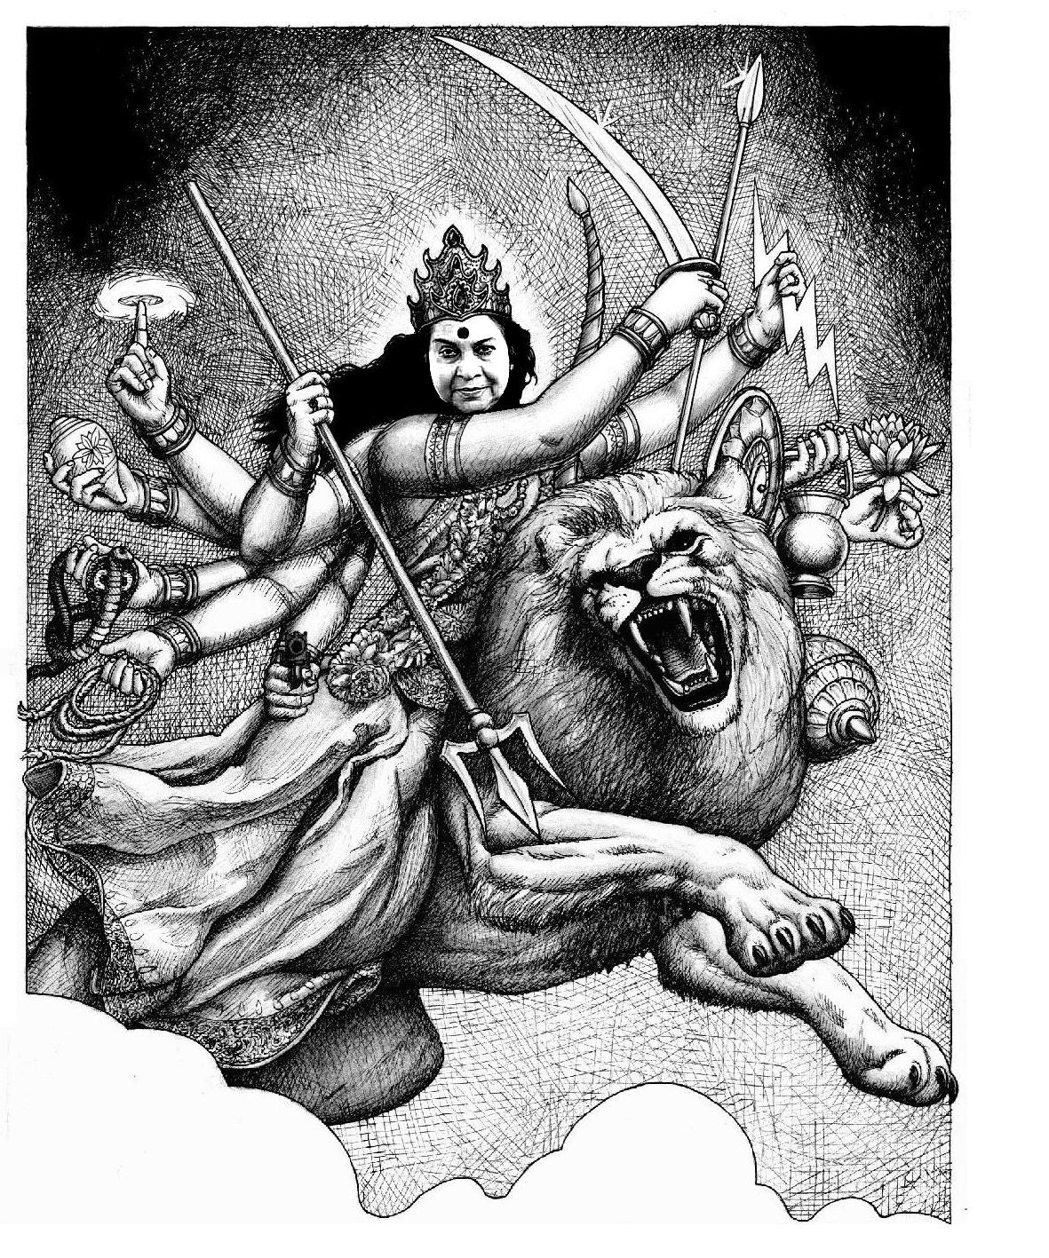
Guidelines for worship during Navaratri:
- It is recommended to wash and decorate Shri Mataji’s Feet (photo sealed in glass) every day.
- Start with Shri Ganesha Mantra once, four or seven times.
- Washing Shri Mataji’s Feet can begin during the Ganesha Atharva Sheersha.
- One or more Bhajans to Shri Ganesha.
- The Devi worship is started with the Nav’ārna Mantra (Aim Hrīm Klīm Chāmuṇḍāyai vicche) (at least twelve times, while decorating Shri Mataji’s Feet)
- One or more Navaratri Bhajans (list of Navaratri Songs, p.23) may be sung before or after the specific praises for the day (during offerings).

Day 1. Prātipada –‘Commencement, First Day’
Aspect of Śhrī Durgā - Shaila-putrī – ‘Daughter of the Mountain’

When Navarātri extends to ten days, the First Day normally covers the first two nights.

Kalaśh Sthāpanā – the Kumbha –‘water-pot’ with leaves and a coconut are installed in the traditional manner.

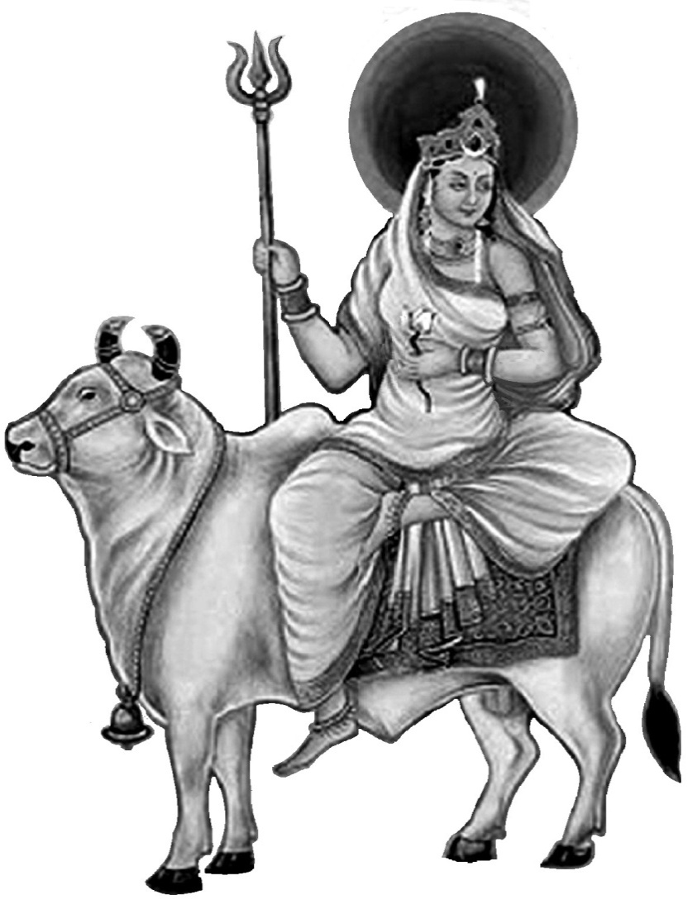
Ghata-sthāpanā –‘seed sowing’.
A pot of earth with nine types of seeds (pulses and grasses) or simply barley or wheat seed, is prepared, watered and offered to the Goddess. It symbolises the power of Nature and is performed by women. It is to be watered every day.

A clay statue of Śhrī Durgā may be installed ceremoniously and worshipped. This is offered to the river/lake/sea at the end of the festival.

On the first day these ceremonies are performed before sunset, but the Pūjās on the following days are done in the night.

Praises that may be offered include:-
- Sapta-shloka –‘Seven verses’ –the seven most auspicious and powerful verses from the Sapta-śhati.
- 108 names of Shrī Durgā. This can be sung as a poem or the names taken as mantras.
- Chapter 1 of Devī Māhātmyam including singing of the Brahma-stuti p.65.

Śhrī Śhaila-putrī –‘daughter of the mountain’ (also called Pārvatī, Hemavatī, Giri-nandinī) rides on Nandī, Śhrī Śhiva’s bull, has two hands bearing a trident and a lotus, with the crescent moon on the forehead. She is the Ādi Śhakti, the Primordial Power of Nature and Creation symbolised by the Ghata-sthāpanā, embodying the powers of Brahmā, Viṣhṇu and Śhiva. To guard Her bathroom and hence Her chastity She created Śhrī Gaṇeśha and this is the day of Mūlādhāra Chakra.
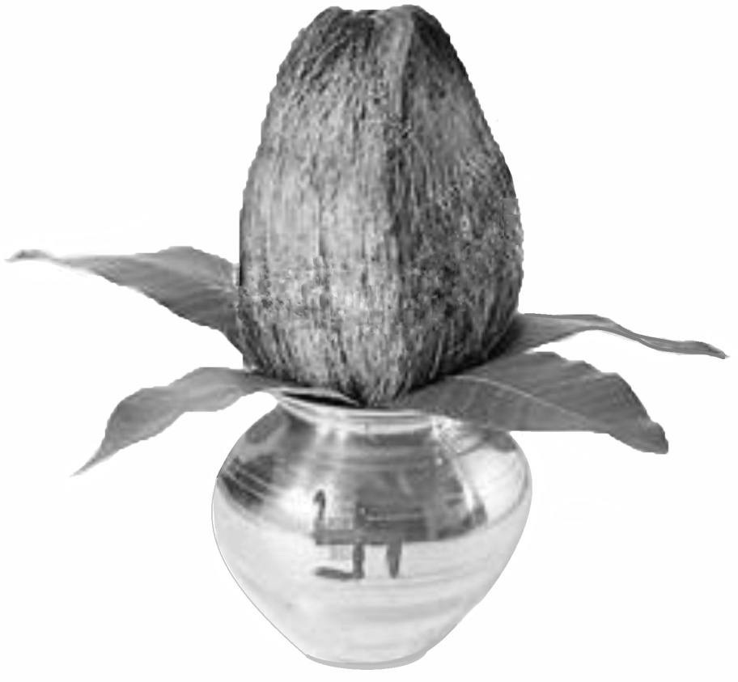
A traditional Kalaśha –‘water-pot’, usually copper, brass or silver, but may be clay, full of water with five mango leaves and a coconut with a tuft of hair left on the top. Any long pointed glossy leaves may be used.
Day 2.
Dvitīyā –‘Second day’.

Aspect of Śhrī Durgā –
Brahma-chārinī –‘Following the Path of God, celibate student’

Chandra darśhan. The New Moon may be visible as a thin ‘nail-paring’ at sunset.

- Devi Sūktam (Ya Devi sarva bhuteshu..)
- Chapters 2, 3 & 4 of Devī Māhātmyam.
- Singing of Shakrādya Stuti, Chapter 4, p.79
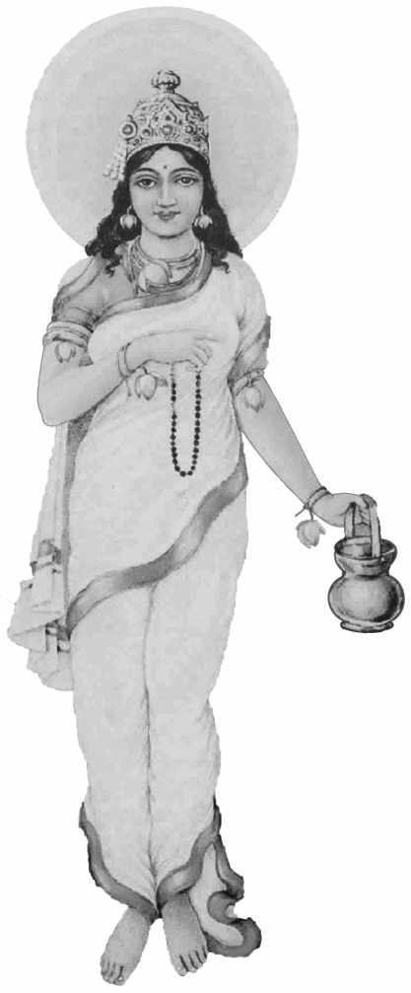
- Mahishāsura Mardini Stotram (Ayi Giri Nandini) p.168

Brahma-chārinī wears white clothes, and holds a rosary and a water-pot in Her two hands. This is the aspect of Śhrī Pārvatī who undertook severe penances to win the love of Lord Śhiva and represents spiritual seeking and devotion to the highest knowledge. She is the Primordial Kuṇḍalinī, embodying all innocence, auspiciousness and purity.

Day 3.
Sindūra Tritīyā –‘Third Day of Sindoor –‘kum-kum’’.

Aspect of Śhrī Durgā –
Chandra-ghantā – ‘having a moon-bell as a weapon’

- Devi Kavach - may be sung collectively to a plain melody.
- Chapters 5 & 6 of Devī Māhātmyam.
- Singing of Tantrika Devi Sūktam – ‘Ya Devi Sarva Bhuteshu’ p.90
- Worship with sindoor –‘red powder’ on Mataji’s Feet

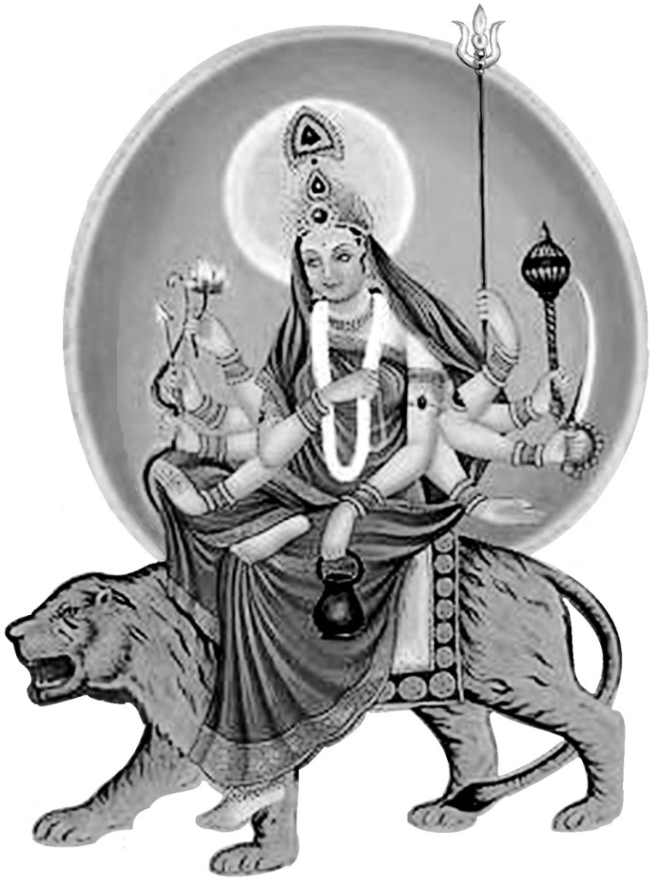
Chandra-ghaṇṭa is a fierce form of Shrī Durgā also known as Chandi –‘fired-up’ and Chāmuṇḍā –‘destroyer of Chanda and Munda’ always ready to destroy demonic forces troubling Her devotees. She rides a tiger and has ten arms holding trident, mace, bow, arrows, sword, lotus, bell, water-pot and abhaya -'giving fearlessness' with both hands. She bestows courage and removes mental and physical suffering.
Chandraghaṇṭa -‘ending the sins of the Left Side’ (Chandra –‘moon, left side’, agha –‘sin, evil’ anta –‘ending, destroying’) is the protective power of the Left Side.

Day 4.
Varad-vināyaka Chaturthī – ‘Fourth Day of the Peerless Giver of Boons’. (Chaturthī –‘fourth day’ is sacred to Śhrī Ganesha)

Aspect of Śhrī Durgā –
Kūṣhmāṇḍā¹ – ‘Creative energy of the Universe’.

Heart Chakra – Prāṇa-maya Koṣha –‘Sheath of Life-breath’

- Devi Kavach is also sung on this day.
- Chapter 7 of Devī Māhātmyam.
- Argala Stotram. p.51

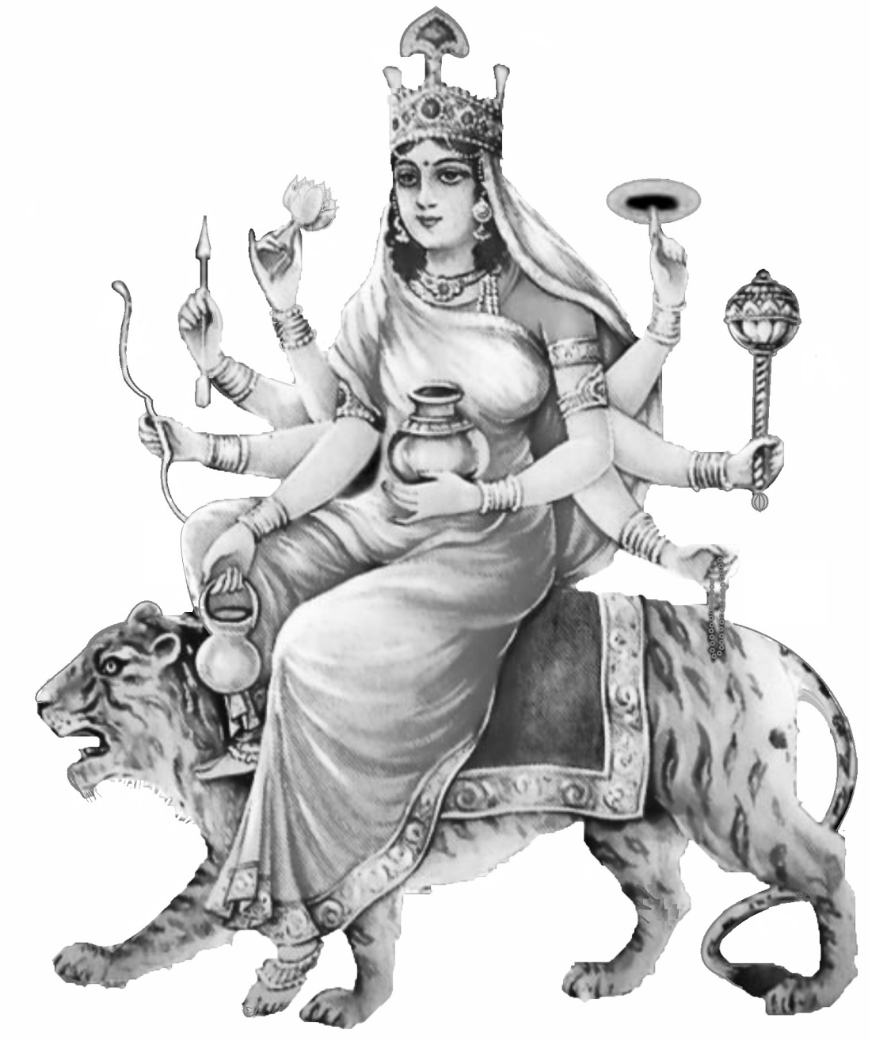
Kūṣhmāṇḍā is Aṣhṭabhūja –‘eight armed’ holding discus, mace, bow, rosary, lotus, water-pot and a jar of Amṛut –‘nectar of immortality’. She rides a tiger and is the Creative Power of the Sun (Right Side). Her worship bestows spiritual power and energy to devotees.

¹ Ka –‘creation’, uṣhma –‘heat, energy’, aṇḍa –‘egg, universe²’.

² The Universe is called Brahmāṇḍa –‘egg of the Supreme Spirit’

³ Kūṣhmānda are also a class of demons which She destroys.

Day 5. Lalitā Pañchamī – ‘Fifth Day of the Playful Goddess’.

Aspect of Śhrī Durgā - Skanda-mātā – ‘Mother of Śhrī Kārttikeya’

Viśhuddhi Chakra. Mano-maya Kosha –‘Sheath of Heart/Mind’

- Shrī Lalitā Sahasra-nāma. If time is limited half may be recited and the other half on the next day. (full poem is about 45 minutes)
- Chapter 8 of Devī Māhātmyam.
- Kilaka Stotram. p.54

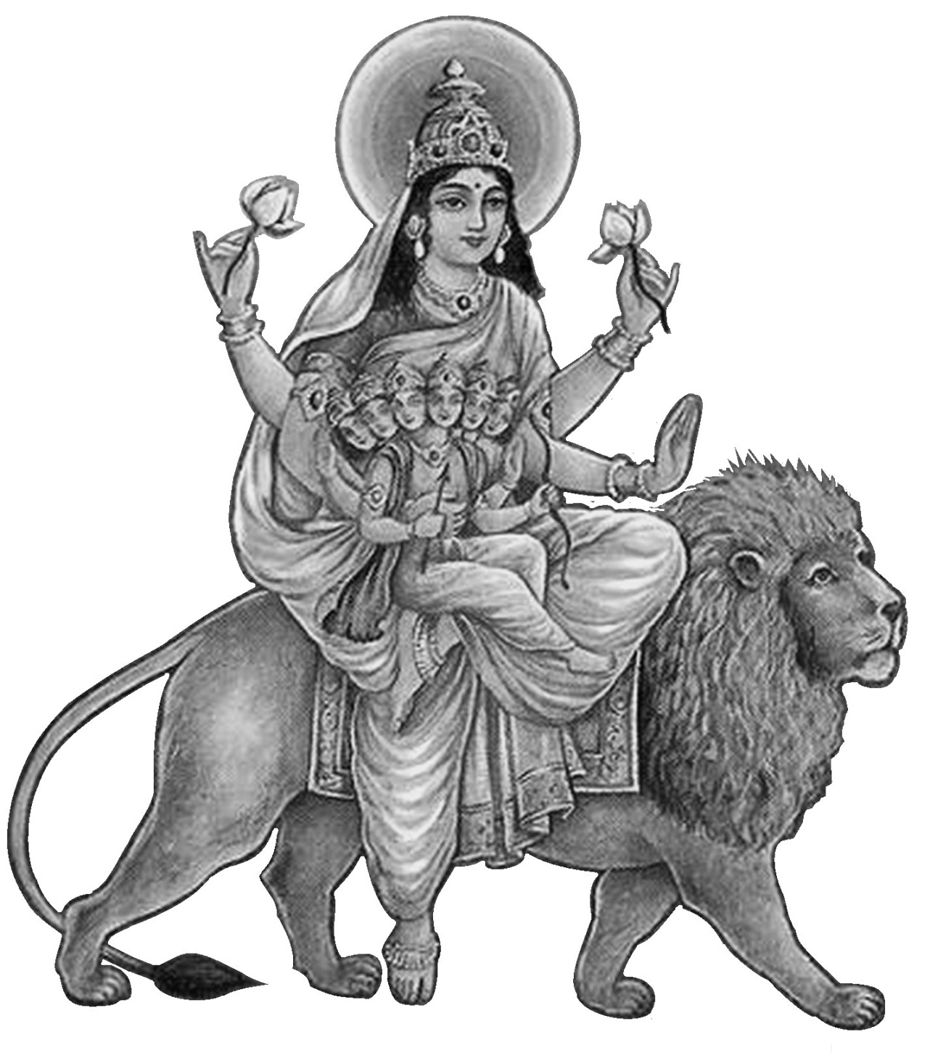
The demon Tārakāsura, who had over-run the heaven of the Devas –‘Gods’, had a boon that he could only be killed by a son of Lord Śhiva who was unmarried. So the Devas conspired to marry Him to Śhri Pārvatī. The six-headed boy Kārttikeya (Skanda) was duly born who led the army of the Gods and destroyed Tārakāsura.

Śhrī Skanda-mātā has four arms and rides a lion. Her worship, which purifies the heart and gives liberation from material attachments, is also pleasing to Śhrī Kārttikeya who leads all the Divine forces against evil-doers.

Day 6. Saraswatī Avahan / Pūjā.

Aspect of Śhrī Durgā –
Kātyāyani – ‘Incarnated as of Sage Katyayana’s Daughter’

Āgñyā Chakra - Vigñyāna-maya Kosha –‘Sheath of Understanding’.

- Shri Saraswatī Pūjā
- Chapters 9 + 10 of Devī Māhātmyam.
- Books, musical instruments, craft tools, (computers) may be offered on stage for blessing as manifestations of Shrī Saraswatī.

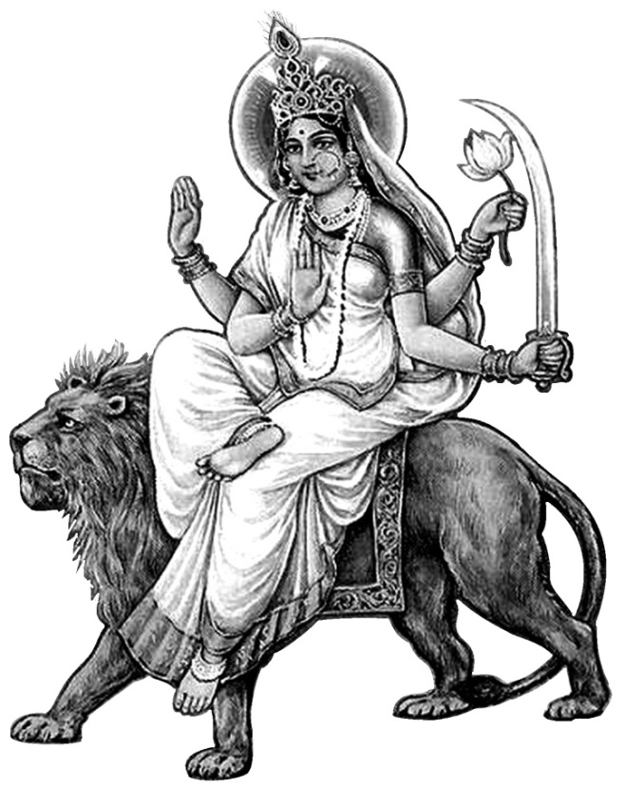
Katyayanī was created from the combined energy of the Devas –‘Gods’ who each donated their special powers and weapons to help Her destroy the demonic forces.

Her beauty captivated Mahiṣhāsura but She told him She would only marry one who defeated Her in battle. In the ensuing fight Mahiṣḥāsura, the chief and most powerful of the demons, was finally slain. She is the great remover of ego and demonic tendencies in Her devotees.

She rides a lion and is sometimes depicted with eighteen arms and three eyes.
Day 7. Mahālakshmī Pūjā.

Aspect of Śhrī Durgā – Kāla-rātrī – ‘Dark Night of Dissolution’

Sahasrāra Chakra - Ānanda-maya Kosha –‘Sheath of Bliss’

- Shri Mahālakshmi Puja.
- Mahālakshmī Stotram (Namaste-‘stu Mahāmāye...) p.178
- Devi Atharva Sheersha. p.161
- Chapter 11 – ‘Hymn to Narayani’ p.112
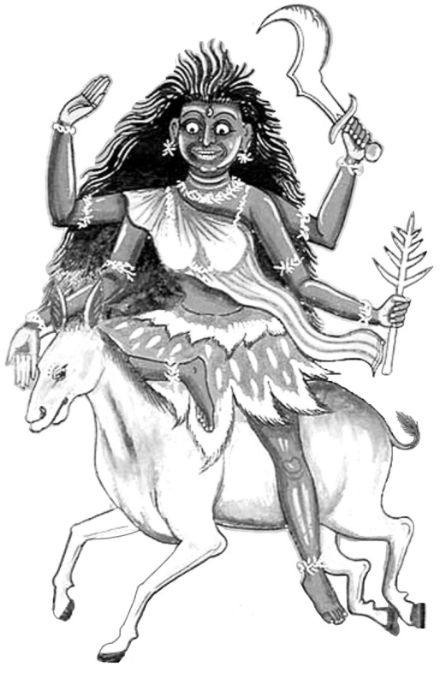
- Rātri Sūktam (Vedic p.58 and Tantric p.91)

The Dark Night is the state of emptiness where all passions, thoughts and desires are extinguished. One of the fiercest forms of Śhrī Durgā, Śhrī Kālarātrī (kāla –‘dark, black, time, destruction’, rātri –‘night’) confers auspiciousness, bliss and protection for devotees.
kālarātrī-mahārātrī-moharātrī –‘You are the dark night of worldly dissolution, the great night of final dissolution and the terrible night of delusion’.

Day 8. Mah’āṣhṭamī –‘Great Eighth day’.

Aspect of Śhrī Durgā - Mahāgaurī – ‘Very Fair and Shining’

- Chapter 12 of Devī Māhātmyam.
- Mahālakshmī Stotram. p.178
- Shri Annapūrṇeshwari Stotram. p.175

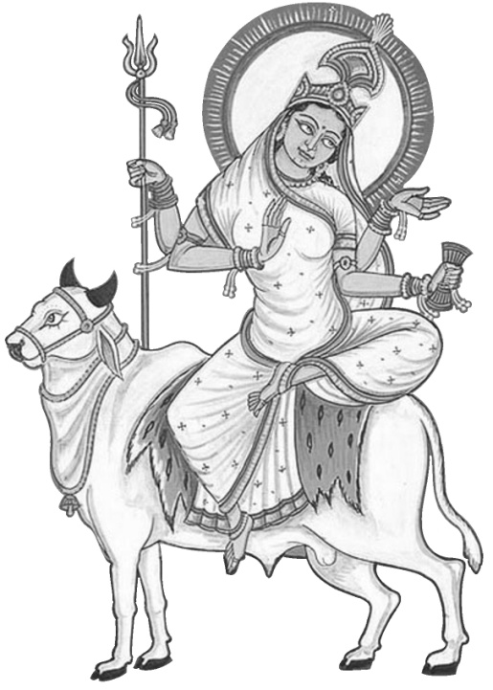
Mahāgaurī is the aspect representing the Bindu –‘dot’ Chakra – the first chakra above Sahasrāra where we experience the Nirvikalpa -‘doubtless’ state of meditation being immersed the blissful nature of the Goddess.

She has four hands holding a trident indicating Her mastery over the three guṇas, a drum which, as the heartbeat, shows Her control over life and existence, and giving fearlessness and blessings.

Shrī Pārvatī became Mahāgauri –‘very fair’ when She shed Her dark skin which took the form of Goddess Kaushiki to destroy Shumbha and Nishumbha. She takes us into that realm where we leave behind all worldy troubles.
Day 9. Mahā-navamī –‘Ninth day’.

Aspect of Śhrī Durgā – Siddhi-dātrī – ‘Granting Self-realisation’

- Chapter 13 of Devī Māhātmyam.
- Kuñjika Stotram. p.182

At Ardha-bindu –‘crescent moon’ (second chakra above Sahasrāra) the Goddess bestows on us the attainment of our goal of Kaivalya –‘absolute one-ness with the Divine’. This is the completion of our seeking and we enjoy being Her instruments channelling Divine Love, Peace and Joy onto this Earth.
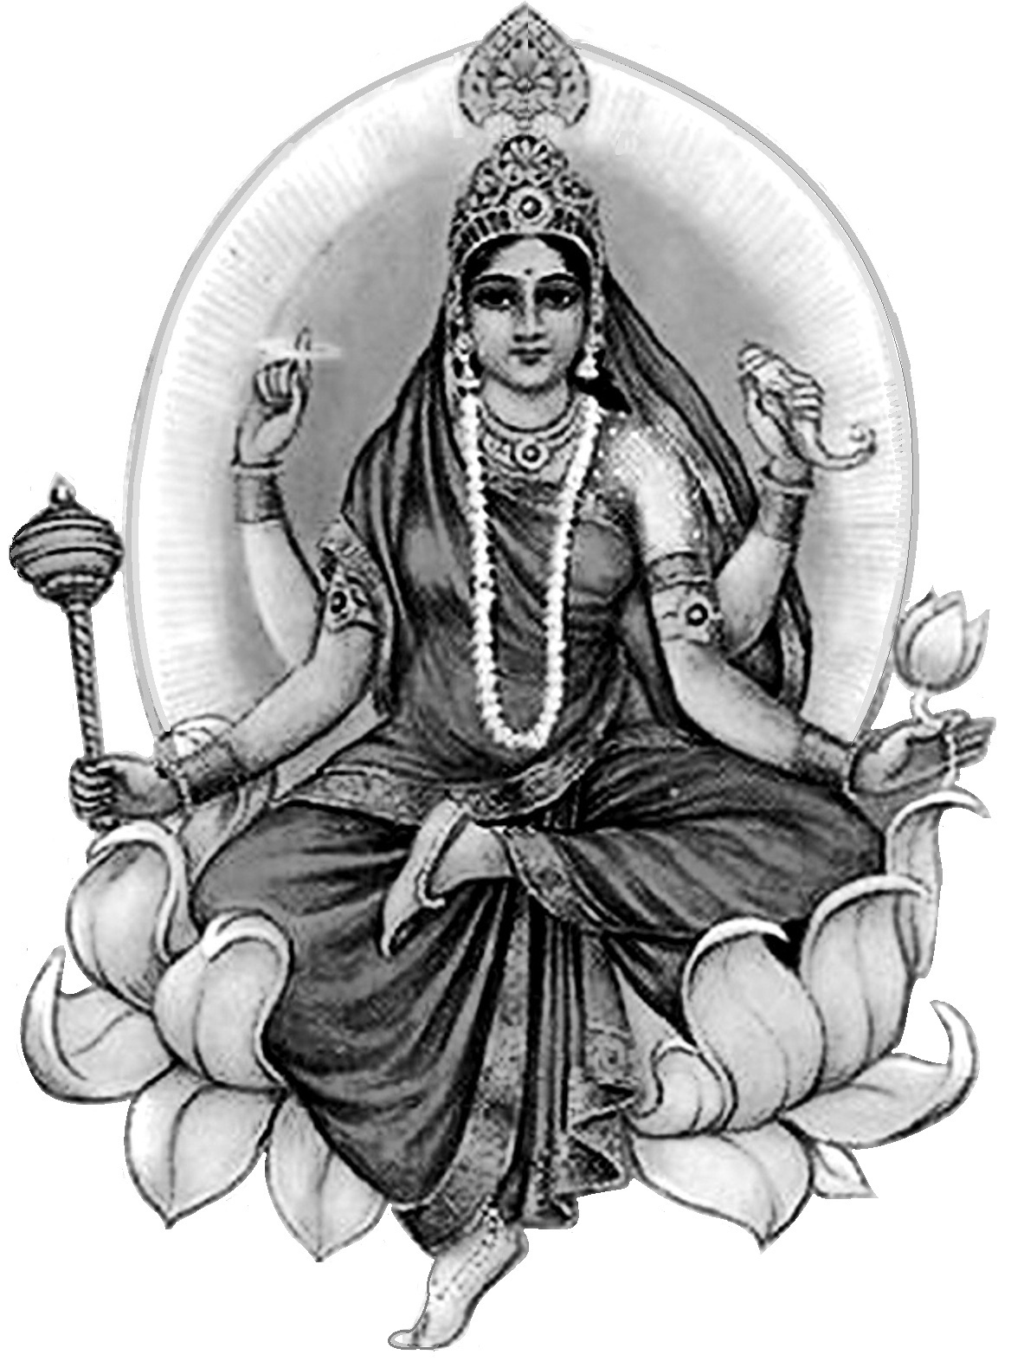
Shrī Siddhi-dātrī (Siddhi –‘success, fulfilment, Self-realisation, Yogic powers’, dātrī –‘giver’) has four hands, holding mace, discus, conch and lotus (like Śhrī Viṣhṇu) and is seated on a lotus.
As well as giving the aṣhṭa-siddhi –‘eight powers’ and nava-nidhi –‘nine treasures’, Her influence is healing and nourishing to all our four bodies, physical, emotional, mental and spiritual.
Day 10. Vijaya-daśhamī (Dussehra) – ‘Tenth Day of Victory’.

- Shrī Rāma Pūjā.
- Prayer for forgiveness. p.180
- Burning of Rāvana effigy.
- Durgā Visarjan –the statue of Śhrī Durgā can be taken in a procession for immersion in the lake/river/sea.
- Cutting the Ghata-sthāpanā. The grass shoots can be cut and offered as Prasad.

Dussehra (daśha –‘tenth’, ahara –‘day’) can also be interpreted as ‘Daśha-Hara’, meaning the cutting of the ten heads of Rāvana. So, let us resolve on this day to cut the ten heads of the demon Ego - passion, pride, anger, greed, infatuation, lust, hatred, jealousy, ignorance, revenge, selfishness and crookedness.

Other Auspicious Activities

Dandiya - stick-dancing – is pleasing to the Goddess. This is traditionally enjoyed on the Dussehra evening celebration – but may also be practiced at other times during Navarātri.
Sweets made of gram (chick pea) flour and jaggery (raw sugar) are auspicious for Prasād.

Collective singing
Shri Mataji has commented many times on how the vibrations flow more when we perform songs and praises collectively; so let us try to sing the beautiful praises associated with Navarātri as collectively as possible. This is one of the purposes of this book.

Praises like the Kavach of the Devi and the Lalitā Sahasranāma were composed as poems with wonderful flowing rhythms (Anushtubh metre), ideally suited to being sung to a simple melody.

We sing shortened versions of ‘Ayi Giri Nandini’ and ‘Sarva Mangala’ but during Navarātri it is appropriate to perform the full versions. (pp.138 & 86)

Navaratri songs
listed in the order they appear in the Sahaja Yoga Songbook (2014)

Jay Jay Bhavani Sanskrit 1
Ayi Giri Nandinī Sanskrit 2 – All 20 verses, p. 168.
Sarva Mangala Sanskrit 3 – All 40 verses, p. 112.
Jay Jagadambe, Mata Bhavani Sanskrit 5
Ya Devi Sarva Bhuteshu Sanskrit 6 – Full Stotram – p. 91.
Mahalakshmi Stotram Sanskrit 8
Anyatha Saharanam Nasti Sanskrit 31
Bhavani Dayani Marathi 2
Zog.wa Marathi 7
Adi Maya Ambabai Marathi 20
Jay Jagadambe, jay Ganesha-ji ki Hindi 11
Ghane ghane jang.la Hindi 13
Durgā, Adi Shakti Hindi 21
Durgati harinī Hindi 33
Jago savera Hindi 63
Mahamaya mahakali Hindi 64
Mātā, O Mātā Hindi 66
Jago he jagadambe Hindi 84
Shrī Jagadambe aayi re Hindi 91
Jaya He Hindi 101
Shrī Devi Stotram (Gatis-twam) IS3
Mother please come in my heart English 0
O Holy Virgin English 6

The Durgā Sapta-śhati
‘Seven Hundred Verses in praise of Shrī Durgā’

The Sapta-śhati –‘Seven hundred verses’ is another name for the Devī-māhātmyam –‘Glory of the Goddess’ from the Mārkandeya Purāna. The 13 chapters are in four sections, to Shrī Mahākāli, Mahālakshmī and Mahāsaraswatī telling the stories of the destruction of demons and each containing a great hymn of praise. The Shakr’ādya Stuti (p.59) is one of the deepest, subtlest and most beautiful of hymns. Finally there is the great Hymn to Nārāyanī (Ch.11) and the concluding chapters.

Chapter 1. The Story of the Merchant and the King. p.60
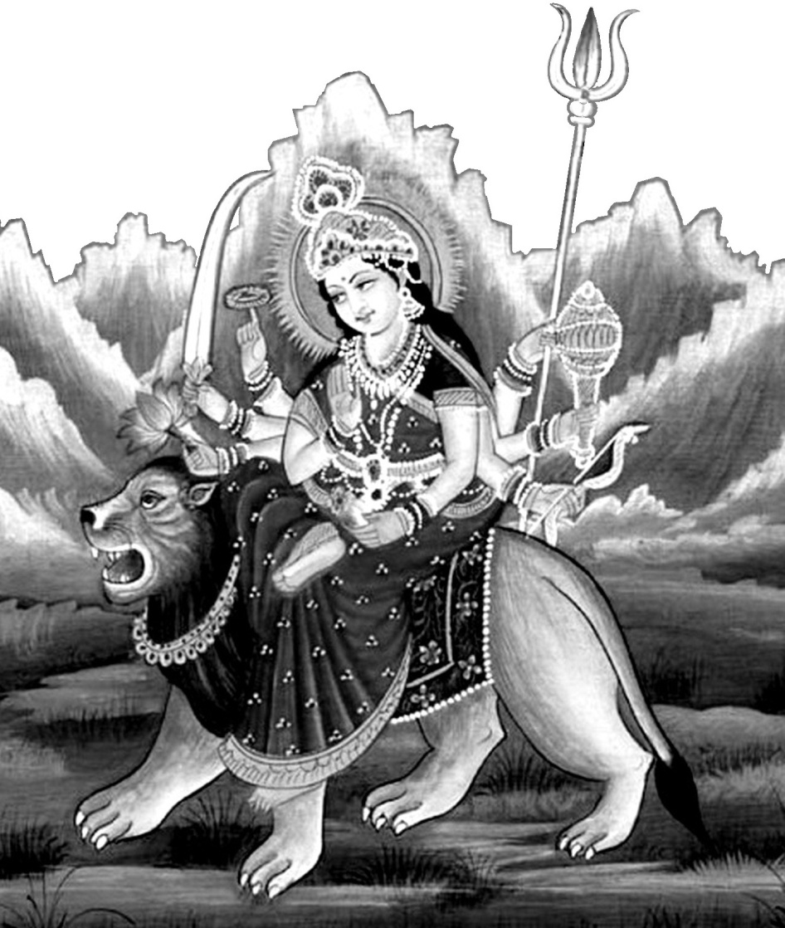
A king and a merchant, both in despair at the ways of the world, find themselves in Sage Medhas’s ashram. The Sage kindly enlightens them by recounting the story of the Goddess:

While Shrī Vishnu was in Yoga-nidra –‘mystic sleep’ reclining on the serpent Śheṣha upon the waters which were covering the Earth, two demons Madhu and Kaitabha emerged from His ear-wax and attempted to destroy Shrī Brahmā, who was seated on a Lotus emerging from Shrī Vishnu’s navel. Lord Brahmā invoked Shrī Mahākālī to remove Her Yoga–nidra (Tamasic/Sleep) form from Shrī Vishnu, who then awoke and destroyed the demons.
Hymn – Brahma-stuti (‘Twam swāhā Twam swadhā..’) v.83-87 to Shrī Mahākāli
Chapter 2. The Slaughter of Mahishāsura’s army. p.63
Chapter 3. The Slaying of Mahishāsura. p.66
Chapter 4. After destroying Mahishāsura and his followers, the Goddess is eulogised by Lord Indra (a.k.a. Śhakra) and the other Devas with the Śhakr’ādi Stuti –‘Praise by Indra and the other Gods’. p.79
Chapter 5. Shumbha and Nishumbha are terrorising the world. Shrī Mahāsaraswatī is invoked with the Devi-sūktam (‘Ya Devi sarva bhuteshu..’). p.89
Chapter 6. Slaying of Dhumra-lochana. p.95
Chapter 7. Slaying of Chanda and Munda. p.98
Chapter 8. Slaying of Raktabīja. p.101
Chapter 9. Slaying of Nishumbha. p.106
Chapter 10. Slaying of Shumbha. p.109
Chapter 11. Hymn to Nārāyanī (‘Sarva maṅgala’) (Shri Mahālakshmī) p.112
Chapter 12. Promise of Blessings. p.120
Chapter 13. The Merchant and the King are given boons. p.123

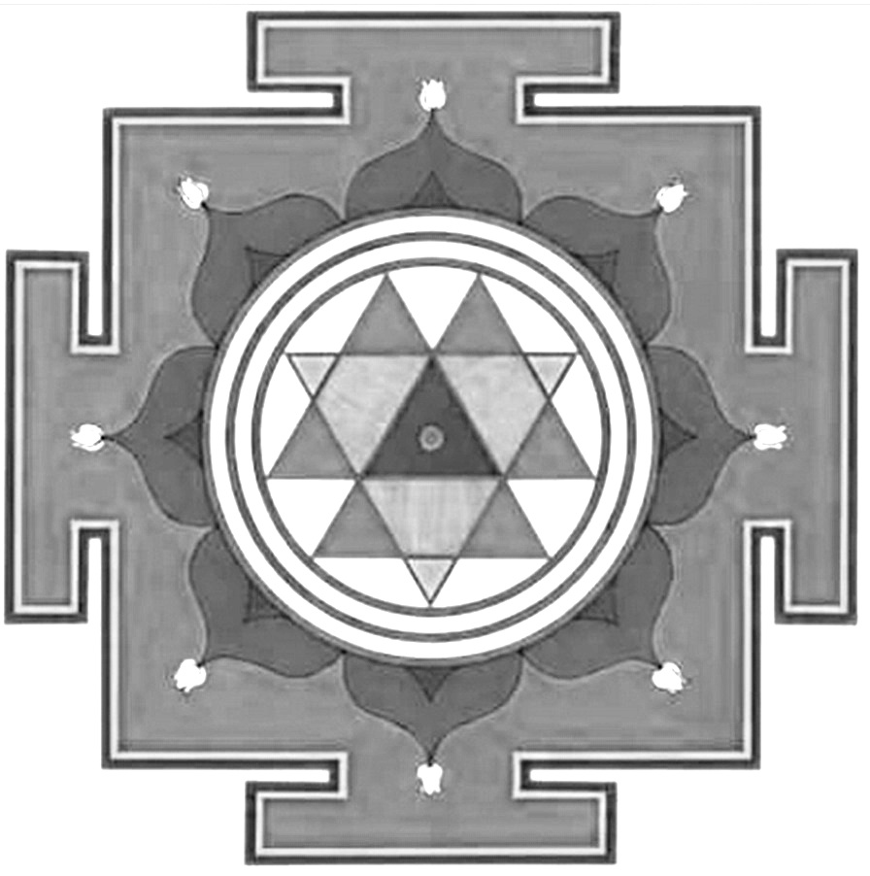

Shrī Durgā Yantra
The inner design has nine outward-pointing triangles as the nine forms of Shrī Durgā.

It may represent the Three Channels overlapping with the Brahma Nāḍī in the centre.

Translation of:

Her Supreme Holiness Shrī Mataji's Marathi Letter

01-10-78

To All Sahaja Yogis, Many Blessings.

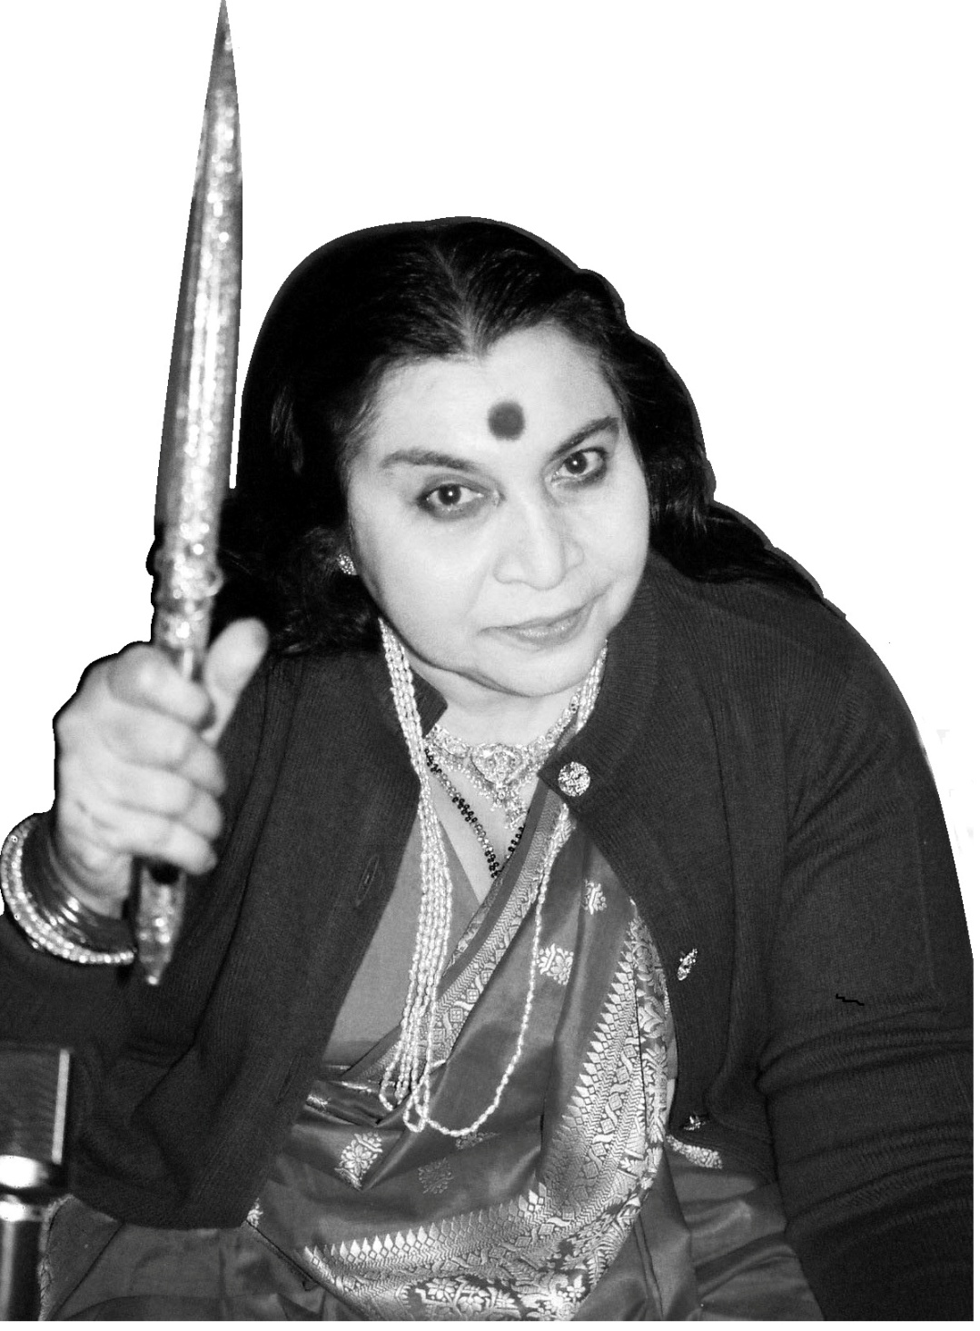
Today is the first day of Navaratri. Today your attention should be on Shri Ganesha. His devotion is infinite. He has never worshipped anybody else except Mother. Hence He is so great. All other Gods appear very strong; everyone has some specialty. What is Mother's speciality? Her ego (aham) is nowhere felt by others. Hence Shri Ganesha who has surrendered to such a Mother, is so wise and venerable.

Mother has nothing with Her. Her very name begins with 'Ni' e.g. Nish-kanchan -‘having no wealth’, Nirlepa -‘unaffected’, Nirvichara –‘thoughtless’, Nishprayojana -‘having no motives’, Nirgarvita -‘egoless’, Niriccha -‘desireless’ etc. Therefore, surrendering to such a Mother, who has nothing with Her, needs some kind of subtle thought, in that Mother has nothing with Her and therefore, nothing can be asked from Her.

It shows how Shri Ganesha by Himself, is fully satisfied. Where does this contentment of Shri Ganesha come from? It is His own power.

When the gate of the Self opens, nothing else is required. It is the Mother who opens this gate and therefore She is so dear to Shri Ganesha. Complete Self-Realization is that stage, attaining which nothing else is required. Thereafter, only enjoying the Bliss and the Satisfaction of Fulfilment.

You are made in the pattern of Shri Ganesha. Therefore, your power is unmatched, but for that, you should have devotion and innocence like Shri Ganesha's. Then Mother would admire you and the whole world would witness that beautiful sight.

I have worked in the operation and lda Nadi of all has become much lighter. Ida means past and all good and bad impressions. All that is bad should be removed like cleaning of an excellent cloth that gets back its colour and new look. Right Side improves by discipline. I myself will observe fast and clean your Right Side, so that your power to do the work increases and you start Sahaja Yoga work with new vigour.

However, Left Side can be kept clean by discriminating between good and bad deeds and strictly doing only that which is good. That means you have to do only that which is auspicious and helpful. Right Side can be activated by discipline. Balance is very important in Sahaja Yoga. The age-old maxim: ‘Ati Sarvatra Varjayet‘ –‘Extremes should be avoided everywhere’ really holds good.

I am very eager to meet you all.

Your Mother – Nirmala

The Nav’ārna Mantra
‘The Nine-syllabled Mantra’

The Nine-syllabled Mantra is an integral part of Navarātri and worship during the nine nights is traditionally started by saying it at least twelve times, after salutations to Śhrī Ganesha. Some of the aṅga’s –‘limbs’ of the Sapta-śhati -‘seven hundred verses’ give ¹instructions on the performance of this mantra.
Om Aīm Hrīm Klīm Chāmuṇḍāyai vichche
Shri Mataji has talked about this mantra in Her writings and lectures:
‘Om Aim Hreem Kleem Châmundâyai Vichche ²namah is properly used to awaken Âdi Shakti as Jagadamba or Châmundâ. This beautiful and powerful mantra should only be used by a realized soul under the guidance of an evolved Guru.’ BoAS. Ch.5.

Aim, Hrīm and Klīm are the A, U and M of Om in their evolved forms:
- Aim (‘Ayeem’) – Śhrī Mahākālī, Pure Desire, Awakening of Kundalini, supported by the lower chakras. Sat –‘existence, reality’ of Sat-chit-ānanda.
- Hrīm – Śhrī Mahālakshmī (Hari-Vishnu), Central Channel, Kundalini rising through Suṣhumnā Nāḍī, evolution, peace, Chit –‘attention, consciousness’.
- Klīm – Śhrī Mahāsaraswatī, Bliss in the Sahasrāra, Divine Connection, Ānanda –‘joy, bliss’.
- Chāmuṇḍā – Destroyer of the demons Chaṇḍa –‘anger’ and Muṇḍa –‘bald head’ ie. destroying Ego and Conditionings. Also means ‘bathing in auspiciousness’ - Chām – ‘peace, well-being, auspiciousness.’ Unda – ‘flow, outpouring, bathing’.

- In the instructions from the Purānas the mantra is to be said at least a thousand times per day, making ten thousand over the nine nights. Saying the mantra 1000 times, at 7 seconds per mantra, would take two hours.
- Adding namaḥ at the end is a matter of personal preference.

One may salute the Bījas with these mantras:
Om Aiṁ Mahākalyai namaḥ
Om Hrīṁ Mahālakshmyai namaḥ
Om Klīṁ Mahāsaraswatyai namaḥ
Om Śhrī Chāmuṇḍāyai namaḥ
Sākṣhāt Śhrī Ādi Śhakti Mātājī Śhrī Nirmalā Devyai namo namaḥ

“These Three Primordial Syllables AA, OO and MA represent the three powers of the Primordial Mother: These Three Syllables later on form the Primordial Words Aim, Hrīm and Klīm.” BoAS Ch 1.

“Aim, Klîm, Hrîm are the three words denoting the three powers of the Goddess. Aim, Hrîm and Klîm: Aim is the Mahâkâlî, Hrîm is the Mahâlakshmî and Klîm is the Mahâsaraswatî.” 26-01-84, India

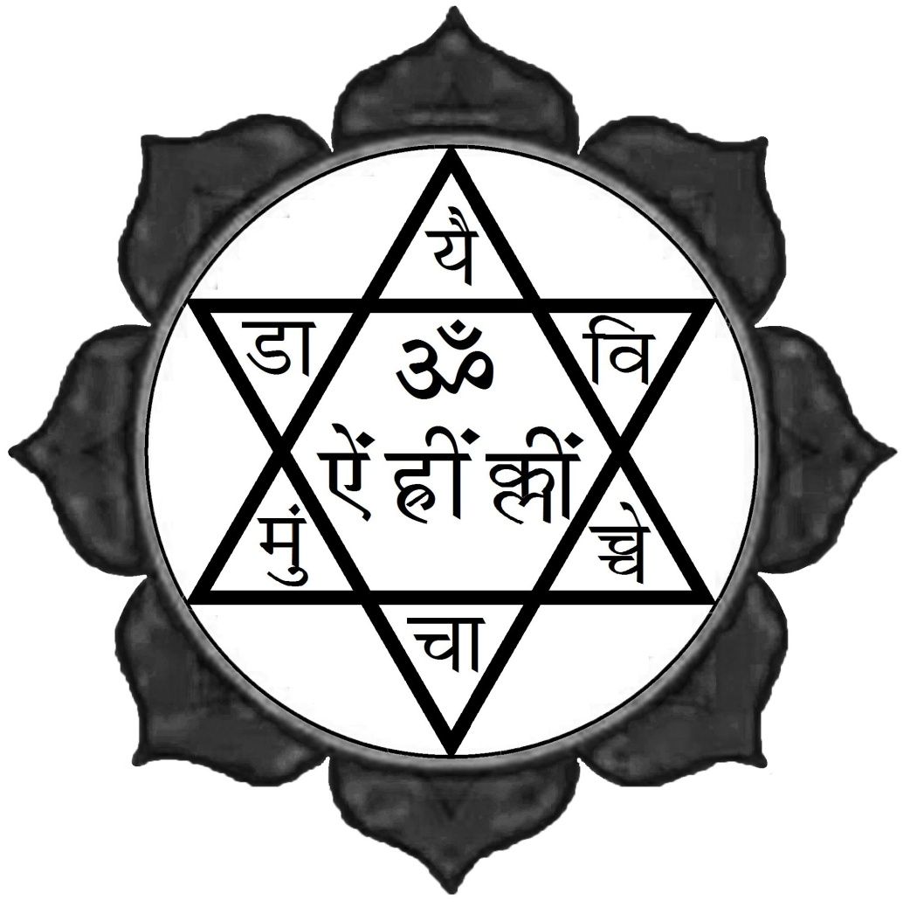
“Supposing you want to raise your Kundalinî, then the bîja mantra is ‘Hrîm’. ‘Ra’ is the energy, Rādhā. The one who sustains the energy is Rādhā. She is Mahâlakshmî that is why she sustains the Kundalinî. ‘Eee’ is the primordial Mother and ‘Ra’ is the energy that is Kundalin$î$. So the ‘Hrîm’ means that you have the energy passing through the Mahâlakshmî tattwa which is Ra. You see the Energy is passing towards the Primordial Being. So ‘Hrîm’.” 17-10-88, Pune.
The Nine-syllabled Mantra
Om Aim Hrīm Klīm Chāmuṇḍāyai vichche inscribed in the Yantra.
Śhrī Durgā Sapta-śhlokī
Seven verses to Shrī Durgā

Śhiva uvācha: - Lord Shiva said:
Devi tvaṁ bhakta-sulabhe sarva kārya vidhāyinī
Kalau hi kārya-siddhy’artham-upāyaṁ brūhi yat-nataḥ ||
O Goddess, easily achieved by devotees, dispenser of all outcomes
Explain how, in this Kali Yuga, to achieve the success of one’s enterprises

Devy’uvācha: - The Devi said:
Śhṛiṇu deva pravakṣhyāmi kalau sarv’eṣhṭa-sādhanam
Mayā tav’aiva snehen’āpy’ambā-stutiḥ prakāśhyate ||
Listen, O Lord, I will explain the fulfilment of all wishes in this Kali Yuga
By Your Grace; it will be illuminated by this praise of the Divine Mother.

Oṁ asya Śhrī Durgā sapta-śhlokī stotra Of these seven verses to Durgā
Mahā-mantrasya Nārāyaṇa ṛiṣhiḥ Shrī Vishnu is the Composing Seer,
Anuṣhṭubh’ādīni chhandāṁsi The metres are Anushtubh, etc.
Śhrī Mahākālī Mahālakṣhmī Mahāsarasvatyo devatāḥ
The Presiding Deities are Śhrī Mahākālī, Mahālakṣhmī and Mahāsarasvatī
Śhrī Dūrgā prīty’arthaṁ sapta-śhlokī Durgā pāṭhe viniyogaḥ
This recitation of the Seven Verses is undertaken to please Śhrī Durgā

Jñāninām-api chetāṁsi Devī Bhagavatī hi sā
Balād-ākṛiṣhya mohāya Mahāmāyā prayachchhati || 1 ||
The attention of even the wise and knowledgeable is forcibly attracted by
That Illustrious Goddess who as Shrī Mahāmāyā causes delusion.

Durge smṛitā harasi bhītim-aśheṣha jantoḥ
Svasthaiḥ smṛitā matimatī-va śhubhāṁ dadāsi
Dāridrya duḥkha-bhaya-hāriṇi kā tvad-anyā
Sarv’opakāra-karaṇāya sadā-‘rdra chittā || 2 ||
O Goddess Durgā, when remembered You remove all fear, When recollected, You grant intelligence and happiness, Who other than You,
O destroyer of hardships, sorrow and fear, can deliver all assistance
with ever-tender intentions.
Śhrī Durgā Sapta-śhlokī
Sarva maṅgala māṅgalye śhive sarv’ārtha sādhike
Śharaṇye tryambake gauri Nārāyaṇi namo-’stu te || 3 ||
O Conferrer of all Bliss and Happiness, Auspicious Fulfiller of all undertakings
O Shining Three-eyed Giver of Shelter, O Refuge of Humanity, we bow to You

Śharaṇ’āgata dīn’ārta pari-trāṇa parāyaṇe
Sarvasy’ārti-hare devi Nārāyaṇi namo-’stu te || 4 ||
The Supreme Goal and Protector of the Afflicted who seek Refuge in You
O Goddess who removes the pain of everyone, Narayani, we bow to You

Sarva-svarūpe sarveśhe sarva-śhakti-samanvite
Bhaye-bhyas-trā-hi no Devi Durge Devi namo-’stu te || 5 ||
Assuming the form of the Universe, controlling everything, having all powers,
Protecting us trembling with fear, O Goddess Durgā, we bow to You

Rogā naśheṣh’ānapahaṁsi tuṣhṭā
Ruṣhṭā tu kāmān sakal’ānabhīṣhṭān
Tvām āśhritānāṁ na vipannarāṇāṁ
Tvām āśhritā hy’āśhrayatāṁ prayānti || 6 ||
If satisfied You destroy illness and promote vitality,
But if angry You give all un-wished-for desires.
Those attached to You do not get afflicted;
Those depending on You become the refuge of others

Sarvā-bādhā praśhamanaṁ trai-lokyasy’ākhileśhvari
Evam-eva tvayā kāryam-asmad-vairi vināśhanam || 7 ||
You pacify all troubles, being the Supreme Controller of the Three Worlds
Thus completely destroying the works of our enemies

|| Iti Durgā sapta-śhlokī sampūrṇā ||
Here ends the Seven Verses to Śhrī Durgā.

The 108 names of Śhrī Durgā

Śhata-nāma pra-vakṣhyāmi Śhṛinuṣhva kamal'ānane
(Lord Shiva said…) I will recite the hundred names, listen well, O Lotus-faced One
Yasya prasāda-mātrena Durgā prītā bhavet Satī
Only by this offering will Mother Durga be pleased, O Faithful Spouse.

Om Twameva sākṣhāt Śhrī You are…

Satī The First Incarnation and Devoted Wife of Shrī Shiva;
the Most Excellent Abode of Truth
Sādhvī The Bearer of All Virtues
Bhava prītā Loved by Shrī Shiva
Bhavānī The Loving Consort of Shrī Shiva; the Source
of All Existence and Contemplation
Bhava-mochanī The One who Liberates us from Worldly Existence 5
Āryā Honourable and Noble
Durgā The Goddess who is Hard to Attain
Jayā The Goddess of Victory
Ādyā The Primordial Goddess
Tri-netrā Three-eyed 10

Śhūla dhārinī The Wielder of the Trident
Pināka dhārinī The One who bears Shrī Shiva's Pinaka Bow
Chitrā Of Many Excellent Forms
Chaṇḍa-ghaṇṭā Ringing a Mighty Bell to Instil Fear in Evil-Doers
Mahā-tapā Practicing Great Austerities 15
Mānas The Psyche as the Combination of Heart and Mind
Buddhi The Intellect and Understanding
Ahaṁkārā The Illusion of Individuality, the Ego
Chitta rūpā In the Form of the Attention
Chitā Consciousness 20

The 108 names of Shrī Durga
Chiti Understanding and Reflection
Sarva-mantra mayī The Essence of All Mantras
Sattā Truth and Reality
Saty'ānanda swarūpinī Characterised by blissful immersion
in the Ultimate Reality
Anantā Eternal 25
Bhāvinī The Fulfillment of all good qualities
Bhāvyā What we aspire to become
Bhavy’ābhavyā What is destined to be and what is not to be
Sadā-gati Always Moving – as Wind or Spirit
Śhāmbhavī The Beneficent Wife of Shrī Shiva 30

Deva-mātā The Mother of the Gods
Chintā The One who Takes Care of our Well-Being
Ratna priyā Fond of Jewels (Realised Souls)
Sadā . Ever-existent
Sarva vidyā All Knowledge 35
Dakṣha kanyā The Daughter of King Daksha
Dakṣha-yagñya-
-vināśhinī The One who destroyed King Daksha's sacrifice,
when he insulted Shrī Shiva
Aparṇā Undertaking severe penance to win Shrī Shiva
not even eating leaves
Aneka varnā The One who Manifests in Many Styles
Pātalā Having a Rosy Glow 40

Pātalā-vatī Surrounded by Roses and Pink Lotuses
Pītāmbara-pari-dhānā Clothed in Yellow Garments
Kamal’ānjīra-rañjinī Adorned with Lotus-Blossoms
Ameya-vikramā Of Immeasurable Valour
Krūrā Formidable 45

The 108 names of Shrī Durga
Sundarī Beautiful
Sura-sundarī Heavenly Beauty
Vana-durgā The Goddess of the Forest
Mātaṅgī The Mother of the Tribe of Elephants (Great Souls)
Mātaṅga-muni pūjitā Worshipped by the Sage Matanga 50

Brāhmī The Shakti of Shrī Brahma
Mah'eśhwarī The Shakti of Shrī Shiva
Aindrī The Shakti of Shrī Indra
Kaumārī The Shakti of Shrī Kārtikeya
Vaiṣhṇavī The Shakti of Shrī Vishnu 55
Chāmuṇḍā The Goddess who Destroys Demons
Vārāhī The Shakti of Shrī Vishnu in the Boar Incarnation
Lakṣhmī The Goddess of Good Fortune and Spiritual Ascent
Puruṣh’ākṛiti Having the Form of the Primordial Being
Vimalā Unsullied and Spotless 60

Ut-karṣhiṇī The Highest Ascending Glory
Gñyānā Knowledge
Kriyā Action
Nityā Eternal
Buddhidā The Bestower of Enlightened Intelligence 65
I
Bahulā Abundant
Bahula premā Overflowing with Love
Sarva vāhana-vāhanā Whose Army is conveyed in All Vehicles
*Niśhumbha-
-śhumbha-hananī Annihilating the Demons Nishumbha and Shumbha
*Mahiṣh’āsura mardinī The Slayer of the Evil Mahisha 70
*Madhu-Kaitabha hantrī .The Destroyer of the Demons Madhu and Kaitabha
*Chaṇḍa-Muṇḍa-
-vināśhinī Crushing the Demons Chanda and Munda

The 108 names of Shrī Durga
Sarv’āsura vināśhinī The One who Grinds All Demons into Dust
Sarva-danava ghātinī The Slayer of All the Demons
Sarva-śhāstra mayī In the Form of All Science and Knowledge 75
Satyā The Ultimate Reality
Sarv’āstra-dhārinī Wielding all Negativity Destroying Missiles
Aneka-śhastra hastā Bearing many Sacred Books in the Hands
Anek’āstrasya dhārinī Brandishing Many Weapons
Kumārī The Virgin Goddess 80

Eka-kanyā The Supreme Virgin
Kaiśhorī The Youthful Goddess
Yuvatī Appearing as a Young Girl
Yati Ascetic
Apraudhā . Having the Form of a Youthful Maiden 85
Praudhā Appearing as an Older Woman
Vṛiddha mātā Taking the form of a Mature Mother
Bala-pradā The Bestower of Strength
Mah'odarī The One who has a Large Belly
Mukta keśhī Whose Hair is Loose and Flowing 90

Ghora rūpā Of Terrifying Form
Mahābalā Of Very Great Strength
Agni jvālā Blazing with Fire
Raudra mukhī Fierce-faced
Kāla-rātri The Dark Night of Dissolution 95
Tapasvinī Undertaking Austerities
Nārāyaṇī The Shakti of Shrī Vishnu, the Refuge of Humanity
Bhadra-kālī The Auspicious Dark-skinned Mother
Viṣhṇumāyā Shrī Vishnu's Creative Power who
announces Divine Incarnations
Jal'odarī Holding all the waters of the Earth in Your belly 100

The 108 names of Shrī Durga
Śhiva dutī Recruiting Shrī Shiva as Your Messenger
Karālī Of Very Dreadful Aspect, with Wide-Gaping Mouth
Anantā Infinite and Eternal
Param'eśhwarī The Supreme Goddess
Kātyāyanī Born as the Daughter of Sage Katyayana, from
the brilliance of all the Gods to destroy
the evil Mahishasura and his followers 105
Sāvitrī The Life-giving Power of the Sun
Pratyakṣhā The Manifested World of the Senses
Brahma-vādinī The One who Teaches Knowledge of the Supreme Spirit


Sākṣhāt Śhrī Ādi Śhakti Mātājī Śhrī Nirmalā Devyai namo namaḥ
Who is verily before us as Our Holy Mother Shri Mataji

The 108 names of Śhrī Durgā
Durg’āṣhṭottara-śhata-nāma Stotram

Īśḥvara uvacha: Shrī Śhiva said:-

Śhata-nāma pra-vakṣhyāmi śhṛinuṣhva kamal'ānane
Yasya prasāda-mātrena Durgā prītā bhavet Satī ǁ 1 ǁ
I will recite the hundred names, listen well, O Lotus-faced One
Only by this offering will Mother Durga be pleased, O Faithful Spouse.

Satī Sādhvī Bhava-prītā Bhavānī Bhava-mochanī
Āryā Durgā Jayā ch’Ādyā Tri-netrā Śhūla-dhārinī ǁ 2 ǁ

Pināka-dhārinī Chitrā Chaṇḍa-ghaṇṭā Mahā-tapāḥ
Māno Buddhir Ahaṁkārā Chittarūpā Chitā Chitiḥ ǁ 3 ǁ

The 108 names of Shrī Durga
Sarva-mantra-mayī Sattā Saty'ānanda-swarūpinī
Anantā Bhāvinī Bhāvyā Bhavy’ābhavyā Sadā-gatiḥ ǁ 4 ǁ

Śhāmbhavī Deva-mātā cha Chintā Ratna-priyā Sadā
Sarva-vidyā Dakṣha-kanyā Dakṣha-yagñya-vināśhinī ǁ 5 ǁ

Aparṇ’āneka-varnā cha Pātalā Pātalā-vatī
Pītāmbara-pari-dhānā Kamal’ānjīra-rañjinī ǁ 6 ǁ

Ameya-vikramā Krūrā Sundarī Sura-sundarī
Vana-durgā va Mātaṅgī Mātaṅga-muni pūjitā ǁ 7 ǁ

Brāhmī Mah'eśhwarī ch’Aindrī Kaumārī Vaiṣhṇavī tathā
Chāmuṇḍā Vārāhī chaiva Lakṣhmīśh-cha Puruṣh’ākṛiti ǁ 8 ǁ

Vimal’ot-karṣhiṇī Gñyānā Kriyā Nityā cha Buddhidā
I
Bahulā Bahula-premā Sarva vāhana-vāhanā ǁ 9 ǁ

Niśhumbha-śhumbha-hananī Mahiṣh’āsura mardinī
Madhu-Kaiṭabha hantrī cha Chaṇḍa-Muṇḍa-vināśhinī ǁ 10 ǁ

Sarv’āsura vināśhinī cha Sarva-dānava ghātinī
Sarva-śhāstra-mayī Satyā Sarv’āstra-dhārinī tathā ǁ 11 ǁ

Aneka-śhastra-hastā cha Anek’āstrasya-dhārinī
Kumārī ca’Aika-kanyā cha Kaiśhorī Yuvatī Yatiḥ ǁ 12 ǁ

Aprauḍhā chaiva Prauḍhā cha Vṛiddha-mātā Bala-pradā
Mah'odarī Mukta-keśhī Ghora-rūpā Mahābalā ǁ 13 ǁ

Agni jvālā Raudra-mukhī Kāla-rātri Tapasvinī
Nārāyaṇī Bhadra-kālī Viṣhṇumāyā Jal'odarī ǁ 14 ǁ

Śhiva-dūtī Karālī cha Anantā Param'eśhwarī
Kātyāyanī cha Sāvitrī Pratyakṣhā Brahma-vādinī ǁ 15 ǁ

The 108 names of Shrī Durga
Phala-śhṛuti –‘Listening to the Rewards’

Ya idam prapaṭhen-nityam Durgā-nāma-śhat’āṣhṭakam
Nāsādhyam vidyate Devi triṣhu-lokeṣhu Pārvati ǁ 16 ǁ
One reciting this 108 names of Shrī Durga daily,
Becomes the foremost in the Three Worlds, O Devi Parvati

Dhanam dhānyam sutam jāyām hayam hastinam-eva cha
Chatur-vargam tathā chānte
labhen-muktam cha śhāśhvatīm ǁ17ǁ
Wealth, health, children, a faithful wife, horses and elephants he obtains
And the four aims of life, and at the end of Earthly Existence achieves Liberation

Kumārī pūjayitvā tu dhyātvā Devī sureśhvarīm
Pūjayet parayā bhaktyā paṭhai-nāma-śhat’āṣhṭakam ǁ 18 ǁ
Worshipping first the Virgin Goddess, then meditating on the Ruler of the Gods
After worshipping with devotion, read this hundred and eight names

Tasya siddhir-bhaved Devi sarveḥ sura-varair-api
Rājāno dāsatām yānti rājya-śhriyam-avāpruyāt ǁ 19 ǁ
He gets the power of that Goddess who is everything, the Best of the Devas.
Kings become his servants, and he obtains majesty and prosperity

Gorochanā-laktaka-kuṁkumena sindhūra
karpūra madhu-trayeṇa
Vilikhya yantram vidhinā vidhigñyo bhavet
sadā dhārayate purāriḥ ǁ 20 ǁ
With yellow paste, red lac, red powder, red lead, camphor and the three sweets
Anointing the design knowing rules and methods he becomes always like Shrī Shiva

Bhaumāvāsyā niśhāmagre chandre śhata-bhiṣhāṁ gate
Vilikhya prapaṭhet Stotraṁ sa bhavet sampadāṁ padam ǁ 21 ǁ
Reciting first on the day of the New Moon in the sign of ‘100 Healers’ (Aquarius)
After anointing, reciting this praise aloud he completes the procedure

Sākṣhāt Śhrī Ādi Śhakti Mātājī Śhrī Nirmalā Devyai namo namaḥ
Who is incarnated in person as Our Holy Mother Shri Mataji Nirmala Devi

The Kavach of the Devī
Shrī Chaṇḍī Kavacham
‘The ‘Armour’ of the Goddess who is all fired-up to protect Her children’

Om Śhrī Gaṇeśhāya namaḥ Salutations to Shri Ganesha
Asya Śhrī-Chaṇḍī-kavachasya Of this Shrī Chandi-Kavach
Brahmā ṛiṣhiḥ The Presiding Sage is Brahma,
Anuṣhtup chhandaḥ The Metre is Anushtubh.
Chāmuṇḍā devatā The Presiding Deity is Chamundā.
Aṅga-nyās'okta-mātaro-bījam The Seed is Anga-nyas’okta mātar –
‘Putting attention to parts of the body
while reciting’.
Digbandha-devatās-tattvam The Principle is Digbandha·devatā –
‘Facing the direction of the Deity’.
Śhrī-Jagadambā-prīty’arthe, To please Shrī Jagadamba
Sapta-śhatī pāṭh’āṅgatvena as part of Sapta-shati –‘700 verses’
jape viniyogaḥ this recitation is undertaken
Om namaśh-Chaṇḍikāyai Amen. Obeisance to Śhrī Chandika.

Mārkaṇḍeya uvācha Thus spoke Sage Markandeya:

1 Om yad-guhyam paramam loke, sarva-rakṣhā-karam nṛiṇām
Yan-na kasya-chid'ākhyātam, tanme brūhi Pitāmaha
Amen. O Brahmadeva, please tell me that which is very secret,
Has not been told to anyone else and which protects all beings in this world.

Brahm'ovācha - Brahmadeva said:
2 Asti Guhya-tamam vipra, sarva-bhūt'opa-kārakam
Devy’āstu kavacham puṇyam, tat-śhṛiṇuṣhwa Mahāmune
O Brahmin! That which is most secret, auspicious and benevolent to all beings
Is the Kavach of the Devī. Please listen to that, O Great Sage.

The Kavach of the Devī
3 Prathamam Śhaila-putrī cha, dvitīyam Brahma-chāriṇī
Tritīyam Chandra-ghaṇṭ'etī, Kūṣhmāṇḍ'eti chaturthakam
Shrī Durgā is known by these nine names: First- Shaila-putri – ‘Daughter of
the Mountain’: Second- Brahma-chārinī – ‘Observing the state of celibacy’
Third- Chandra-ghanta -’Adorned with the moon as Her bell’
Fourth- Kushmanda -‘The One whose void contains the Universe’

4 Pañchamam Skanda-māt'eti, ṣhaṣhṭham Kātyāyan'īti cha
Saptamam Kāla-rātrīśh cha, Mahāgaur'īti ch’āṣhṭamam
Fifth- Skanda-mātā –‘The Mother of Kārttikeya’,
Sixth- Kātyāyanī –‘The Daughter of Sage Katyayana’
Seventh- Kālarātrī –‘The Dark night of dissolution’,
Eighth- Mahāgaurī–‘Very bright - the Ādi Kundalini’

5 Navamam Siddhi-dātrī cha, nava Durgāḥ prakīrtitāḥ
Uktāny'etāni nāmāni, Brahmaṇ'aiva Mah’ātmanā
Ninth- Siddhi-dātrī –‘One who grants Moksha’
These nine names have been told by the Great Soul Brahmadeva Himself

6 Agninā dahya-mān’āstu, śhatru-madhye gato raṇe
Viṣhame durgame ch'aiva, bhayārtāḥ śharaṇam gatāḥ
Those who are engulfed by fire or surrounded by enemies on the battlefield,
Or being at an impassable place or frightened, if they surrender to Shri Durga,

7 Na teṣhām jāyate kiñchid, aśhubham rana-saṅkate
N’āpadam tasya paśhyāmi, śhoka-duḥkha-bhayam na hi
They would never suffer any misery or misfortune, even at time of war.
They would face no calamity, grief, sorrow or fear.

8 Yaistu bhaktya smṛita nūnam, teṣham vṛiddiḥ prajayate
Ye tvām smaranti Deveśhi, rakṣhase tānna saṁśhayaḥ
Those who remember You with great devotion, indeed have prosperity.
Undoubtedly, O Supreme Goddess, You protect those who remember You.

The Kavach of the Devī
9 Preta-saṁsthā tu Chāmuṇḍā, Vārāhī mahiṣh’āsanā
Aindrī gaja-samārūdhā, Vaiṣhṇavī Garud’āsanā
The Goddess Chamunda sits on a corpse, Vārāhi rides on a buffalo,
Aindri is mounted on an elephant and Vaiṣhnavi on a condor (Garuda),

10 Mah'eśhvarī vṛiṣh’ārudhā, Kaumārī śhikhi-vāhanā
Lakṣhmī padm’āsanā Devī, padma-hastā Hari-priyā
Maheśhvari is riding on a bull, the vehicle of Kaumari is a peacock,
Lakṣhmi, the beloved of Śhrī Vishnu, is seated on a lotus with a lotus in Her hand.

11 Śhveta-rūpa-dharā Devī, Īśhvarī vṛiṣha-vāhanā
Brahmī haṁsa-samārūdhā, sarv’ābharana-bhūṣhitā
The Goddess lshwari, of white complexion, is riding on a bull,
Brahmi who is bedecked with all ornaments is seated on a swan.
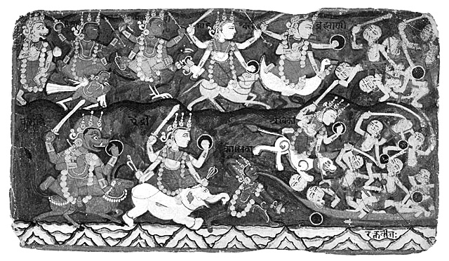
The 9 Forms of Shri Chandī on their vehicles doing battle with the demonic forces. v.9-11. ‘Vārāhī rides a buffalo, Aindrī is mounted on an elephant’ (lower left) etc.

The Kavach of the Devī
12 lty'etā Mātaraḥ sarvāḥ, sarva-yoga sam-anvitāḥ
Nānā-bharana-śhobhā-dhyā, nānā-ratn'opa-śhobhitāḥ
All the Mother Goddesses are endowed with yoga
and are adorned with different ornaments and jewels.

13 Dṛiśhyante ratham-ārudhā, Devyaḥ krodha-samā-kulāḥ
Śhaṅkham chakram gadām śhaktim,
halam cha musal’āyudham
All the Goddesses are seen mounted in chariots and very angry.
They are wielding conch, discus, mace, plough, club, javelin,

14 Khetakam tomaram chaiva, paraśhum-pāśham-eva cha
Kunt’āyudham triśhūlam cha,
śhārṅgam-āyudham-uttamam
Axe, noose, barbed dart, halter, whip, trident, spear, bow and arrows.

15 Daityānām deha-nāśhāya, bhakt’ānāma-abhayāya cha
Dhārayanty’āyudhān’īttham, Devānām cha hitāya vai
These Goddesses are wielding their weapons, to destroy the bodies of demons,
For the protection of devotees and for the benevolence of the Gods.

16 Namaste'stu Mahāraudre, Mahāghora-parakrame
Mahābale Mahotsāhe, Mahābhaya-vināśhini
Salutations to You O Goddess, of very dreadful appearance, of frightening valour,
Of tremendous strength and energy, the destroyer of the worst of fears.

17 Trāhi mām Devī duṣh-prekṣhye, śhatrunām bhaya-vardhini
Prāchyām rakṣhatu mām-Aindrī, Āgneyyām-Agni devatā
O Devī, it is difficult to have even a glance at You.
You increase the fears of Your enemies, please protect me.
May Goddess Aindri protect me from the east,
Agni devatā –‘Goddess of fire’ from the south-east,

The Kavach of the Devī
18 Dakṣhine'vatu Vārāhī, Nairutyām Khadga-dhārinī
Pratīchyām Varunī rakṣhed, Vāyavyām Mṛiga-vāhinī
Vārahī –‘the Shakti of Vishnu in His boar form’ from the south,
Khadga-dharini –‘wielding a sword’ from the south-west,
Varuni –‘the Shakti of Varuna the rain God’ from the west,
Mṛiga-vāhinī –‘riding a deer’ protect me from the north-west.

19 Udīchyām pātu Kaumārī, Aiśhānyām Śhūla-dhārinī
Ūrdhvam Brahmāni me rakṣhed, adhas-tād-Vaiṣhṇavī tathā
May Goddess Kaumari –‘Shakti of Kārttikeya’ protect me from the north and
Goddess Shūla-dhārinī –‘who wields a trident’ from the north-east,
Brahmāni – ‘the Shakti of Brahmā’ from above and
Vaishnavi –‘Shakti of Vishnu’ from below, protect me.

20 Evam daśha diśho rakṣhyech, Chāmuṇḍā Śhava-vāhanā
Jayā me chāgrataḥ pātu, Vijayā pātu pṛiṣhṭhataḥ
Goddess Chamundā, who sits on a corpse, protect me from the ten directions.
May Goddess Jaya protect me from the front and Vijaya from the rear,

21 Ajitā vāma-pārśhve tu, dakṣhine ch’āparājitā
Śhikham me Dyotinī rakṣhed, Umā mūrdhni vyava-sthitā
Ajitā from the left and Aparajitā from the right.
May Goddess Dyotini protect the top-knot and Uma sit on and protect my head.

22 Mālā-dharī lalāte cha, bhṛivau rakṣhed-Yaśhasvinī
Trinetrā cha bhṛivor-madhye-Yama-ghaṇṭā cha nāsike
May I be protected by Mālā-dharī -‘wearing a garland’ on the forehead,
Yashasvinī – on the eye-brows, Trinetra on the Hamsa,
Yama-ghanta on the inner part of the nose,

23 Śhaṅkhinī chakṣhuṣhor-madhye, śhrotrayor Dwāra-vāsinī
Kapolau Kālikā rakṣhet karna-mūle tu Śhāṅkarī
Shankhini on both the eyes, Dwara-vasini on the ears.
May Kalika protect my cheeks and Shankari the roots of the ears.

The Kavach of the Devī
24 Nāsikāyām Sugandhā cha, uttar'oṣhṭhe cha Charchikā
Adhare ch’āmṛuta-kalā, jihvāyām cha Sarasvatī
May I be protected, by Sugandha on the nose, Charchika - the upper lip,
Amruta-kala - the lower lip, Saraswatī - the tongue,

25 Dantān-rakṣhatu Kaumarī, kantha-deshe tu Chaṇḍikā
Ghaṇṭikām Chitra-ghaṇṭā cha, Mahāmāyā cha tāluke
Kaumari - the teeth, Chandika - the throat,
Chitra-ghanta - the sound-box, Mahāmaya - the crown of the head,

26 Kāmākṣhī chibukam rakṣhed, vācham me Sarva-maṅgalā
Grīvāyām Bhadrakālī cha, pṛiṣhṭha-vaṁśhe Dhanur-dharī
Kamakṣhi - the chin, Sarvamangala - speech,
Bhadrakali - the neck, Dhanurdhari- the spine.

27 Nīla-grīvā bahiḥ-kanthe, nalikām Nalakūbarī
Skandhayoh khadginī rakṣhed, bāhū me Vajra-dhārinī
May Nilagriva protect the outer part of my throat and Nalakubari the windpipe.
May Khadgini protect my shoulders and Vajra-dharini protect my arms.

28 Hastayor-Daṇḍinī rakṣhed, Ambikā ch’āṅguIīṣhu cha
Nakhāñ Chhūleśhvarī rakṣhet, kukṣhau rakṣhet Kuleśhvarī
May Devī Dandini protect both my hands, Ambika - the fingers,
Shuleśhvari my nails and may Kuleśhvari protect my belly.

29 Stanau rakṣhen Mahādevī, manaḥ Śhoka-vināśhinī
Hṛidaye Lalitā Devī, udare Śhūla-dhāriṇī
May I be protected by Mahādevī - the breast, Shoka-vinashini - the mind,
Lalita Devī - the heart, Shula-dharini - the stomach,

30 Nābhau cha Kāminī rakṣhed, guhyam Guhyeśhvarī tathā
Pūtanā kāmikā medhram, gude Mahiṣha-vāhinī
Kamini - the nabhi, Guhyeswari- the hidden parts,
Putana kamika - the reproductive organs, Mahisha-vahini - the rectum.

The Kavach of the Devī
31 Katyām Bhagavatī rakṣhej-jānunī Vindhya-vāsinī
Jaṅghe Mahābalā rakṣhet-sarvakāma pradāyinī
May Goddess Bhagavati protect my waist, Vindhyvasini - the knees,
The wish fulfilling Mahābala protect my thighs.

32 Gulphayor-Nārasiṁhī cha, pāda-pṛiṣhṭhe tu Taijasī
Pād’āṅgulīṣhu Śhrī rakṣhet-pād’ādhas-Talavāsinī
May Narasimhi protect my ankles, may Taijasi protect my feet,
Śhrī Devī protect my toes, may Talavasini protect the soles of my feet,

33 Nakhan-daṁṣhṭrā-karālī cha, keśhāñ-chaiv'Ordhva-keśhinī
Roma-kūpeṣhu Kauberī, tvacham Vāgīśhvarī tathā
May Daṁshtra-karali protect my nails, Urdhvakeshini - the hair,
Kauberi - the pores, Vagishwari - the skin.

34 Rakta-majjā-vasā-māṁsāny'asthi-medaṁsi Pārvatī
Antrāṇi kāla-rātriśh-cha, pittam cha Mukuteśhvarī
May Goddess Pārvatī protect blood, marrow of the bones, fat and bone,
Goddess Kalaratri - the intestines, Mukuteśhvari – bile and liver.

35 Padmāvatī padma-kośhe, kaphe Chūdā-maṇistathā
Jvālā-mukhī nakha-jvālām, Abhedyā sarva-sandhiṣhu
May Padmavati protect the Chakras, Chudamani - phlegm,
Jwalamukhi - lustre of the nails and Abhedya - all the joints,

36 Śhukram Brahmānī me rakṣhet, śhāyām Chhatreśhvarī tathā
Ahaṁkāram mano buddhim, rakṣhen-me Dharma-dhārinī
Brahmani - semen, Chhatreśhvari - the shadow of my body,
Dharmadharini - ego, superego and intellect,

37 Prāṇā-pānau tathā vyānam, udānam cha samāna-kam
Vajra-hastā cha me rakṣhet, prāṇam Kalyāṇa-śhobhanā
Vajra-hasta- ‘the five vital breaths - prana, apana, vyana, udana, samana,
Kalyana-shobhana - Prana (the life force).

The Kavach of the Devī
38 Rase rūpe cha gandhe cha, śhabde sparśhe cha Yoginī
Sattvam rajas-tamas-chaiva, rakṣhen-Nārāyaṇī sadā
May Yogini protect the senses of tasting, seeing, smelling, hearing and touching,
May Narayani protect Sattwa, Rajas and Tamo Gunas.

39 Āyū rakṣhatu Vārāhī, dharmam rakṣhatu Vaiṣhṇavī
Yaśhaḥ kīrtim cha Lakṣhmīn-cha,
dhanam vidyām cha Chakrinī
Varahi - life, Vaishnavi - dharma,
Lakṣhmi -success and fame, Chakrini - wealth and knowledge,

40 Gotram-lndrāṇī me rakṣhet, paśhūn-me rakṣha Chaṇḍike
Putrān-rakṣhen-Mahālakṣhmīr, bhāryām rakṣhatu Bhairavī
lndrani - relatives, Chandika - cattle (sustenance),
Mahālakṣhmi - children and Bhairavi - spouse (wife).

41 Panthānam Supathā rakṣhen, mārgam Kṣhema-karī tathā
Rāja-dvāre Mahālakṣhmīr, Vijayā sarvataḥ sthitā
Supatha may protect my journey and Kṣhemakari my way.
Mahālakṣhmi may protect me in the king's courts and Vijaya everywhere.

42 Rakṣhā-hīnam tu yat-sthānam, varjitam kavachena tu
Tat-sarvam rakṣha me Devī, Jayantī pāpa-nāśhinī
O Goddess Jayanti, any place that has not been mentioned in the Kavach
and has thus remained unprotected, May that be protected by You,
the Destroyer of sins.

Phala-śhruti - ‘Listening to the fruits’

43 Padam'ekam na gacchet tu, yadīcchet-śhubham'ātmanaḥ
Kavachen'āvṛito nityam, yatra-yatr'aiva gacchati
One should invariably cover oneself with this Kavach wherever one goes
And should not walk even a step without it, if one desires auspiciousness.

The Kavach of the Devī
44 Tatra tatrārtha-lābhaśh-cha, Vijayaḥ sarva-kāmikah
Yam yam chintayate kāmam, tam tam prāpnoti niśhchitam
Param'aiśhvaryam-atulam, prāpsyate bhūtale pumān
Then one is successful everywhere, in all things: All one's desires
Are surely fulfilled, and that person enjoys great prosperity on the Earth.

45 Nirbhayo jāyate martyaḥ, saṅgrāmeṣhv’aparājitaḥ
Trailokye tu bhavet-pūjyaḥ, kavachen'āvṛitaḥ pumān
The person who covers himself with Kavach becomes fearless, is never defeated
In battle, And becomes worthy of being worshipped in the three worlds.

46 ldam tu Devyāḥ kavacham, Devānām'api dur-labham
Yaḥ pathet-prayato nityam, trisandhyam śhraddhay'ānvitaḥ
This Devī Kavach is inaccessible even to the Gods.
One who reads with faith every day thrice, morning, noon and evening,

47 Daivī kalā bhavet-tasya, trailokye-‘py’āparājitaḥ
Jīved-varṣha-śhatam sāgram, apa-mṛityu-vivarjitaḥ
Receives the divine arts, is undefeated in the three worlds,
Lives for a hundred years and is free from accidental death.

48 Naśhyanti vyādhayaḥ sarve, lūtā-visphoṭak’ādayaḥ
Sthā-varam jaṅga-mam chaiva, kṛitrimam ch’āpi yad-viṣham
All diseases, like boils, scars etc. are destroyed. Movable (scorpions and snakes)
And immovable (other) poisons cannot affect him.

49 Ābhi-chārāni sarvāni, mantra-yantrāni bhūtale
Bhū-charāḥ khe-charāśh-ch'aiva jalajāśh ch'opadeśhikāḥ
All those who cast magical spells by mantras or yantras, on others for evil purposes,
All bhoots, goblins, malevolent beings, moving on the Earth or in the sky,

50 Sahajā kulajā mālā, dākinī śhākinī tathā
Antarikṣha-charā ghorā dākinyaśh-cha Mahā-balāḥ
All those who mesmerise others, All female goblins

The Kavach of the Devī
51 Graha-bhūta-piśhāchāśh-cha, yakṣha-gandharva-rākṣhasāḥ
Brahma-rākṣhasa-vetālāḥ, kūṣhmāndā bhairav’ādayaḥ
All Yakshas and Gandharvas, all demonic forces,

52 Naśhyanti darśhanāt-tasya, kavache hṛidi saṁsthite
Mānonnatir-bhaved rāgñyas tejo-vṛiddhi-karam param
Are destroyed just by the sight of the person having Kavach in his heart.
That person receives more and more respect and prowess.

53 Yaśhas āvardhate so-ʽpi, kīrti-mandita-bhūtale
Japet-sapta-śhatīm Chaṇḍīm, kṛitva tu kavacham purā
On the Earth he rises in prosperity and fame
By reading the Kavach and Sapta-shati (seven hundred verses)

54 Yāvad-bhū-maṇḍalam dhatte saśhaila-vana-kānanam
Tāvat-tiṣhṭhati medinyām, santatiḥ putra-pautrikī
As long as the Earth is rich with mountains and forests, His progeny would thrive

55 Dehānte paramam sthānam, yat surair api durlabham
Prāpnoti puruṣho nityam, Mahāmāyā-prasādataḥ
Labhate paramam rūpam, Śhivena saha modate
By the grace of Mahāmaya, he would attain the highest state,
Which is extremely difficult even for the Gods,
And is eternally blissful in the company of Lord Shiva.

lti Devi Kavacham sampūrnam
Thus the Devī Kavach is completed.

Sākṣhāt Śhrī Ādi Śhakti Mātājī Śhrī Nirmalā Devyai namo namaḥ

From the Vārāha Purāṇa.

The Devī Kavach is sung on both the third and fourth nights of Navaratri.

Argala Stotram
‘Door-latch praise’

Jaya Tvam Devi Chāmuṇḍe jaya bhū-tāpa-hāriṇi,
Jaya Sarva-gate Devi Kālarātri namo-‘stu Te ǁ 1 ǁ
Victory to You, O Goddess Chāmundā, Victory to the Remover of Worldly afflictions; Victory to You O Devi, who is present everywhere;
Salutations to You, the Dark Night of Dissolution.

Jayantī maṅgalā Kālī Bhadrakālī Kapālinī,
Durgā Śhivā Kṣhamā Dhātrī Svāhā Svadhā namo-‘stu Te ǁ 2 ǁ
O Ever-Victorious and Ever-Fortunate Ruler of Time and Destruction, the Auspicious Dark Goddess wearing a garland of skulls; Salutations to Śhrī Durgā, benevolent, forgiving and supportive; the Embodiment of the auspicious mantras Swāhā and Swadhā, salutations to You!

Madhu Kaiṭabha vidhvaṁsi vidhātṛi varade namaḥ,
Rūpam dehi, jayam dehi, yaśho dehi, dviṣho jahi ǁ 3 ǁ
Salutations to the Destroyer of Madhu and Kaitabha, who dispenses fate and grants boons; O Devi, please grant us a virtuous character, give us victory over negativity, make us worthy of respect and destroy all enmity.

Mahiṣhāsura-nirnāśhi bhaktānām sukha-de namaḥ,
Rūpam dehi, jayam dehi, yaśho dehi, dviṣho jahi ǁ 4 ǁ
Salutations to Devi Durga who annihilated the Demon Mahiṣhāsura,
Giving Great Joy to Your Devotees. O Devi, please grant ..........

Dhūmra-netra vadhe Devi dharma kām’ārtha-dāyini,
Rūpam dehi, jayam dehi, yaśho dehi, dviṣho jahi ǁ 5 ǁ
O Goddess, Slayer of the Demon Dhumralochana; who bestows
Righteousness, affection and purpose on Your devotees. Grant us ....

Argala Stotram
Raktabīja-vadhe Devi Chaṇḍa-Muṇḍa-vināśhini,
Rūpam dehi, jayam dehi, yaśho dehi, dviṣho jahi ǁ 6 ǁ
O Goddess who slew the Demon Raktabīja and destroyed Chanda
and Munda, Please grant us good character, victory and honour
and remove enmity.

Niśhumbha Śhumbha nirnāśhi trailokya-śhubha-de namaḥ,
Rūpam dehi, jayam dehi, yaśho dehi, dviṣho jahi ǁ 7 ǁ
Salutations to the Annihilator of Nishumbha and Shumbha;
To the Bestower of Happiness in the Three Worlds.
Please grant us good character, victory and honour and remove enmity.

Vandita-aṅghri-yuge Devi sarva saubhāgya dāyini,
Rūpam dehi, jayam dehi, yaśho dehi, dviṣho jahi ǁ 8 ǁ
O Devi whose Feet are to be worshipped, and who bestows all welfare
And good fortune. O Devi, please grant us ......

Achintya rūpa charite sarva śhatru vināśhini,
Rūpam dehi, jayam dehi, yaśho dehi, dviṣho jahi ǁ 9 ǁ
Salutations to You, whose Form cannot be conceived
And who destroys all enemies. O Devi, please grant us ......

Natebhyaḥ sarvadā bhaktyā ch’āparṇe durit’āpahe,
Rūpam dehi, jayam dehi, yaśho dehi, dviṣho jahi ǁ 10 ǁ
Granting everything to those who bow to You with devotion, O Pārvati
of great penances, You completely remove sins. O Devi, please grant us ....

Stuvadbhyo bhakti pūrvam Tvām Chaṇḍike vyādhi-nāśhini,
Rūpam dehi, jayam dehi, yaśho dehi, dviṣho jahi ǁ 11 ǁ
O Chandika, to those who Praise You with full devotion, You destroy their sorrows; O Devi, please grant us .......

Argala Stotram
Chaṇḍike satatam yuḍhe jayanti pāpa-nāśhini,
Rūpam dehi, jayam dehi, yaśho dehi, dviṣho jahi ǁ 12 ǁ
O Goddess who is blazing with anger, who is always Victorious in Battle, and is the Destroyer of all Sins; O Devi, please grant us good character, victory and honour and remove enmity.

Dehi saubhāgyam-ārogyam dehi Devi param sukham,
Rūpam dehi, jayam dehi, yaśho dehi, dviṣho jahi ǁ 13 ǁ
O Devi, please bestow Welfare, Good Health and the Highest Joy of Supreme Knowledge; O Devi, please grant us .......

Vidhehi Devi Kalyāṇam vidhehi vipulām śhriyam,
Rūpam dehi, jayam dehi, yaśho dehi, dviṣho jahi ǁ 14 ǁ
Be Gracious, Auspicious Goddess, be Honoured, O Glory of this Earth;
O Devi, Grant us good character, victory, honour and remove enmity.

Vidhehi dviṣhatām nāśham vidhehi balam-uchchakeḥ,
Rūpam dehi, jayam dehi, yaśho dehi, dviṣho jahi ǁ 15 ǁ
Be Kind, Destroyer of Enemies; Be propitious, O Goddess
of Exalted Strength; O Devi, please grant us .....

Sur’āsura śhiro ratna nighṛiṣhṭa charaṇe-‘mbike,
Rūpam dehi, jayam dehi, yaśho dehi, dviṣho jahi ǁ 16 ǁ
O Mother, the Gods and Demons rub each other’s Crest Jewels bowing at Your Feet; O Devi, please grant us .....

Vidyā-vantaṁ yaśhas-vantaṁ
Lakṣhmī-vantaṁ cha mām kuru,
Rūpam dehi, jayam dehi, yaśho dehi, dviṣho jahi ǁ 17 ǁ
O Devi, make us Full of Knowledge, Full of Glory and Full of Spirituality and Prosperity. O Devi, please grant us .....

Argala Stotram
Devi prachaṇḍa dordaṇḍa daitya-darpa-niṣhūdini,
Rūpam dehi, jayam dehi, yaśho dehi, dviṣho jahi ǁ 18 ǁ
Salutations to Impetuous, Long-armed Devi, who nullifies the mighty pride of the demons. O Devi, please grant us good character, victory, honour and remove enmity.

Prachaṇḍa daitya-darpa-ghne Chaṇḍike praṇatāya me,
Rūpam dehi, jayam dehi, yaśho dehi, dviṣho jahi ǁ 19 ǁ
Prostrations to Devi Chandika, who destroys the fierce pride
Of the Ferocious Demons; O Devi, please grant us .....

Chatur-bhuje chatur-vaktra samstute Parameśhvari,
Rūpam dehi, jayam dehi, yaśho dehi, dviṣho jahi ǁ 20 ǁ
Salutations to the Supreme Ruler of this Universe with four arms, who is praised by the Four-faced Lord Brahma; O Devi, please grant us ....

Kṛiṣhṇena saṁstute Devi śhaśhvad bhaktyā sad’āmbike,
Rūpam dehi, jayam dehi, yaśho dehi, dviṣho jahi ǁ 21 ǁ
Salutations to the Supreme Mother, Ever Praised by Lord Krishna with
eternal devotion. Please grant us .....

Himāchala-sutā-nātha samstute Parameśhvari,
Rūpam dehi, jayam dehi, yaśho dehi, dviṣho jahi ǁ 22 ǁ
Salutations to the Supreme Goddess, who is Praised by the Husband of the Mountain’s Daughter, Lord Shiva; O Devi, please grant us .....

Indrāṇī-pati sad-bhāva pūjite Parameśhvari,
Rūpam dehi, jayam dehi, yaśho dehi, dviṣho jahi ǁ 23 ǁ
Salutations to the Supreme Goddess, who is worshipped with True Devotion by Indrani’s Husband Indra. O Devi, please grant us .....

Devi bhakta jan’oddāma datt’ānand’odaye-‘mbike,
Rūpam dehi, jayam dehi, yaśho dehi, dviṣho jahi ǁ 24 ǁ
O Mother, You give rise to an Upsurge of Unbounded Joy
In the Hearts of Devotees. O Devi, please grant us .....

Argala Stotram
Bhāryā manoramām dehi mano-vṛiṭt’ānu-sāriṇīm,
Rūpam dehi, jayam dehi, yaśho dehi, dviṣho jahi ǁ 25 ǁ
O Devi, Grant me an enchanting wife who matches
My mental disposition, O Devi, please grant us .....

Tāriṇi durga-samsāra sāgarasy’āchal’odbhave,
Rūpam dehi, jayam dehi, yaśho dehi, dviṣho jahi ǁ 26 ǁ
O Mother Durga, You carry us across the Hard-to-traverse Ocean
Of Worldly Existence. O Devi, please grant us .....

Idam stotram paṭhitvā tu mahāstotra paṭhen-naraḥ,
Sapta-śhatīm sam-ārādhya varam-āpnoti durlabham ǁ 27 ǁ
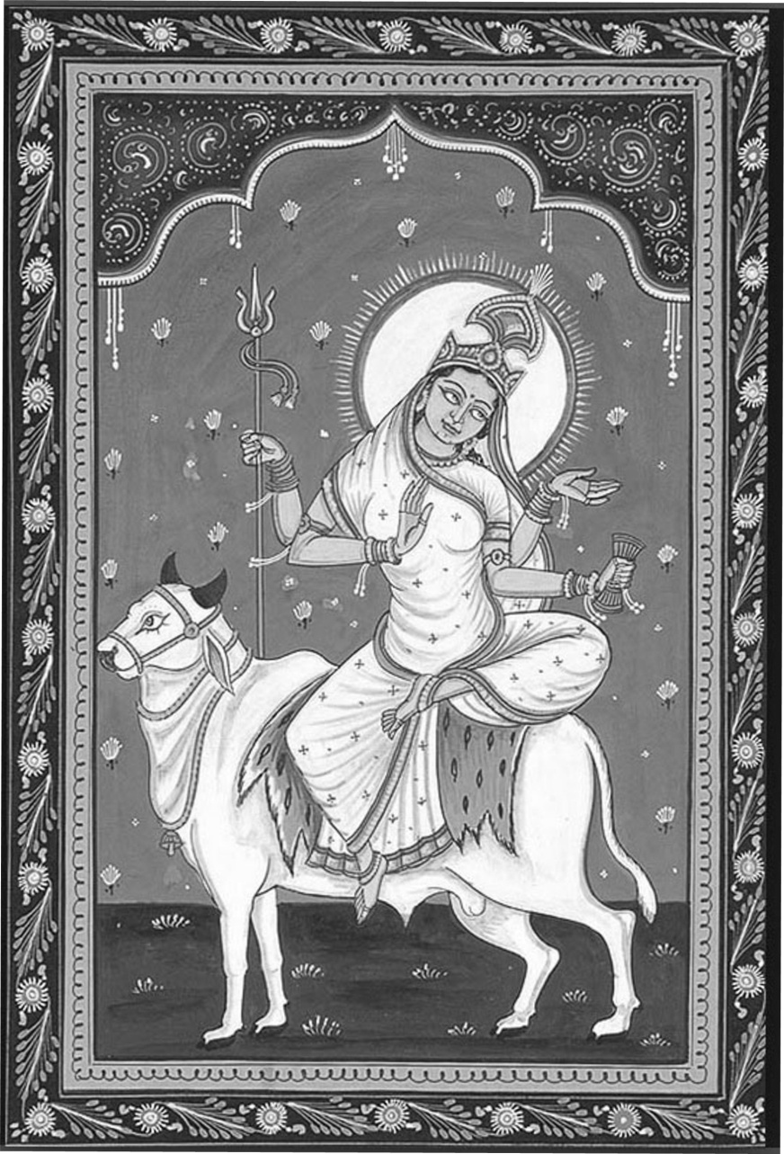
Having read this Argala Stotram, the Great Praise (Saptashati) is to be recited; One performing the Saptashati receives the most hard-to-attain boons.

Here ends the
Argala Stotram.

.
Shri Mahāgaurī
–‘very fair and shining’, the aspect of Shrī Durgā worshipped on the eighth night.

Kīlaka Stotram
‘Bolt–pin Praise’

Om Śhrī Gaṇeśhāya namaḥ
Om, Salutations to the Lord of Ganas and Remover of Obstacles

Oṁ asya Śhrī Kīlaka mantrasya Of these mantras of Kilaka Stotram
Śhiva ṛiṣhiḥ, Lord Shiva is the Composing Seer
Anuṣhṭup Chandaḥ, The Metre is Anushtubh
Shrī Mahāsaraswatī devatā, Shri Mahasaraswati is the Presiding Deity
Shrī Jagadambā prīty’arthaṁ To please Shri Jagadamba
Sapta-śhatī-pāṭh’āṅgatvena With this limb of the Saptashati
Jape viniyogaḥ This recitation is undertaken

Oṁ namaśh Chaṇḍikāyai Om, Salutations to Goddess Chandikā

Mārkaṇḍeya uvācha:- Sage Markandeya said:-

Viśhuddha-gñyāna-dehāya tri-vedī divya-chakshuṣhe
Śhreyaḥ-prāpti-nimittāya namaḥ som’ārdha-dhāriṇe. ǁ 1 ǁ
Salutations to the Wearer of the Crescent Moon, Shri Śhiva, whose body is Pure Knowledge, possessing the Three Vedas, of Heavenly Eyes, the Cause of the Acquisition of Auspiciousness.

Sarvam-etad vijānī-yān mantrāṇām api kīlakam
So-‘pi kshemam-avāpnoti satatam japya tatparaḥ ǁ 2 ǁ
All who wish to understand about this Kīlaka-‘key’ of the 700 mantras
Will obtain Well-being by devoting themselves to constantly reciting this.

Siddhy’anty’uch-chāṭan’ādīni karmāṇi sakalāny’api
Etena stuvatām devīm stotra matrena bhaktitaḥ ǁ 3 ǁ
Reciting this removes obstacles such as quitting before completion
Only if he devotes himself to worshipping the Goddess with this praise.

Kīlaka Stotram
Na mantro n’auṣhadhaṁ tasya na kinchid api vidyate
Vinā japyena siddhyet-tu sarvam uch-chāṭan’ādikam ǁ 4 ǁ
There exists no mantra, no medicine, indeed nothing
Except this recitation which will succeed in removing all failure etc.

Sam-agraṇy’api setsyanti loka-śhaṅkām-imām haraḥ
Kṛitvā nimantra yāmā-sa sarvam-edam-idam shubham ǁ 5 ǁ
They will indeed accomplish everything. Lord Shiva, the Remover,
when creating worldly anxiety, gave this invocation whose recitation
grants all happiness in this world and the next.

Stotram vai Chaṇḍikā yāstu tach-cha guhyaṁ chakāra saḥ
Samāpnoti sa puṇyena tām yathāvan-nimantraṇām ǁ 6 ǁ
Goddess Chandikā made this praise secret; He obtains merit by
repeating it whoever invokes properly.

So-‘pi kshemam avāpnoti sarvam eva na samśhaya Kṛiṣhṇāyām vā chatur-daśhyām aṣhṭamyam vā samāhitaḥ ǁ 7 ǁ
He gets all comforts, of this there is no doubt; observing the necessary rules for chanting on the fourteenth or eighth day of the New Moon.

Dadāti prati gṛuhṇāti n’ānyath’aiṣhā prasīdati
Ittham rūpeṇa kīlena Mahādevena kīlitam ǁ 8 ǁ
Unless he does that the Goddess will not be pleased with him.
This has been fixed like a driving nail by the Great Lord Shiva.

Yo niṣhkīlām vidhāyainām Chaṇḍīṁ japati nityaśhaḥ
Sa siddhaḥ sa gaṇaḥ so-‘pi gandharvo jāyate dhruvam ǁ 9 ǁ
Whoever recites constantly without this as a worshipper of Goddess Chandī
He becomes realised, an attendant of the Goddess or a divine musician.

Na chaiv’āpāṭavaṁ tasya bhayam kvāpi ha jāyate
Nāpa-mṛutyu vaśham yāti mṛute cha moksham āpnuyāt ǁ10 ǁ
He will have no fear anywhere in the world, he will never be
subject to untimely death and after death he will attain salvation

Kīlaka Stotram
Gñyātwā prārabhya kurvīta hy’akurvāṇo vinaśhyati
Tato gñyātw’aiva sampūrṇam-idam prārabhyate budha ǁ 11 ǁ
This should be undertaken if well known, for omissions will render it
ineffective. So the wise undertake to complete this with full understanding.

Saubhāgy’ādi cha yat kiñchid dṛiśhyate lalanā-jane
Tat sarvam tat prasādena tena japyam-idam śhubham ǁ 12 ǁ
Even people chanting a little playfully will get benefits like good fortune,
So pleasing the Goddess by reciting the whole gives great well-being.

Śhanais-tu japya-māne-‘smin stotre sampatti ruchchakaiḥ
Bhavaty’eva samagr’āpi tataḥ prārabhyam-eva tat ǁ 13 ǁ
Chanting this praise quietly confers brilliance
All his desires are fulfilled by undertaking this.

Aiśhwaryam tat prasādena saubhāgy’ārogyam-eva cha
Śhatru-hāniḥ paro mokṣha stūyate sā na kim janaiḥ ǁ 14 ǁ
By pleasing the Goddess one obtains Power, Fortune, Health, Destruction
of one’s enemies, and Final Liberation. Why are people not praising Her?

Chaṇḍikāṁ hṛidayen’āpi yaḥ smaret satataṁ naraḥ
Hṛidyaṁ kāmam-avāpnoti hṛidi devī sadā vaset ǁ 15 ǁ
Those persons who constantly remember Shri Chandika in their heart
Obtain their heart’s desire and the Goddess resides always in their heart.

Agrato-‘muṁ mahādeva-kṛitaṁ kīlaka-vāraṇam
Niṣhkīlañcha tathā kṛitvā paṭhitav’yaṁ samāhitaiḥ ǁ 16 ǁ
When Śhrī Śhiva first created this invincible Key-praise
Whoever performed that recitation gets well-connected in meditation.

Iti shrī bhagavatyāḥ kīlaka stotraṁ samāptam.
Here ends the Nail-praise of the Goddess of all Good Fortune.

The Kīlaka and Argala Stotra form part of the Sapta-śhaty’aṅga
–‘Limbs of the Devi Mahatmyam’ recited before the main story.

Vedoktam Rātri-sūktam
Praise of the Goddess of the Night recited in the Vedas

Om Rātri-sūktasya Kuśhikaḥ-ṛiṣhiḥ,
Om, Of this Rātri-sūktam Kuśhika is the Composing Seer,
Gāyatrī-chhandaḥ*, Rātri devatā,
The Metre is Gāyatrī, the Presiding Deity is the Goddess of the Night,
Devī-māhātmya-pāṭhe viniyogaḥ.
This is recited as a part of the Glory of the Goddess.

Om
Rātri vy-akhyad-āyatī, purutrā devy-akṣhabhiḥ,
Viśhvā adhi śhriyo-‘dhita. ǁ 1 ǁ
The Goddess of the Night arrives illuminating the many directions
with Her Eyes over the World, bringing happiness.

Or-vaprā amarty-ā, nivato devy-udvataḥ
Jyotiṣhā bādhate tamaḥ. ǁ 2 ǁ
The eternal rising and falling are controlled by the Goddess
With Her Light She banishes darkness.

Niru swasāramas-kṛit, oṣhasaṁ devy-āyatī
Apedu hāsate tamaḥ. ǁ 3 ǁ
Dispelling with Her glory, the Goddess arrives as the Dawn,
The Darkness departs joyfully.

* Note on Pronunciation: The poem is in Gāyatri Metre, three blocks of eight syllables. Vedic pronunciation differs from classical Sanskrit in that Y is a syllable so, in the first verse, vy-akhyad is viyakhyad and devy-akṣha is deviyakṣha, creating eight syllables.

Vedoktam Rātri-sūktam
Sā no adya yasyā vayaṁ, ni te yām-anna-vikṣhmahi,
Vṛikṣhe na basatiṁ vayaḥ. ǁ 4 ǁ
She furnishes each day, that sustenance we require,
Providing for us like a wish-fulfilling tree.

Ni grāmāso avikṣhata, ni padvanto ni pakṣhiṇaḥ,
Ni śhyenāsaśh-cid-arthinaḥ. ǁ 5 ǁ
For those living in villages, for travellers, for birds,
For eagles, they obtain what they have in mind.

Yāvayā vṛiky-aṁ vṛikaṁ, yavaya stenam-ūrmy-e,
Athā naḥ sutarā bhava. ǁ 6 ǁ
Protecting from wolves and predators, protecting from night-robbers,
We are truly well-protected.

Upa mā pepiśhattamaḥ, kṛiṣhṇaṁ vy-aktam-asthita,
Uṣha ṛiṇeva yātaya. ǁ 7 ǁ
As if drinking up the perceptible but impermanent blackness,
O Dawn, remove it dutifully.

Upa te gā ivākaraṁ, vṛinīṣhva duhitar-divaḥ,
Rātri stomaṁ na jigyuṣhe. ǁ 8 ǁ
As is Your wont, please grant our boon, O Daughter of Heaven
Accept our praise to You, O Victorious Goddess of the Night.

Here ends the Vaidika Rātri-sūktam.

The Tantrika Rātri-sūktam, also known as the Brahma-stuti,
appears in Chapter 1 of the Devī Māhātmyam on page 60.

The Devi Māhātmyam
‘The Glory of the Goddess’

The Devi Māhātmyam from the Markaṇḍeya Purāṇa, also known as the Durgā Sapta-śhati –‘seven hundred verses’, is the foremost praise in the worship of the Goddess, along with the Śhrīmad Devī Bhagavatam and the Shrī Lalitā Sahasranāma. It is recited especially during *Navarātri.
The first chapter is dedicated to Śhrī Mahākālī, the next three to Śhrī Mahālakṣhmī and six chapters to Śhrī Mahāsaraswatī, finishing with the ‘Hymn to Nārāyanī’ (Ch.11) and the concluding chapters. This signifies the progression from Tamas to Rajas to Sattva and final liberation.
The Devi Māhātmyam is read every day during Navaratri or may be read in parts, viz:- Hymn page no.
Day 1. Ch 1 Slaying of Madhu and Kaitabha (Brahma Stuti- p.65) 60
Day 2. Ch 2-4 Slaying of Mahiṣhāsura (Shukrādya Stuti- p.79) 69,74,80
Day 3. Ch 5,6 Slaying of Dhūmra-lochana (Devi Sūktam- p.90) 89,95
Day 4. Ch 7 Slaying of Chaṇḍa and Muṇḍa 98
Day 5. Ch 8 Destruction of Rakta-bīja 100
Day 6. Ch 9, 10 Slaying of Śhumbha and Niśhumbha 106,109
Day 7. Ch 11 Hymn to Śhrī Nārāyanī (Sarva Mangala- p.113) 112
Day 8. Ch 12 Phalaśhruti – ‘the Rewards of Recitation’ 120
Day 9. Ch 13 Granting Boons to the King and the Merchant. 123
Notes on the Devī Māhātmyam 126

* Sharada –‘autumn’ Navarātrī is the most important of the four Navarātrīs and starts on the first day of the month Ashvin, the New Moon with the Sun in Virgo in Vedic astrology, (Sept 18 - Oct 17) The other three Navaratris are Vasantha –‘Spring’ (Chaitra–March/April), Ashada -(June/July), and Magha (Dec/Jan). These times when the seasons change are dangerous and one needs extra protection.

The Devī Māhātmyam

CHAPTER 1

The Slaying of Madhu and Kaitabha
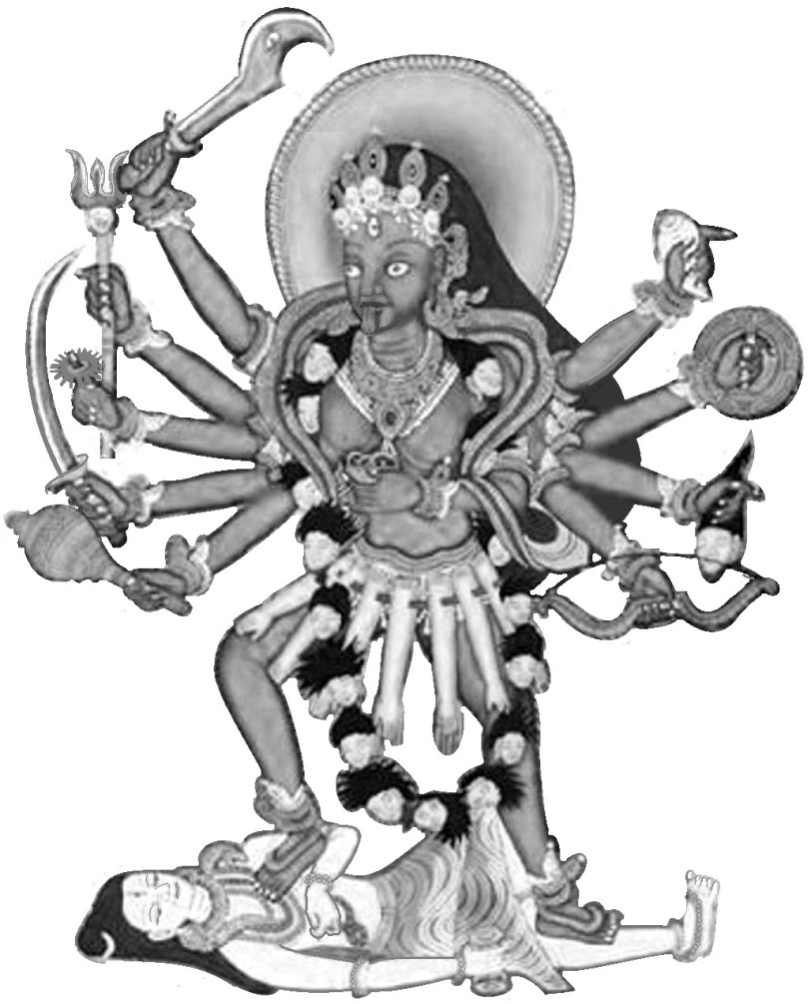

Meditation on Śhrī Mahākālī

Om khaḍgaṁ chakra gadeṣhu
ch’āpa-parighāñ śhūlam bhuśhuṇḍīṁ śhiraḥ śḥankhaṁ saṁdadhatīṁ karais tri-nayanāṁ sarv’āṅga bhūṣh’āvṛitām ǀ

Nīlāśhma-dyutim’āsya pāda
daśhakāṁ s’eve Mahākālikāṁ Yāmast’aut-svapite harau kamala-jo hantuṁ Madhuṁ Kaiṭabham ǁ
I take refuge at the Feet of the Three-eyed Shrī Mahākālī, who holds in Her Ten Hands the Sword, Discus, Mace, Arrows, Bow, Club, Spear, Missile, Human Head and Conch; whose Limbs are rich with ornaments, is Luminous like a Blue-black Jewel; and whom the Lotus-born Shrī Brahmā extolled in order to rouse Shrī Viṣhṇu from His Mystic Sleep and destroy the demons Madhu and Kaitabha.

- Mārkaṇḍeya said to his disciple Bhaguri: ‘Savarni, the son of Sūrya, is called the eighth Manu. Listen, while I describe in detail about his birth, how Savarni, the illustrious son of Sūrya, became the Lord of the Eighth Manvantara by the grace of Mahāmāyā.

Devi Māhātmyam - Chapter 1
4. In previous times there was a King named Suratha, born of the Chaitra dynasty, ruling over the whole world in the period of Svarochiṣha. He protected his subjects duly like his own children. At that time the Kolā kings, who were the destroyers of the Chaitras, became his enemies.
6. He, the wielder of powerful weapons, fought a battle with the Kolā destroyers, but was defeated by them though they were a small force. Then he returned to his own city, and ruled over his own country. Then that illustrious King was attacked by those powerful enemies.
8. Even in his own city, the King, now bereft of strength, was robbed of his treasury and army by his own powerful, vicious and evil-disposed ministers.
Thereafter, deprived of this sovereignty, the King left alone on horse-back for a dense forest, under the pretext of hunting.
10. He saw there the hermitage of Medhas- the supreme among the twice-born - inhabited by wild animals which were peaceful, and graced by the disciples of the Sage. Entertained by the Sage, Suratha spent some time moving about in the hermitage of the great Sage.
12. Then, overcome with attachment, he fell into the thought, 'I do not know whether the capital which was well guarded by my ancestors and recently deserted by me is being guarded righteously or not by my servants of evil conduct. I do not know what enjoyments my chief elephant, heroic and always elated, and now fallen into the hands of my foes, will get. Those who were my constant followers and received favour, riches and food from me, now certainly pay homage to other kings. The treasure which I gathered with great care will be squandered by those constant spendthrifts, who are addicted to improper expenditures.'

Devi Māhātmyam - Chapter 1
17. The King was continually thinking of these and other things. Near the hermitage of the Sage he saw a merchant, and asked him: 'Ho! Who are you? What is the reason for your coming here? Wherefore do you appear afflicted with grief and depressed in mind?' Hearing this speech of the King, uttered in a friendly spirit, the merchant bowed respectfully and replied to the King.
20. The Merchant said: 'I am a merchant named Samadhi, born in a wealthy family. I have been cast out by my sons and wife, who became wicked through their greed for wealth. My wife and sons have misappropriated my riches, and left me penniless. Cast out by my trusted kinsmen, I have come to the forest grief-stricken. Dwelling here, I do not know anything as regards good or bad of my sons, kinsmen and wife. At present is welfare or ill-luck theirs at home? How are they? Are my sons living good or evil lives?'
26. The King said: 'Why is your mind affectionately attached to those covetous folk, your sons, wife and others, who have deprived you of your wealth?'
29. The Merchant said: 'This very thought has occurred to me, just as You have uttered it. What can I do? My mind does not become harsh; it bears deep affection to those very persons who have driven me out in their greed for wealth, abandoning love for a father and attachment to one's master and kinsmen. I do not comprehend although, I know it. O noble hearted King, how it is that the mind is prone to love even towards worthless kinsmen. On account of them I heave heavy sighs and feel dejected. What can I do since my mind does not become hard towards those unloving ones?’
35. Mārkaṇḍeya said: ‘Then O Brahmana, the merchant Samadhi and the noble King together approached the Sage Medhas; and after observing the proper etiquette as was worthy of him, they sat down and conversed with him on various topics.

Devi Māhātmyam - Chapter 1
39. The King said: 'Sir, I wish to ask You one thing. Be pleased to reply to it. Without the control of my intellect, my mind is afflicted with sorrow. Though I have lost the kingdom, like an ignorant man - though I know it - I have an attachment to all the paraphernalia of my kingdom. How is this, O Best of Sages? And this merchant has been disowned by this children, wife and servants, and forsaken by his own people; still he is inordinately affectionate towards them. Thus both he and I, drawn by attachment towards objects whose defects we know, are exceedingly unhappy. How does this happen, then, sir, that though we are aware of it, this delusion comes? This delusion besets me as well as him, blinded as we are in respect of discrimination.'
46. The Ṛiṣhi said: ‘Sir, every being has the knowledge of objects perceivable by the senses. And object of sense reaches it in various ways. Some beings are blind by day, and others are blind by night; some beings have equal sight both by day and night. Human beings are certainly endowed with knowledge, but they are not the only beings to be so endowed, for cattle, birds, animals and other creatures also cognize objects of the senses.
50. The knowledge that men have, birds and beasts too have; and what they have men also possess; and the rest like eating and sleeping is common to both of them. Look at these birds, which though they possess knowledge, and are themselves distressed by hunger are yet, because of the delusion, engaged in dropping grains into the beaks of their young ones. Human beings are, O tiger among men, attached to their children because of greed for return help. Do you not see this? Even so men are hurled into the whirlpool of attachment, the pit of delusion, through the power of Mahāmāyā the Great Illusion, who makes the existence of the world possible. Marvel not at this. This Mahāmāyā is the Yoga-nidra of Viṣhṇu, the Lord of the World. It is by

Devi Māhātmyam - Chapter 1
Her the World is deluded. Verily She, the Bhagavati, the Mahāmāyā forcibly drawing the minds of even the wise, throws them into delusion. She creates this entire Universe, both moving and unmoving. It is She who, when propitious, becomes a boon-giver to human beings for their final liberation. She is the Supreme Knowledge, the Cause of Final Liberation, and Eternal; She is the Cause of the Bondage of Transmigration and the Sovereign over All Lords.
59. The King said: 'Venerable sir, who is that Devi whom You call Mahāmāyā? How did She come into being, and what is Her sphere of action, O Brāhmin? What constitutes Her nature? What is Her form? Wherefrom did She originate? All that I wish to hear from You, supreme amongst the Knowers of Brahman.'
63. The Ṛiṣhi said: ‘She is Eternal, Embodied as the Universe. By Her all this is pervaded. Nevertheless She incarnates in manifold ways; hear it from me.
64. When She manifests Herself in order to accomplish the purposes of the Devas, She is said to be born in the world, though She is Eternal. At the end of a Kalpa when the Universe was one ocean with the waters of the deluge and the adorable Lord Viṣhṇu stretched out on Śheṣha and took Mystic Slumber, two terrible Asuras, the well-known Madhu and Kaiṭabha, sprung into being from the wax of Viṣhṇu's ears and sought to slay Brahmā, the Father of Beings, who was sitting in the Lotus that came out from Viṣhṇu's Navel. Seeing these two fierce Asuras and Janārdana asleep, and with a view to awakening Hari, Brahmā with concentrated mind extolled Śhrī Yoga-nidra, dwelling in Hari's eyes. The resplendent Lord Brahmā extolled the incomparable Goddess Yoga-nidra, the Queen of the Cosmos, the Supporter of the Worlds, the Cause of the Sustentation and Dissolution alike of the Universe.

The Brahmā Stuti - ‘Praise by Shrī Brahmā’
Also known as the Tantrika Rātri Sūktam
– ‘Praise of the Goddess of the Night’

Om Viśhv’eśhvarīm Jagad-Dhātrīm Sthiti-Samhāra-Kāriṇīm |
Nidrām Bhagavatīm Viṣhṇor-atulām Tejasah Prabhuh ǁ 1 ǁ
Om, She is the Supreme Ruler of the Universe, the Cause of the Creation,
Sustaining and Withdrawing of this Illusory World; the Goddess of Sleep
Having the power over the Dream State of the most excellent Shri Vishnu.

Brahm’ovācha (Addressing that Goddess, Shri Brahma said ...)
Tvam svāhā Tvam svadhā Tvam hi vaṣhaṭ-kāraḥ svar’ātmikā,
Sudhā Tvam aksḥare nitye tridhā-mātr’ātmikā sthitā ǁ 2 ǁ
You are Svāhā and Svadhā; the Controller and the Embodiment of Sound,
You are the Nectar, O Eternal and Imperishable Essence of the Threefold AUM.

Ardha-mātrā sthitā nityā y’ān-uchchāryā viśheṣhataḥ,
Tvameva sāndhyā sāvitrī Tvam Devi jananī parā ǁ 3 ǁ
You are particularly the Eternal Half-syllable, which cannot be uttered.
You are the Times of Worship, Power of the Sun and the Divine Mother Supreme.

Tvayai tad dhāryate viśhvaṁ tvayai tat sṛijyate jagat,
Tvayai tat pālyate Devi Tvam atsy’ante cha sarvadā ǁ 4 ǁ
By You This Universe is carried, by You This World is created,
By You it is protected, O Devi, and You always consume it at the end.

Visṛistau sṛisti-rūpā Tvam sthiti-rūpā cha pālane,
Tathā saṁhṛiti-rūpānte jagato-'sya jagan-maye ǁ 5 ǁ
O You, whose Form is the Universe, at the time of creation You are the Creative Force, At the time of sustentation You are the Protective Power, and at the time of the Dissolution of the World, You are the Destructive Power.

Devi Māhātmyam - Chapter 1
Mahā-vidyā mahā-māyā mahā-medhā mahā-smṛitiḥ,
Mahā-mohā cha bhavatī mahā-devī mah’āsuṛī ǁ 6 ǁ
You are the Supreme Knowledge and Great Illusion,
the Highest Intelligence and Contemplation, the Great Delusion,
the Supreme Goddess and the Great Demoness.

Prakṛitis-tvam cha sarvasya guṇa-trayā vibhāvinī,
Kāla-rātrir mahā-rātrir mohā-rātriśh cha dāruṇā ǁ 7 ǁ
You are the Primordial Cause of Everything, bringing into force the Three Qualities. You are the Dark Night of Periodic Dissolution, You are the Great Night of Final Dissolution, and the Terrible Night of Delusion.

Tvam Śhrīs-tvam Īsvaṛī Tvam Hrīs
tvam buddhir bodha-laksḥaṇā,
Lajjā puṣhṭis-tathā tuṣhṭis-tvam śhāntiḥ ksḥāntir eva cha ǁ 8 ǁ
You are the Goddess of Good Fortune, the Supreme Ruler, Modesty,
Intelligence characterized by Knowledge, Bashfulness, Nourishment,
Contentment, Tranquillity and Patience.

Khadginī śhulinī ghorā gadinī chakriṇī tathā,
Śhaṅkhinī chāpinī bāṇa-bhuśhuṇḍī parigh’āyudhā ǁ 9 ǁ
Armed with Sword, Spear, Club, Discus, Conch, Bow, Arrows, Sling
And Iron Mace, You are of Very Terrifying Appearance.

Saumyā saumyatar’āśheṣha saumyebhyas tv’ati-sundarī
Par’āparāṇām paramā Tvameva parameśhvaṛī ǁ 10 ǁ
At the same time You are Pleasing, More Pleasing than all pleasing things and Exceedingly Beautiful. You are the Supreme Ruler, beyond All Duality.

Yachcha kiñchit kvachid-vastu sad-asadv’ākhil’ātmike,
Tasya sarvasya yā śhaktiḥ sā Tvam kim stūyase tadā ǁ 11 ǁ
Wherever a thing exists, real or unreal, whatever power that possesses is You.
O You who are the Soul of Everything, how can I extol You more?

Devi Māhātmyam - Chapter 1
Yayā tvayā jagat-sraṣhṭā jagat pātyatti yo jagat,
So-'pi nidrā vaśham nītaḥ kastvām stotum-iheśhvaraḥ ǁ 12 ǁ
By You, even He who creates, sustains and devours this world, is put to sleep.
Who is here capable of extolling You?

Viṣhṇuḥ śhaṛīrā grahaṇām aham Īśhānā evā cha,
Kāritāste yato-'tastvām kaḥ stotum śhaktimān bhavet ǁ 13 ǁ
Who is capable of praising You, who have made all of us - Viṣhṇu,
Myself and Śhiva - take our embodied forms?

Sā Tvam-ittham prabhāvaiḥ svair udārair Devi saṁstutā,
Mohayaitau durādharṣhāv’asurau Madhu-Kaiṭabhau ǁ 14 ǁ
O Devi, being lauded thus, bewitch these two unassailable Asuras
Madhu and Kaitabha with Your Superior Powers.

Prabodham cha jagat-svāmī nīyatām achyuto laghu,
Bodhaśh-cha kriya tāmasya hantum-etau mahāsurau ǁ 15 ǁ
Let the Imperishable Viṣhṇu, Lord of the World, be quickly awakened
from sleep and rouse up His Nature to slay these two great Asuras.'

Here ends the Brahma-stuti.
88. The Ṛiṣhi said: ‘There, the Devi of Delusion, extolled thus by Brahmā, the Creator, in order to awaken Viṣhṇu for the destruction of Madhu and Kaitabha, drew herself out from His eyes, mouth, nostrils, arms, heart and breast, and appeared in the sight of Brahmā of Inscrutable Birth. Janārdana, Lord of the Universe, quitted by Her, rose up from His couch on the Universal Ocean, and saw those two evil Asuras, Madhu and Kaitabha, of exceeding heroism and power, eyes red with anger, endeavouring to devour Brahmā. Thereupon the All-pervading Bhagavan Viṣhṇu got up and fought with the Asuras for five thousand years, using His Own Arms as Weapons. And they, frenzied with their exceeding power, and deluded by Mahāmāyā, exclaimed to Viṣhṇu, ' Ask a boon from us.'

Devi Māhātmyam - Chapter 1
96. Bhagavan Viṣhṇu said: 'If You are satisfied with Me, You must both be slain by Me now. What need is there of any other boon here? My choice is this much indeed.'
99. The Ṛiṣhi said: ‘Those two Asuras, thus bewitched by Mahāmāyā, gazing then at the entire world turned into water, told Bhagavan, the Lotus-eyed One, 'Slay us at the spot where the Earth is not flooded with water.'
102. The Ṛiṣhi said: ‘Saying 'Be it so', Bhagavan Shrī Viṣhṇu, the Great Wielder of Conch, Discus and Mace, took them on His Loins and there severed their heads with His Discus. Thus Mahāmāyā Herself appeared when praised by Brahma. Now listen as I again expound the Glory of this Devi.’

Here ends the First Chapter called 'The Slaying of Madhu and Kaitabha' of Devī Māhātmyam in Mārkaṇḍeya Purāṇa, during the period of Savarni Manu.
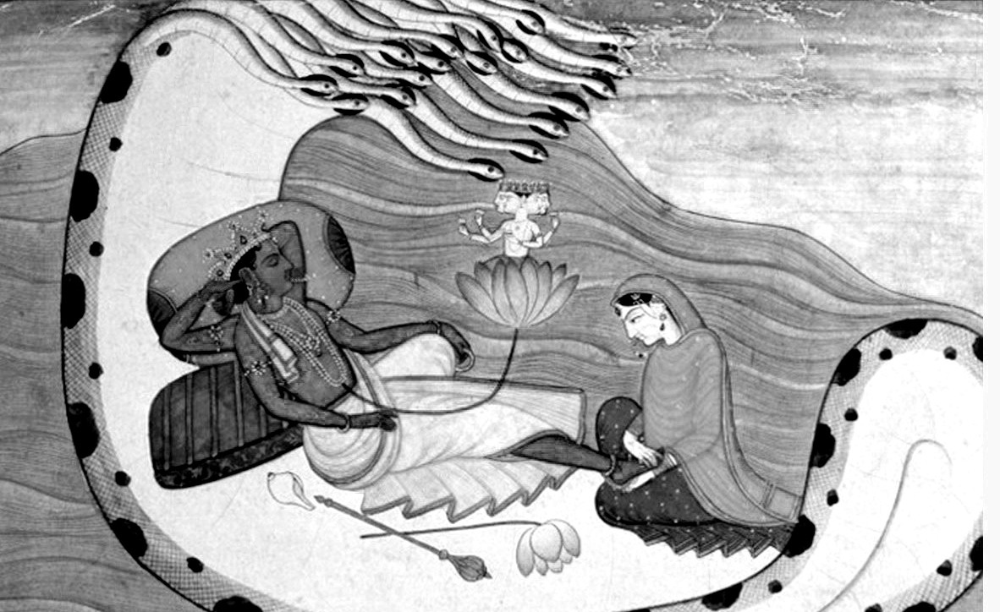
Shrī Viṣhṇu reclining on the waters, on the serpent Śheṣha. Shrī Brahmā is seated on a lotus emerging from His navel and Shrī Lakshmī is rubbing His Feet.

CHAPTER 2

The Slaughter of the Armies of Mahiṣhāsura

Meditation on Śhrī Mahālakṣhmī

Om Akśhasrak-paraśhuṁ gadeśhu kuliśhaṁ padmaṁ
dhanuḥ kuṇḍikāṁ daṇḍaṁ śhaktim-asiṁ cha
charma-jalajaṁ ghantāṁ sur’ābhājanamǀ

Śhūlaṁ pāśha sudarśhane cha dadhīṁ hastaiḥ
prasann’ānanām s’eve sairibha-mardinīm iha
Mahālakṣhmiṁ saroja-sthitām ǁ
I resort to Shrī Mahālakṣhmī, the Cheerful-faced Destroyer of the Buffalo Demon, who is seated on a Lotus, is of the complexion of Coral and who holds in Her Eighteen Hands Rosary, Axe, Mace, Arrow, Thunderbolt, Lotus, Bow, Pitcher, Rod, Spear, Sword, Shield, Conch, Bell, Wine-cup, Trident, Noose and the Discus Sudarṣhana.

1. The Ṛiṣhi said: ‘Of yore when *Mahiṣhāsura –‘The Buffalo Demon’ was the Lord of Asuras-‘Demons’ and Indra the Lord of Devas-‘Gods’, there was a war between the Devas and Asuras for a full hundred years. Finally the army of the Devas was vanquished by the valorous Asuras. After conquering all the Devas, Mahiṣhāsura became the Lord of Heaven.
4. Then the vanquished Devas headed by Brahmā, the Lord of Beings, went to the place where Śhiva and Viṣhṇu were. The Devas described to them in detail, as it had happened, the story of their defeat wrought by Mahiṣhāsura.

* Mahiṣha means ‘a buffalo, great, powerful’ and Asura means ‘a demon, one not shining’. See notes on page 126 for the story of Mahishāsura.

Devi Māhātmyam - Chapter 2
6. ‘Mahiṣhāsura himself has assumed the jurisdictions of Sūrya, Indra, Agni, Vayu, Chandra, Yama and Varuna and other Devas. Thrown out from Heaven by that evil-natured Mahiṣha, the hosts of Devas wander on the Earth like mortals. All that has been done by this enemy of the Devas has been related to You both, and we have sought shelter under You both. May both of You be pleased to think out the means of his destruction.'
9. Having thus heard the words of the Devas, Viṣhṇu was angry and also Śhiva, and their faces became fierce with frowns.
10. There issued forth a great light from the face of Viṣhṇu who was full of intense anger, and from that of Brahmā and Śhiva too. From the bodies of Indra and other Devas also sprang forth a very great light. And all this light united together.
12. The Devas saw there a concentration of light like a mountain blazing excessively, pervading all the quarters with its flames. Then that unique light, produced from the bodies of all the Devas, pervading the Three Worlds with its lustre, combined into one and became a female form.
14. By that which was Śhiva's light, Her face came into being; by Yama's light Her hair, by Viṣhṇu's light Her arms; and by Chandra's light Her two breasts. By Indra's light Her waist, by Varuna's light Her shanks and thighs and by Earth's light Her hips.
16. By Brahma's light Her feet came into being; by Sūrya's light Her toes, by Vasu’s light Her fingers, by Kubera's light Her nose; by Prajapati's light Her teeth came into being and similarly by Agni's light Her three eyes were formed. The light of the two Sandhyas became Her eye-brows, the light of Vayu Her ears; the manifestation of the lights of other Devas too contributed to the being of the auspicious Devi.

Devi Māhātmyam - Chapter 2
19. Then looking at Her, who had come into being from the assembled lights of all the Devas, the Immortals who were oppressed by Mahiṣhāsura experienced joy.
20. The Bearer of Pinaka, Śhiva, drawing forth a Trident from His Own Trident presented it to Her; and Viṣhṇu bringing forth a Discus out of His Own Discus gave Her. Varuna gave Her a Conch, Agni a Spear; and Maruta gave a Bow as well as two Quivers full of Arrows.
22. Indra, Lord of Devas, bringing forth a Thunderbolt out of His Own Thunderbolt and a Bell from that of His Elephant Airavata, gave Her. Yama gave a Staff from His Own Staff of Death and Varuna, the Lord of Waters, a Noose; and Brahma, the Lord of Beings, gave a String of Beads and a Water-pot.
24. Sūrya bestowed His Own Rays on all the pores of Her Skin and Kāla –‘Time’ gave a spotless Sword and a Shield.
25. The Ocean of Milk gave a pure Necklace, a pair of un-decaying Garments, a divine Crest-jewel, a pair of Ear-rings, Bracelets, a brilliant half-moon Ornament, Armlets on all Arms, a pair of shining Anklets, a unique Necklace and excellent Rings on all the Fingers. Viśhvakarman gave Her a very brilliant Axe, weapons of various forms and also an impenetrable Armour. The Ocean gave Her a Garland of unfading lotuses for Her Head and another for Her Breast, besides a very beautiful Lotus in Her Hand. The Mountain Himavat gave Her a Lion to ride on and various jewels.
30. The Lord of Wealth Kubera gave Her a Drinking Cup, ever full of Nectar. Śheṣha, the Lord of all Serpents, who supports this Earth, gave Her a Serpent-necklace bedecked with the best jewels. Honoured likewise by other Devas with ornaments and weapons, She the Devi gave out a loud

Devi Māhātmyam - Chapter 2
roar with a decrying laugh again and again. By Her unending, exceedingly great, terrible roar the entire sky was filled, and there was great reverberation. All the Worlds shook, and the Seas trembled.
34. The Earth quaked and all the mountains rocked. 'Victory to You' exclaimed the Devas in joy to Her, the Lion-rider. The Sages, bowing their bodies in devotion, extolled Her. Seeing the Three Worlds agitated, the Foes of the Devas mobilized all their armies and rose up together with uplifted weapons. Mahiṣhāsura, exclaiming in wrath, 'Ha! What is this?' rushed towards that roar, surrounded by innumerable Asuras. Then he saw the Devi pervading the Three Worlds with Her Lustre, making the Earth bend with Her Footstep, scraping the Sky with Her Diadem, shaking the Nether Worlds with the Twang of the Bowstring, and standing there pervading all the quarters around with Her Thousand Arms.
41. Then began a battle between that Devi and the enemies of the Devas, in which the quarters of the sky were illumined by the weapons and arms hurled on both sides. Mahiṣhāsura's general, a great Asura named Chikṣhura, and Chāmara, attended by forces comprising the four parts (Infantry, Cavalry, Chariots, Elephants), and other Asuras fought. A great Asura named Udagra with sixty thousand chariots, and Mahāhanu with ten million chariots gave battle.
44. Asiloman, another great Asura, with fifteen million chariots, and Baskala with six million fought in that battle. Privarita with many thousands of elephants and horses, and surrounded by ten million chariots, fought in that battle. An Asura named Bidala fought in that battle surrounded with five hundred crores of chariots. And other great Asuras, thousands in number, surrounded with chariots, elephants and horses fought with the Devi in that battle.

Devi Māhātmyam - Chapter 2
47. Mahiṣhāsura was surrounded in that battle with thousands of crores of horses, elephants and chariots. Others Asuras fought in the battle against the Devi with iron maces and javelins, with spears and clubs, with swords, axes and halberds. Some hurled spears and others nooses.
49. They began to strike Her with swords in order to kill Her. Showering Her own weapons and arms, that Devi Chandikā very easily cut into pieces all those weapons and arms. Without any strain on Her face, and with the Gods and Sages extolling Her, the Īśhvarī threw Her weapons and arms at the bodies of the Asuras. And the Lion also which carried the Devi, shaking its mane in rage, stalked among the hosts of the Asuras like a conflagration amidst the forests. The sighs which Ambikā, engaged in the battle, heaved became at once Her battalions by hundreds and thousands. Energized by the power of the Devi, these battalions fought with axes, javelins, swords, halberds, and destroyed the Asuras. Of these battalions, some beat drums, some blew conches and others played on tabors in that great martial festival. Then the Devi killed hundreds of Asuras with Her trident, club, showers of spears, swords and the like, and threw down others who were stupefied by the noise of Her bell; and binding others with Her noose, She dragged them to the ground. Some were split into two by the sharp slashes of Her sword, and others, smashed by the blows of Her mace, fell to the ground; and some severely hammered by Her club vomited forth blood.
59. Pierced in the breast by Her trident, some fell on the ground. Pierced all over by Her arrows and resembling porcupines, some of the enemies of the Devas gave up their lives on that field of battle. Some had their arms cut off, some, their necks broken the heads of others rolled down; some others were torn asunder in the middle of their trunks, and some great Asuras fell on the ground with their legs severed.

Devi Māhātmyam - Chapter 2
62. Some rendered one-armed, one-eyed, and one-legged were again clove in twain by the Devi. And others, though rendered headless, fell and rose again.
63. Headless trunks fought with the Devi with their finest weapons in their hands. Some of these headless trunks danced there in the battle to the rhythm of the musical instruments.
64. The trunks of some other great Asuras, with their swords, spears and lances still in their hands, shouted at the Devi with their just severed heads, 'Stop, stop'. That part of the Earth where the battle was fought became impassable with the Asuras, elephants, horses and chariots that had been felled.
66. The profuse blood from the Asuras, elephants and horses flowed immediately like large rivers amidst that army of the Asuras. As fire consumes a huge heap of straw and wood, so did Ambikā destroy that vast army of Asuras in no time.
68. And Her carrier-lion, thundering aloud with quivering mane, prowled about in the battlefield, appearing to search out the vital breath from the bodies of the enemies of the Devas. In that battlefield the battalions of the Devi fought in such a manner with the Asuras that the Devas in Heaven, showering flowers, extolled them.

Here ends the Second Chapter called 'Slaughter of the Armies of Mahiṣhāsura' of Devī Māhātmyam in Mārkaṇḍeya Purāṇa, during the period of the Manu Savarni.

CHAPTER 3

The Slaying of Mahiṣhāsura
The Ṛiṣhi said:
1. ‘Then Chikśhura, the great Asura general, seeing that army being slain by the Devi, advanced in anger to fight with Ambikā. That Asura rained showers of arrows on the Devi in the battle, even as a cloud showers rain on the summit of Mount Meru.
4. Then the Devi, easily cutting asunder the masses of his arrows, killed his horses and their controller with Her arrows. Forthwith She split his bow and lofty banner, and with Her arrows pierced the body of that Asura whose bow had been cut. His bow shattered, his chariot broken, his horses killed and his charioteer slain, the Asura armed with sword and shield rushed at the Devi. Swiftly he smote the lion on the head with his sharp-edged sword and struck the Devi on Her left arm.
8. O King, his sword broke into pieces as it touched Her arm. Thereon his eyes turning red with anger, he grasped his pike. The great Asura flung at Bhadrakālī the pike, blazing with lustre, as if he was hurling the very sun from the skies.
10. Seeing that pike coming upon Her, the Devi hurled Her pike that shattered both his pike into a hundred fragments and the great Asura himself.
11. Mahiṣhāsura's very valiant general having been killed, Chāmara, the afflictor of the Devas, mounted on an elephant, advanced. He also hurled his spear at the Devi. Ambikā quickly assailed it with a whoop, made it lustreless and fall to the ground. Seeing his spear broken and fallen, Chāmara, full of rage, flung a pike, and She split that also with Her arrows.
14. Then the lion, leaping up and seating itself at the centre of the elephant's forehead, engaged itself in a hand to hand fight with that foe of the Devas.

Devi Māhātmyam - Chapter 3
15. Fighting, the two then came down to the Earth from the back of the elephant, and fought very impetuously, dealing the most terrible blows at each other.
16. Then the lion, springing up quickly to the sky, and descending, severed Chāmara's head with a blow from its paw.
17. And Udagra was killed in the battle by the Devi with stones, trees and the like, and Karala also stricken down by Her teeth and fists and slaps.
18. Enraged, the Devi ground Uddhata to powder with the blows of Her club, and killed Baskala with a dart and destroyed Tamra and Andhaka with arrows.
19. The Three-eyed Supreme Īśhvarī killed Ugrasya and Ugravīrya and Mahāhanu also with Her trident. With Her sword She struck down Bidala's head from his body, and dispatched both Durdhara and Durmudha to the abode of Death with Her arrows.
21. As his army was thus being destroyed, Mahiṣhāsura terrified the troops of the Devi with his own buffalo form. Some he laid low by a blow of his muzzle, some by stamping with his hooves, some by the lashes of his tail, and others by the thrusts of his horns. Some he laid low on the face of the Earth by his impetuous speed, some by his bellowing and wheeling movement, and others by the blast of his breath.
24. Having laid low Her army, Mahiṣhāsura rushed to slay the lion of the Mahādevī. This enraged Ambikā.
25. Mahiṣhāsura, great in valour, pounded the surface of the Earth with his hooves in rage, tossed up the high mountains with his horns, and bellowed terribly. Crushed by the velocity of his wheeling, the Earth disintegrated, and lashed by his tail, the sea overflowed all around.

Devi Māhātmyam - Chapter 3
27. Pierced by his swaying horns, the clouds went into fragments. Cast up by the blast of his breath, mountains fell down from the sky in hundreds.
28. Seeing the great Asura swollen with rage and advancing towards Her, Chandikā displayed Her wrath in order to slay him. She flung Her noose over him and bound the great Asura. Thus bound, he quitted his buffalo form.
30. Then he became a lion suddenly. While Ambikā cut off the head of his lion form, he took the appearance of a man with sword in hand.
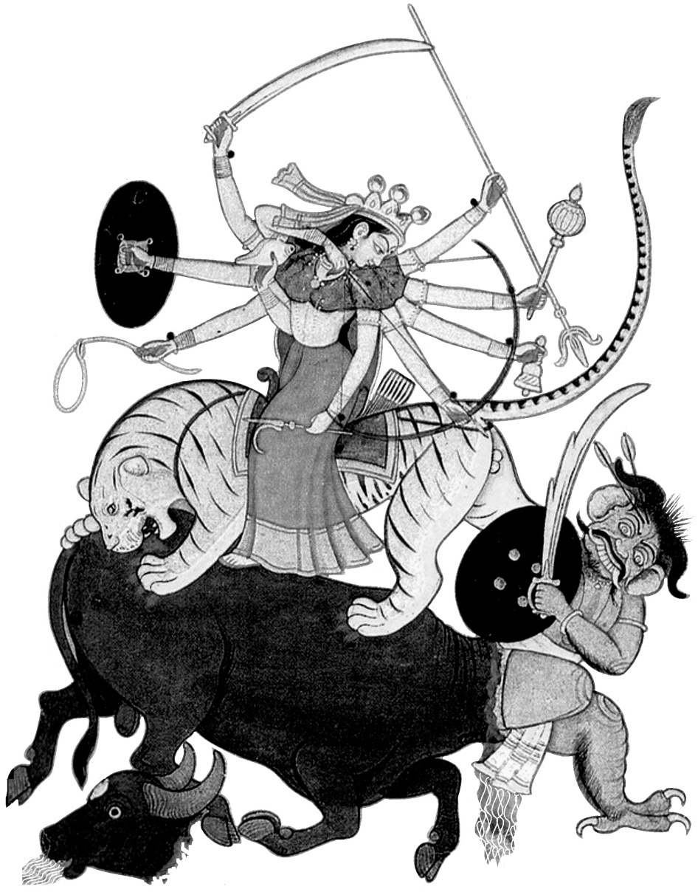
31. Immediately then the Devi with Her arrows chopped off the man together with his sword and shield. Then he became a big elephant.
32. The elephant tugged at Her great lion with his trunk and roared loudly, but as he was dragging, the Devi cut off his trunk with Her sword.
33. The great Asura then resumed his buffalo shape and shook the Three Worlds with their movable and immovable objects.
34. Enraged there-at, Chandikā, the Mother of the World, quaffed a divine drink again and again, and laughed, Her eyes becoming red.

Devi Māhātmyam - Chapter 3
35. And the Asura also roared, intoxicated with his strength and valour, and hurled mountains against Chandikā with his horns.
36. And She with showers of arrows pulverized those mountains hurled at Her, and spoke to him in flurried words, the colour of Her face accentuated with the intoxication of the divine drink.
37. The Devi said: 'Roar, roar, O fool, for a moment while I drink this wine. When You will be slain by Me, the Devas will soon roar in this very place.'
39. The Ṛiṣhi said: ‘Having exclaimed thus, She jumped and landed herself on that great Asura, pressed him on the neck with Her foot and struck him with Her spear.
41. And thereupon, caught up under Her foot. Mahiṣhāsura half issued forth in his real form from his own buffalo mouth, being completely overcome by the valour of the Devi.
42. Fighting thus with his half-revealed form, the great Asura was slain by the Devi who struck off his head with Her great sword.
43. Then, crying in consternation, the whole Asura army perished; and all the hosts of Devas were in exultation.
44. With the Great Sages of Heaven, the Devas praised the Devi. The leading Gandharvas –‘Celestial Musicians’ sang and troupes of Apsarās –‘Heavenly Maidens’ danced.

Here ends the Third Chapter called 'The Slaying of Mahiṣhāsura' of Devī Māhātmyam in the Mārkaṇḍeya Purāṇa during the period of the Manu Savarni.

CHAPTER 4 - The Shakr’ādya Stuti
‘Praise by Śhrī Indra and the other Gods’
The Ṛiṣhi said:
Śhakr’ādayaḥ sura-gaṇā nihate-'tivīrye*
Tasmin dur-ātmani surāri-bale cha devyā,
Taṁ tuṣhṭuvuḥ praṇati namra śhiro dharāṁsā
Vāgbhiḥ praharṣha pulak’od-gama chāru dehaḥ ǁ (2)
When that most valiant but evil-natured Mahiṣhāsura and his army were destroyed by the Devi, Indra and the hosts of Devas, their heads reverently bent, their bodies rendered beautiful and their hair bristling with great joy, uttered these words of praise:-

Devyā yayā tatam-idam jagad-ātma śhaktya
Niḥśheṣa deva-gaṇa śhakti samūha-mūrtyā,
Tām-ambikām akhila deva maharṣhi pūjyaṁ
Bhaktyā natāḥ sma vidadhātu śhubhāni sā naḥ ǁ (3)
To that Mother Goddess who pervades this world with Her power; who is worshipped by all Gods and sages whose powers are Her forms, we bow in devotion. May She grant us auspiciousness and happiness!

Yasyāḥ prabhavam-atulam bhagavān-ananto
Brahmā haraśh-cha nahi vaktu malam balaṁ cha,
Sā chaṇḍik’ākhila jagat paripālanāya
Nāśhāya chāśhubha bhayasya matim karotu ǁ (4)
May Chandikā, whose incomparable greatness and power Bhagavan Viṣhṇu, Brahmā and Śhiva are unable to describe, bestow Her mind on protecting the whole world and destroying the fear of evil.

* See Notes on p.126 for details on the metre and rhythm of this poem.

Devi Māhātmyam - Chapter 4
Yā śhrīḥ svayam sukṛitināṁ bhavaneṣhv’alakṣhmīḥ
Pāp’ātmanaṁ kṛitadhiyām hṛidayeṣhu buddhiḥ,
Sraddhā satām kulajana prabhavasya lajjā
Tāṁ tvām natāḥ sma paripālaya Devi viśhvam ǁ (5)
O Devi, we bow before You, who are good fortune in the dwellings of the virtuous, and ill-fortune for the vicious, intelligence in the hearts of the learned, faith in the hearts of the good, and modesty in the hearts of the high-born. May You protect the Universe!

Kim varṇayāma tava rūpam-achintyam-etat
Kiṁ chāti vīrya masura kṣhaya kāri bhūri,
Kim chāhaveṣhu charitāni tavād bhutāni
Sarveṣhu devy’asura deva gaṇādi keṣhu ǁ (6)
O Devi, how can we describe Your inconceivable form, or Your abundant surpassing Valour that destroys the Asuras, or Your wonderful Feats in battle among the hosts of Gods and Demons?

Hetuḥ samasta jagatām triguṇ’āpi doṣhair-
Na jñāyase hari-har’ādibhir apy’apārā,
Sarvā śhray’ākhilam idam jagadam śhabhūtam-
Avyākṛitā hi paramā prakṛitis Tvam-ādyā ǁ (7)
You are the Origin of all the Worlds! Though possessed of the Three Guṇas You have none of their defects like passion! You are beyond the comprehension of even Viṣhṇu, Śhiva and the other Gods! You are the Refuge of this Entire World which is but an Infinitesimal Portion of Yourself! You are the Supreme Spirit and the Primordial Substance.

Devi Māhātmyam - Chapter 4
Yasyāḥ samasta suratā samudīraṇena,
Tṛiptim prayāti sakaleṣhu makheṣhu Devi,
Svāhāsi vai pitṛi-gaṇasya cha tṛipti hetur-
Uchchāryase tvam-ata eva janaiḥ svadhā cha ǁ (8)
O Devi, You are Svāhā, whose utterance propitiates the Gods during Sacrifices. You are Svadhā which gives satisfaction to the Ancestors. Therefore people chant to You as Svāhā and Svadhā in Sacrifices.

Ya mukti hetu-ravi chintya mahā-vratā tvam
Abhyasyase suniyat’endriya tattva-sāraiḥ,
Mokṣh’ārthibhir munibhir-asta samasta doṣhair-
Vidyāsi sā bhagavatī paramā hi Devi ǁ (9)
O Possessor of Divine Qualities, Liberating Sun of Reason and Ever-faithful to Great Vows, You are the Supreme Knowledge, the Essence of Truth, meditated on by Sages with their senses restrained, for the Purpose of attaining Liberation and the Destruction of Evil Tendencies.

Śḥabd’ātmikā suvimala’rg’yajuṣhām nidhānam-
Udgītha ramya padapāṭha vatām cha sāmnām,
Devi trayī bhagavatī bhava-bhāvanāya
Vārt’āsi sarva jagatām param’ārti hantrī ǁ (10)
You are the Essence of Sound, containing the pure Rig, Yajur and Sama Vedas, whose recital is beautiful! You are the Three-fold Goddess who produces Existence; the Welfare of the whole world and the Destroyer of the greatest sorrows.

Devi Māhātmyam - Chapter 4
Medhāsi Devi vidit’ākhila śhastra-sārā
Durgāsi durga bhava-sāgara naur-asaṅgā,
Śhrīḥ kaiṭabhāri hṛidayai kakṛit’ādhivāsā
Gaurī tvameva śhaśhi-mauli kṛita pratiṣhṭhā ǁ (11)
O Devi, You are the Intelligence which grasps the Essence of All Scriptures. You are Śhrī Durga, the Unobstructed Boat that carries us across the difficult Ocean of Worldly Existence. You are Goddess Lakshmi whose abides in the heart of Śhrī Viṣhṇu. You are Śhrī Gaurī whose place is ever with the Moon-crested Lord Śhiva.

Īṣhat-sahā sam-amalaṁ pari-pūrṇa chandra
Bimb’ānukāri kanak’ottama kānti kāntam,
Aty-adbhutam prahṛitamat taruṣha tath’āpi
Vaktraṁ vilokya sahasā Mahiṣh’āsureṇa ǁ (12)
Your Face, smiling, pure, resembling the Full Moon, is beautiful like the finest gold. Yet strangely, being swayed by anger, Mahiṣhāsura suddenly struck on seeing Your Face.

Dṛiṣhṭvā tu Devi kupitaṁ bhrūkuṭī-karalam
Udyaccha-śhāṅka sadṛisacḥ chhavi yanna sadyaḥ,
Prāṇān mumocha Mahiṣhas tadatīva chitraṁ
Kair-jīvyate hi kupit’āntaka darśhanena ǁ (13)
Even stranger that, after seeing Your Face wrathful, O Devi, frowning and red like the rising moon, Mahiṣhāsura did not immediately lose his life! For, who can live after beholding the enraged Destroyer?

Devi Māhātmyam - Chapter 4
Devi prasīda paramā bhavatī bhavāya
Sadyo vināśhayasi kopavatī kulāni,
Vijñātam etad adhun’aiva yadastam etan
Nītaṁ balaṁ suvipulaṁ mahiśh’āsurasya ǁ (14)
O Devi, if pleased, You give Supreme Prosperity. If enraged, You quickly destroy whole races. This was known when the vast forces of Mahiṣhāsura were annihilated.

Te sammatā jana-padeṣhu dhanāni teṣhām
Teśhāṁ yaśhāṁsi na cha sīdati dharma-vargaḥ,
Dhanyāsta eva nibhṛit-ātmaja-bhṛitya-dārā
Yeṣhāṁ sadābhy’udayadā bhavatī prasannā ǁ (15)
Those Fortunate Ones with whom You are well pleased, are celebrated in their countries, have riches, glories, and their acts of righteousness never perish; they are indeed blessed and possessed of devoted children, servants and wives.

Dharmyāṇi Devi sakalāni sadaiva karmāṇy’
Aty’ādṛitaḥ pratidinaṁ sukṛitī karoti,
Svargaṁ prayāti cha tato bhavatī prasādāl-
Loka-traye-'pi phaladā nanu Devi tena ǁ (16)
Those Blessed by Your Grace, O Devi, perform righteous acts every day with great care and thereby attain Heaven. Indeed, You are the Giver of Rewards in the Three Worlds.

Devi Māhātmyam - Chapter 4
Durge smṛita harasi bhītima śheṣha jantoḥ
Svasthaiḥ smṛitā matimatīva śhubham dadāsi,
Dāridrya duḥkha bhaya hāriṇi kā tvadanyā
Sarv’opakāra karaṇāya sadā-‘rdra chittā ǁ (17)
When remembered in difficulties by anyone, You remove fear. When called to mind during good fortune, You bestow an auspicious and happy mind. Who but You, O Dispeller of poverty, pain and fear, is always compassionate and benevolent to all?

Ebhir-hatair jagad’upaiti sukhaṁ tathaite
Kurvantu nāma narakāya chirāya pāpam,
Saṁgrāma mṛityu-madhigamya divaṁ prayāntu
Matveti nūnama-hitān vinihaṁsi Devi ǁ (18)
By the killing of these foes the world becomes happy. Although they have sins enough to keep them long in Hell, let them reach Heaven by meeting death in the battle with Me - thinking thus benevolently, O Devi, You destroy our enemies.

Dṛiṣhṭv’aiva kiṁ na bhavatī prakaroti bhasma
Sarvā surānariṣhu yat prahiṇoṣhi śhastram,
Lokān prayāntu ripavo-'pi hi śhastra-pūtā
Ittham matir bhavati teṣhvahi teṣhu sādhvī ǁ (19)
Can You not reduce all Asuras to ashes by mere sight? And yet You direct Your weapons against them so that even the most inimical,
Purified by those missiles, may attain the higher worlds.
Such is Your kindly intention towards them.

Devi Māhātmyam - Chapter 4
Khaḍga prabhā nikara visphuraṇais tathograiḥ
Śhūlāgra-kānti nivahena dṛiśho-'surāṇam,
Yannāgatā vilaya maṁśhu madindu khaṇḍa-
Yogyānanam tava vilokayatām tadetat ǁ (20)
If not by the flashes of Your sword or the sparkle of Your spear-point, surely the eyes of the Asuras had been dazzled by seeing Your Moon-like Face radiating Coolness.

Dur-vṛitta vṛitta śhamanam tava Devi śhīlam
Rūpaṁ tath’aitad avichintyam atulyam anyaiḥ,
Vīryaṁ cha hantṛi hṛita-deva-parākramāṇāṁ
Vairiṣhv’api prakaṭit’aiva dayā tvay’ettham ǁ (21)
O Devi, Your nature is to pacify the conduct of the wicked; Your peerless beauty is inconceivable for others; Courageously destroying those who robbed the Devas of their prowess, You have thus manifested Your compassion even towards the enemies.

Kenopamā bhavatu te-'sya parākramasya
Rūpaṁ cha śhatru bhaya kāryati hāri kutra,
Chitte kṛipā samara niṣhṭhu-ratā cha dṛiṣhṭa
Tvayy’eva Devi varade bhuvana-traye-'pi ǁ (22)
To what may Your prowess be compared? Or this Beauty of Yours most charming, yet striking fear in enemies? Compassion of Heart and Relentlessness in Battle are seen only in You, O Devi, Bestower of Boons to the Three Worlds!

Devi Māhātmyam - Chapter 4
Trailokyam-etad akhilam ripu-nāśhanena
Trātaṁ tvayā samara mūrdhani te-'pi hatvā,
Nītā divaṁ ripu-gaṇā bhayam apy’apāstam
Asmākam unmada surāri bhavaṁ namaste ǁ (23)
By destroying these enemies, You protect the entire Three Worlds. Having killed them in the battle, You led those demonic hosts to Heaven, dispelling our fear from those frenzied enemies of the Devas. Salutations to You!

Metre changes to Anushtubh.

Śhūlena pāhi no Devi pāhi khaḍgena ch’āmbike,
Ghaṇṭa-svanena naḥ pāhi chāpajyāniḥ svanena cha ǁ (24)
O Devi, protect us with Your spear. O Ambikā, protect us with
Your sword, protect us by the sound of Your bell and the
twang of Your bow-string.

Prāchyām rakṣha pratīchyām cha chaṇḍike rakṣha dakṣhiṇe,
Bhrāmaṇen’ātma śhūlasya uttarasyām tath’eśhvari ǁ (25)
O Chandikā, guard us in the East, in the West, in the North and in the South by the Divine Power of Your Spear, O Ruler of All!

Saumyāni yānī rūpāṇi trailokye vicharanti te,
Yāni chāty’artha-ghoraṇi tai rakṣhāsmāṁs tatha bhuvam ǁ (26)
Protect us and the Earth with those lovely forms of Yours
moving about in the Three Worlds, as also with Your
exceedingly terrible forms.

Devi Māhātmyam - Chapter 4
Khaḍga śhūla gadādīni yāni ch’āstrāni te-'mbike,
Kara pallava saṅgīni tairasmān rakṣha sarvataḥ ǁ (27)
O Ambikā, protect us on every side with Your Sword, Spear and Club and whatever other weapons Your Delicate Hand has touched.'

Here ends the Śhrī Shakr’ādi Stuti.

28. The Ṛiṣhi said: ‘Thus the Supporter of the Worlds was praised by the Devas, worshipped with Celestial Flowers that blossomed in Nandana and with perfumes and unguents; and with devotion all of them offered Her heavenly incense. Benignly serene in countenance She spoke to the obeisant Devas.
31. The Devi said: 'Choose all of You, O Devas, whatever You desire of me. Gratified immensely with these hymns, I will grant it with great pleasure '
33. The Devas said: ‘Since our enemy, this Mahiṣhāsura, has been slain by You, O Bhagavati, everything has been accomplished, and nothing remains to be done. And if a boon is to be granted to us by You, O Māheśhvarī, whenever we think of You again, destroy our direct calamities.
36. O Mother of spotless countenance, and whatever mortal shall praise You with these hymns, may You, who have become gracious towards us, be also for his increase in this wealth, wife, and other fortunes together with riches, prosperity and life, O Ambikā!'
38. The Ṛiṣhi said: ‘O King, being thus propitiated by the Devas for the sake of the world and for their own sake, Bhadrakālī said: 'So be it' and vanished from their sight.

Devi Māhātmyam - Chapter 4
40. Thus have I narrated, O King, how the Devi who desires the good of all the Three Worlds made Her appearance of yore out of the bodies of the Devas.
41. And again how, as a benefactress of the Devas, She appeared in the form of Gaurī for the slaying of wicked Asuras as well as Śhumbha and Niśhumbha, and for the protection of the worlds, listen as I relate it. I shall tell it to You as it happened.’

Here ends the Fourth Chapter called ‘The Devi Stuti’ of the Devī Māhātmyam in Mārkaṇḍeya Purāṇa during the period of the Manu Savarni.
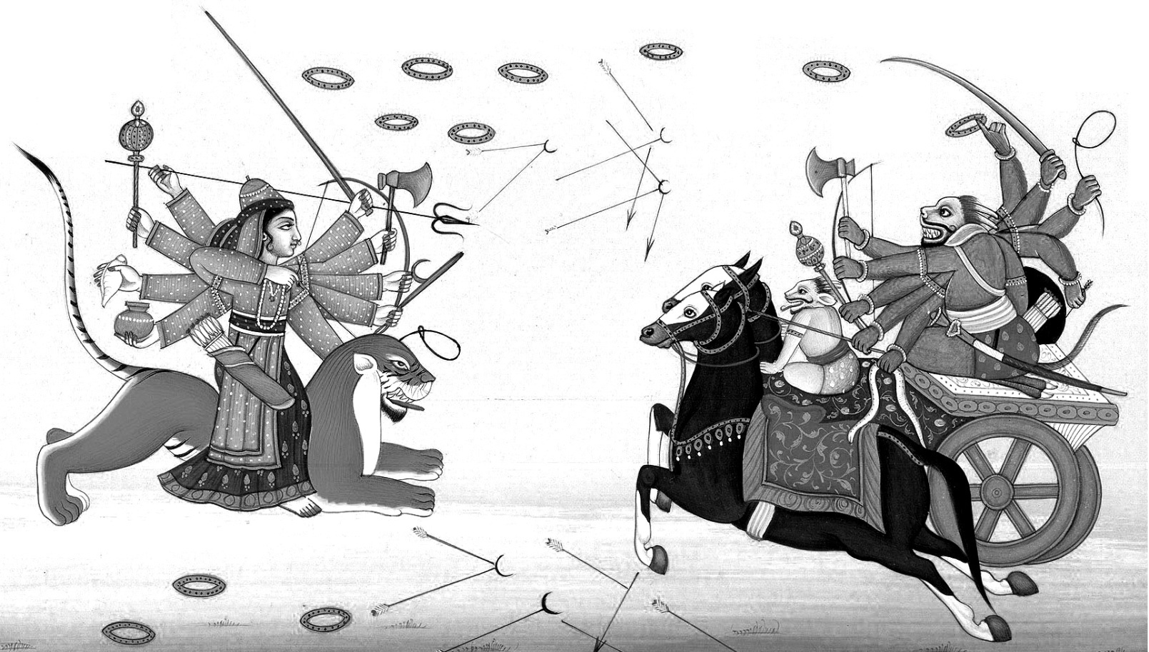

CHAPTER 5

Devi's conversation with the messenger

Meditation on Shrī Mahāsaraswatī:
Om. Ghaṇṭā śhūla halāni śhaṅkha musale chakram dhanuḥ sāyakaṁ; Hast’ābjair-dadhatīm ghan’ānta vilasat śhīt’āṁśhu tulya prabhāṁ; Gaurī deha samudbhavāṁ tri-jagat-ātmādhāra bhūtāṁ; Mahā-pūrvām atra Sarasvatīm anubhaje Śhumbh’ādi daity’ārdinīm
I meditate on the incomparable Śhrī Mahāsaraswatī who holds in Her Eight Lotus-like Hands Bell, Trident, Plough, Conch, Mace, Discus, Bow and Arrow; who is Effulgent as the Destroyer of Śhumbha and other Asuras, who issued forth from Pārvatī's body and is the Substratum of the Three Worlds.

1. The Ṛiṣhi said: ‘Of yore Indra's sovereignty over the Three Worlds and his portions of the sacrifices were taken away by the Asuras, Śhumbha and Niśhumbha, by force of their pride and strength. The two, themselves, took over likewise, the offices of the Sun, the Moon, Kubera, Yama, and Varuna. They themselves exercised Vayu's authority and Agni's duty. Deprived of their lordships and sovereignties, the Devas were defeated.
5. Deprived of their functions and expelled by these two great Asuras, all the Devas thought of the invincible Devi.
6. 'She had granted us the boon, ‘Whenever in calamities you think of Me, that very moment I will put an end to all your worst calamities.’
7. Resolving thus, the Devas went to Himavat, Lord of the mountains, and there extolled the Devi, who is the Illusive Power of Viṣhṇu. The Devas praised Her thus:

Devi Māhātmyam - Chapter 5

The Tantrika Devi Sūktam

Aparājitā Hymn – ‘Praise to the Eternally Undefeated Goddess’

Namo Devyai Mahā-devyai To the Devi, to the Supreme Goddess,
Śhivāye satatam namaḥ, To the Benevolent One, we bow eternally
Namaḥ prakṛityai bhadrāyai The Auspicious Goddess, Primordial Cause,
Niyutāḥ praṇatāḥ sma tām. Ever-humble Prostrations to Her.

Raudrāyai namo nityāyai Salutations to Her who is Terrible, Eternal,
Gauryai dhātryai namo namaḥ,To Shri Gaurī, Supporter of the Universe,
Jyotsnāyai ch’endu-rūpinyai To Her who is the Moon and Moonlight,
Sukhāyai satatam namaḥ. And Happiness itself, we bow constantly.

Kalyānyai praṇatām vṛiddhyai To the Embodiment of Virtue, Prosperity
Siddhyai kurmo namo namaḥ, and Success, we make obeisance.
Nairṛityai bhū-bhṛitam lakṣhmyai To the Good Fortune of Kings and
Śharvāṇyai te namo namaḥ. Wife of the Destroyer, we bow to You

Durgāyai durga-pārāyai Shri Durga, who takes us across hardships,
Sārāyai sarva-kārinyai, Being the Essential Cause of Everything,
Khyātyai tath’aiva kṛiṣhṇāyai The Possessor of Fame and Glory,
Dhumrāyai satatam namaḥ. To the Blue-black Smoke-hued Goddess,

Ati-saumy‛āti-raudrāyai We bow to Her who is at once,
Natās-tasyai namo namaḥ, Most gentle and most terrible.
Namo jagat-pratiṣhṭhāyai To the Support of the World,
Devyai kṛutyai namo namaḥ. The Creative Goddess, we bow.

Devi Māhātmyam - Chapter 5
Yā Devī sarva-bhūteśhu To the Devi who in all beings,
Viṣhṇu-māyeti śhabditā, is called Shri Viṣhṇumāyā,
Namas-tasyai, namas-tasyai Salutations to Her, Salutations to Her,
Namas-tasyai, namo namaḥ. Salutations to Her, again and again.

Yā Devī sarva-bhūteśhu To the Devi who in all beings,
Chetanetya bhi-dhīyate, is termed as Consciousness,
Namas-tasyai, namas-tasyai Salutations to Her, Salutations to Her,
Namas-tasyai, namo namaḥ. Salutations to Her, again and again.

Yā Devi sarva-bhūteśhu To the Devi who abides in all beings,
Buddhi rūpeṇa samsthitā, In the Form of Intelligence,
Namas-tasyai, namas-tasyai Salutations to Her, Salutations to Her,
Namas-tasyai, namo namaḥ. Salutations to Her, again and again.

Nidrā rūpeṇa Form of Sleep
Kṣhudhā rūpeṇa Form of Hunger
Chhāyā rūpeṇa Form of Shadow
Śhakti rūpeṇa Form of Energy
Tṛiṣhṇā rūpeṇa Form of Thirst

Kṣhānti rūpeṇa Form of Patience
Jāti rūpeṇa Form of Position by birth
Lajjā rūpeṇa Form of Modesty
Śhānti rūpeṇa Form of Peace
Śhraddhā rūpeṇa Form of Faith

Kānti rūpeṇa Form of Beauty
Lakṣhmī rūpeṇa Form of Good Fortune
Vṛitti rūpeṇa Form of Character
Smṛiti rūpeṇa Form of Memory

Devi Māhātmyam - Chapter 5
Dayā rūpeṇa Form of Compassion
Tuṣhṭi rūpeṇa Form of Contentment
Mātṛi rūpeṇa Form of Mother
Bhrānti rūpeṇa Form of Delusion and Error

Indriyānām adhiṣhthātrī To the All-pervading Devi,
Bhūtānām chākhileśhu yā Who presides over the senses of all beings,
Bhūteśhu satatam tasye And governs all the elements,
Vyāpti-devye namo namaḥ We bow to Her.

Chiti-rūpeṇa yā kṛutsna Salutations to Her who pervades the
Metad-vyāpya samsthitā jagat Entire world in the Form of Consciousness,
Namas-tasyai, namas-tasyai Salutations to Her, Salutations to Her,
Namas-tasyai, namo namaḥ Salutations to Her, again and again.

Here ends the Devi Sūktam.

81. 'Invoked of yore by the Devas for the sake of their desired object, and adored by the Lord of the Devas every day, may She, the Īśhvarī, the Source of all good, accomplish for us all auspicious things and put an end to our calamities!
82. And who is now again, reverenced by us, Devas, tormented by arrogant Asuras and who, called to mind by us obeisant with devotion, destroys this very moment all our calamities.'
83. The Ṛiṣhi said: ‘O Prince, while the Devas were thus engaged in praises and other acts of adoration, Pārvatī came there to bathe in the waters of the Gaṅgā. She, the lovely-browed, said to those Devas, 'Who is praised by you here?' An auspicious Goddess, springing forth from Her physical sheath, gave the reply: 'This hymn is addressed to Me by the assembled Devas set at naught by the Asura Śhumbha and routed in battle by Niśhumbha.’

Devi Māhātmyam - Chapter 5
87. Because that Ambikā came out of Pārvatī's physical sheath Koṣha, She is glorified as Kauṣhikī in all the worlds. After She had issued forth, Pārvatī became dark and was called Kālīka and stationed on Mount Himalaya.
89. Then, Chaṇḍa, and Muṇḍa, two servants of Śhumbha and Niśhumbha, saw that Ambikā Kauṣhikī bearing a surpassingly charming form.
90. They both told Śhumbha: 'O King, a certain woman, most surpassingly beautiful, dwells there shedding lustre on Mount Himalaya. Such supreme beauty was never seen by anyone anywhere. Ascertain who that Goddess is and take possession of Her, O Lord of the Asuras!
92. She is a gem among women, of exquisitely beautiful limbs, illuminating the quarters with Her lustre, O Lord of the Daityas. you should see Her. O Lord, whatever jewels, precious stones, elephants, horses and others there are in the Three Worlds, they are all now in your house. Airāvata, gem among elephants, has been brought away from Indra and so also this Pārijāta tree and the horse Ucchaih-śhravas.
95. Here stands in your courtyard the wonderful chariot yoked with swans, a wonderful gem of its class. It has been brought here from Brahmā to whom it originally belonged. Here is the treasure named Mahāpadma brought from the Lord of Wealth. And the Ocean gave a garland named Kiñjalkinī made of unfading lotus flowers. In your house stands the gold-showering umbrella of Varuna. And here is the excellent chariot that was formerly Prajāpati's.
98. By you, O Lord, Death's Śhakti weapon named Utkrāntidā has been carried off. the noose of the ocean-king is among your brother's possessions. Niśhumbha has every kind of gem produced in the sea. Fire also gave you two garments which are purified by fire. Thus, O Lord of Asuras, all gems have been brought by you. Why this beautiful lady-jewel is not seized by you?’

Devi Māhātmyam - Chapter 5
101. The Ṛiṣhi said: ‘On hearing these words of Chaṇḍa and Muṇḍa, Śhumbha sent the great Asura Sugrīva as messenger to the Devi. He said: 'Go and tell Her thus in my words and do the thing in such a manner that She may quickly come to me in love.'
104. He went there where the Devi was staying in a very beautiful spot on the mountain and spoke to Her in fine and sweet words. The messenger said: 'O Devi, Śhumbha, Lord of Asuras, is the supreme sovereign of the Three Worlds. Sent by him as messenger, I have come here to Your presence. Hearken to what has been said by him whose command is never resisted among the Devas and who has vanquished all the foes of the Asuras:
108. He says, ‘All the Three Worlds are mine and the Devas are obedient to me. I enjoy all their hares in sacrifices separately. ‘All the choicest gems in the Three Worlds are in my possession; and so is the gem of elephants, Airavata, the vehicle of the King of Devas carried away be me. The Devas themselves offered to me with salutations that gem of horses named Ucchaih-śhravas which arose at the churning of the Milk-ocean.
111. O Beautiful Lady, whatever other rare objects there existed among the Devas, the Gandharvas and Nāgas are now with me. We look upon You, O Devi, as the jewel of womankind in the world. You who are such, come to me, since we are the enjoyers of the best objects.
113. Take to me or to my younger brother Niśhumbha of great prowess, O unsteady-eyed lady, for You are in truth a jewel. Wealth, great and beyond compare, You will get by marrying me. Think over this in Your mind, and become my wife.’
115. The Ṛiṣhi said: ‘Thus told, Durga the adorable and auspicious, by whom this Universe is supported, then became serene and spoke.

Devi Māhātmyam - Chapter 5
117. The Devi said: ‘You have spoken truth; nothing false has been uttered by you in this matter. Śhumbha is indeed the sovereign of the Three Worlds and likewise is also Niśhumbha. But in this matter, how can that which has been promised be made false? Hear what promise I had made already out of foolishness. ‘He who conquers Me in battle, removes My pride and is My match is strength in the world shall be My husband.’ So let Śhumbha come here then, or Niśhumbha the great Asura. Vanquishing Me here, let him soon take My hand in marriage. Why delay?'
122. The messenger said: 'O Devi, You are haughty. Talk not so before me. Which man in the Three Worlds will stand before Śhumbha and Niśhumbha? All the Devas verily cannot stand face to face with even the other Asuras in battle. Why mention You, O Devi, a single woman? Indra and all other Devas could not stand in battle against Śhumbha and other demons, how will You, a woman, face them? On my word itself, You go to Śhumbha and Niśhumbha. Let it not be that You go to them with Your dignity lost be being dragged by Your hair.'
127. The Devi said: ‘Yes, it is; Śhumbha is strong and so is Niśhumbha exceedingly heroic! What can I do since there stands My ill-considered vow taken long ago? Go back, and tell the Lord of Asuras carefully all this that I have said; let him do whatever he considers proper.'

Here ends the Fifth Chapter called 'Devi's Conversation with the Messenger' of the Devī Māhātmyam in the Mārkaṇḍeya Purāṇa during the period of the Manu Savarni.

CHAPTER 6

The Slaying of Dhūmra-lochana

The Ṛiṣhi said:
1. ‘The messenger, filled with indignation on hearing the words the Devi, returned and related them in detail to the King of the Daityas.
3. Then the Asura monarch, enraged on hearing that report from his messenger, told Dhūmra-lochana, a chieftain of the Daityas: 'O Dhūmra-lochana, hasten together with your army and fetch here by force that shrew, distressed when dragged by Her hair.
5. Or if any one else stands up as Her saviours, let him be slain, be he a God, a yaksha or a gandharva.' The Ṛiṣhi said:
6. Then the Asura Dhūmra-lochana, commanded thus by Śhumbha, went forth quickly, accompanied by sixty thousand Asuras.
8. On seeing the Devi stationed on the snowy mountain, he asked Her aloud, 'Come to the presence of Śhumbha and Niśhumbha.
9. If You will not go to my Lord with pleasure now, here I take You by force, distressed when dragged by Your hair.'
10. The Devi said: ‘You are sent by the Lord of the Asuras, mighty yourself and accompanied by an army. If you thus take Me by force, then what can I do to you?'
12. The Ṛiṣhi said: ‘Thus told, the Asura Dhūmra-lochana rushed towards Her and thereupon Ambikā reduced him to ashes with a mere heave of the sound 'hum'
14. Then the great army of Asuras became enraged and showered on Ambikā sharp arrows, javelins, and axes.
15. Then the lion, vehicle of the Devi, shaking its mane in anger, and making the most terrific roar, fell on the army of the Asuras.

Devi Māhātmyam - Chapter 6
16. Some Asuras, it slaughtered with a blow of its fore paw, others with its mouth, and other great Asuras, by treading over with its hind legs.
17. The lion, with its claws, tore out the hearts of some and severed heads with a blow of the paw.
18. And it severed arms and heads from others, and shaking its mane drank the blood from the hearts of others.
19. In a moment all that army was destroyed by that high-spirited and exceedingly enraged lion who bore the Devi.
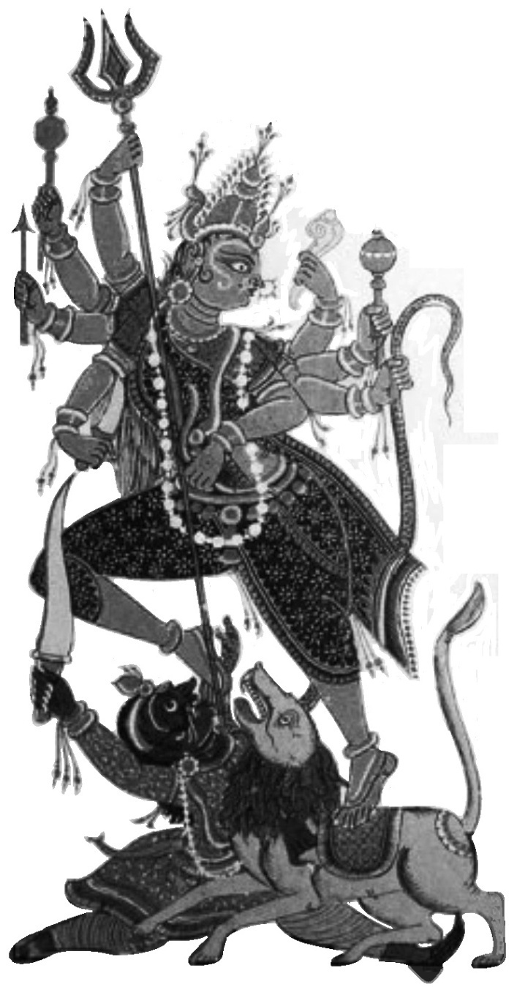
20. When Śhumbha, the Lord of Asuras, heard that Dhūmra-lochana was slain by the Devi and all his army was destroyed by the lion of the Devi, he was infuriated, his lip quivered and he commanded the two mighty Asuras Chaṇḍa and Muṇḍa:
22. 'O Chaṇḍa, O Muṇḍa, go there with large forces, and bring Her here speedily, dragging Her by Her hair or binding Her. But if you have any doubt about doing that, then let the Asuras strike Her in the fight with all their weapons.
24. When that shrew is wounded and Her lion stricken down, seize that Ambikā, bind and bring Her quickly.'

Here ends the Sixth Chapter called 'The Slaying of Dhūmra-lochana' of Devī Māhātmyam in the Mārkaṇḍeya Purāṇa during the period of Savarni Manu.

CHAPTER 7

The Slaying of Chaṇḍa and Muṇḍa

The Ṛiṣhi said:
1. Then at his command the Asuras, fully armed, and with Chaṇḍa and Muṇḍa at their head, marched in fourfold array.
3. They saw the Devi, smiling gently, seated upon the lion on a huge golden peak of the great mountain. On seeing Her, some of them excited themselves and made an effort to capture Her, and others approached Her, with their bows bent and swords drawn.
5. Thereupon Ambikā became terribly angry with those foes, and in Her anger Her countenance then became dark as ink. Out from the surface of Her forehead, fierce with frown, issued suddenly Kālī of terrible countenance, armed with a sword and noose.
7. Bearing a skull-topped staff, decorated with a garland of skulls, clad in a tiger's skin, very appalling owing to Her emaciated flesh, with gaping mouth, fearful with Her tongue lolling out, having deep-sunk reddish eyes and filling the regions of the sky with Her roars, and impetuously falling upon and slaughtering the great Asuras in that army, She devoured those hosts of the foes of the Devas.
10. Snatching the elephants with one hand She flung them into Her mouth together with their rear men and drivers and their warrior-riders and bells. Taking likewise into Her mouth the cavalry with the horses, and chariot with its driver, She ground them most frightfully with Her teeth.
12. She seized one by the hair and another by the neck; one She crushed by the weight of the foot, and another of Her body.
13. And She caught with Her mouth the weapons and the great arms shot by those Asuras and crunched them up with Her teeth in Her fury.

Devi Māhātmyam - Chapter 7
14. She destroyed all that host of mighty and evil-natured Asuras, devoured some and battered others.
15. Some were killed with Her sword, some were beaten with Her skull-topped staff, and other Asuras met their death being ground with the edge of Her teeth.
16. On seeing all the hosts of Asuras laid low in a moment, Chaṇḍa rushed against that Kālī, who was exceedingly terrible.
17. The great Asura Chaṇḍa with very terrible showers of arrows, and Muṇḍa with discuses hurled in thousands covered that terrible-eyed Devi.
18. Those numerous discuses, disappearing into Her mouth, looked like numerous solar orbs disappearing into the midst of a cloud.
19. Thereat Kālī, who was roaring frightfully, whose fearful teeth were gleaming within Her dreadful mouth, laughed terribly with exceeding fury.
20. Then the Devi, mounting upon Her great lion, rushed at Chaṇḍa, and seizing him by his hair, severed his head with Her sword.
21. Seeing Chaṇḍa laid low, Muṇḍa also rushed at Her. She felled him also the ground, striking him with Her sword in Her fury.
22. Seeing the most valiant Chaṇḍa and Muṇḍa laid low, the remaining army there became panicky and fled in all directions.
23. And Kālī, holding the heads of Chaṇḍa and Muṇḍa in Her hands, approached Chandikā and said, Her words mingled with very loud laughter.
24. 'Here have I brought You the heads of Chaṇḍa and Muṇḍa as two great animal offerings in this sacrifice of battle; Śhumbha and Niśhumbha, You shall Yourself slay.' The Ṛiṣhi said:

Devi Māhātmyam - Chapter 7
25. Thereupon seeing those Asuras, Chaṇḍa and Muṇḍa brought to Her, the auspicious Chandikā said to Kālī these playful words: 'Because You have brought Me both Chaṇḍa and Muṇḍa, You O Devi, shall be famed in the world by the name Chāmuṇḍā.

Here ends the Seventh Chapter called 'The slaying of Chaṇḍa and Muṇḍa' of Devī Māhātmyam in Mārkaṇḍeya Purāṇa, during the period of the Manu Savarni.
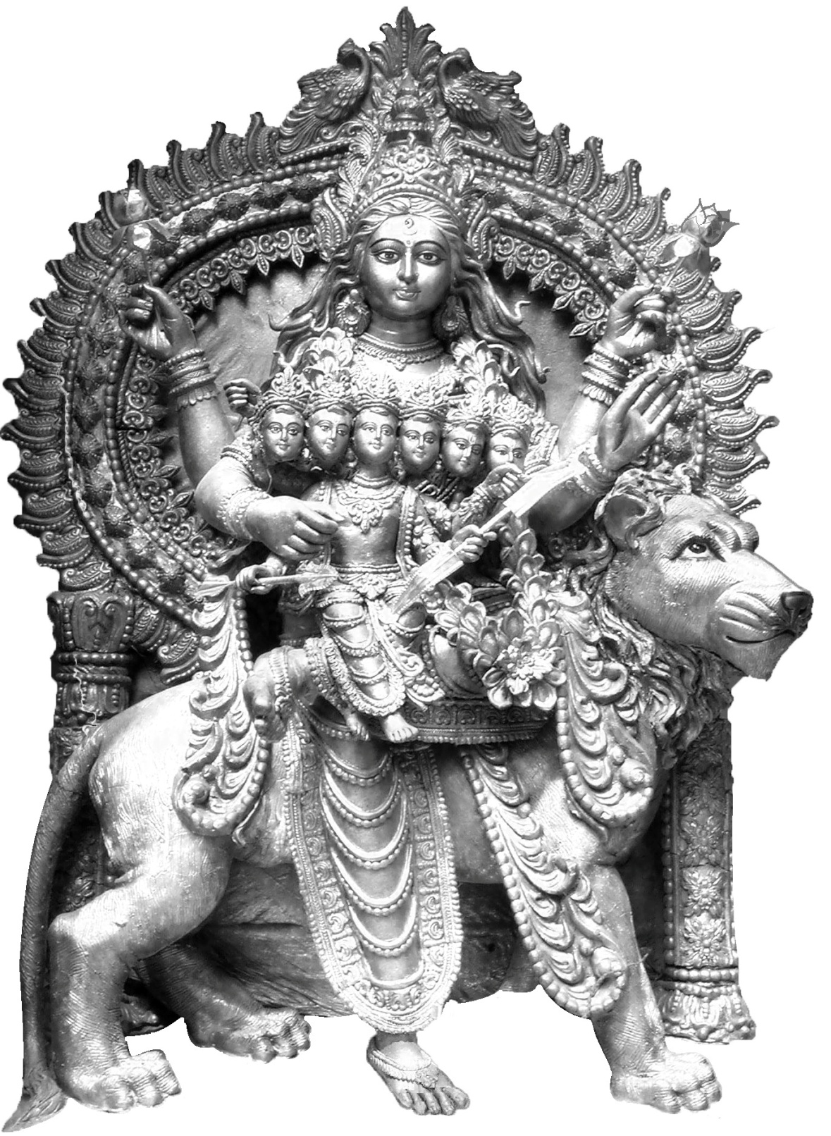
Shrī Skanda-mātā
–‘Mother of Shri Karttikeya’, the aspect of Shrī Durgā worshipped on the fifth day.

A statue from Calcutta, Bengal where Shrī Durgā
is the main Deity.

CHAPTER 8

The Slaying of Raktabīja
The Ṛiṣhi said:
1. After the Daitya Chaṇḍa was slain and Muṇḍa was laid low, and many of the battalions were destroyed, the powerful Śhumbha, Lord of the Asuras, with mind overcome by anger, commanded the mobilization of all the Daitya hosts: ‘Now let the eighty-six Asuras - upraising their weapons - with all their forces, and the eighty-four Kambūs, surrounded by their own forces, go out. Let the fifty Asura families of Koṭivīryas and the hundred families of Dhaumras go forth at my command. Let the Kālakas, Daurhṛidas, the Mauryas and the Kālakeyas hasten at my command and march forth ready for battle.'
7. After issuing these orders, Śhumbha, the Lord of the Asuras and a ferocious ruler, went forth, attended by many thousands of battalions.
8. Seeing that most terrible army coming, Chandikā filled the space between the Earth and the Sky with the twang of Her bow-string. Thereon Her Lion made an exceedingly loud roar, O King, and Ambikā magnified those roars with the clanging of Her Bell. Kālī, expanding Her Mouth wide and filling the quarters with the sound ‘Hum’ overwhelmed the noises of Her bow-string, Lion and Bell by Her terrific roars.
11. On hearing that roar the enraged Asura battalions surrounded the Lion, the Devi Chandikā and Kālī on all four sides.
12. At this moment, O King, in order to annihilate the enemies of Devas and for the well-being of the Devas, there issued forth, endowed with exceeding vigour and strength, Śhaktis from the bodies of Brahma, Śhiva, Karttikeya, Viṣhṇu and Indra, and with the form of those Devas went to Chandikā.

Devi Māhātmyam - Chapter 8
14. Whatever was the form of each Deva, whatever his ornaments and vehicle, in that very form his Śhakti advanced to fight with the Asuras.
15. In a Heavenly Chariot drawn by Swans advanced Brahmā's Śhakti carrying a Rosary and a Water-pot. She is called Brahmāṇī.
16. Māheśhvarī arrived, seated on a bull, holding a fine trident, wearing bracelets of great snakes and adorned with a crescent moon.
17. Ambikā Kaumarī, in the form of Karttikeya, holding a spear in hand riding on a fine peacock, advanced to attack the Asuras. Likewise the Śhakti of Viṣhṇu came, seated upon Garuda, holding conch, club, bow and sword in hand.
19. The Śhakti of Hari, who assumed the incomparable form of a sacrificial boar, She also advanced there in a boar-like form.
20. Nārasiṁhī arrived there, assuming a body like that of Narasiṁha-‘Man-lion’, bringing down the constellations by the toss of Her mane.
21. Likewise the thousand-eyed Aindrī, holding a thunderbolt in hand and riding on the Lord of Elephants arrived just like Śhakra Indra.
22. Then Śhiva, surrounded by those Śhaktis of the Devas, said to Chandikā, 'Let the Asuras be killed forthwith by You for My gratification.'
23. Thereupon from the body of Devi issued forth the Śhakti Chandikā, most terrific, exceedingly fierce and yelling like a hundred jackals.
24. And that invincible Śhakti told Śhiva, of dark-coloured matted locks, 'Go, My Lord, as Ambassador to the presence of Śhumbha and Niśhumbha. Tell those two haughty Asuras and the other Asuras assembled there for battle. ‘Allow Indra to reclaim the Three Worlds and let the Devas once more enjoy the sacrificial oblations. Go you to the Nether World, if you wish to live. But if, proud of your strength, you are anxious for battle, come then.

Devi Māhātmyam - Chapter 8
Let My jackals be satiated with your flesh.' Because that Devi appointed Lord Śhiva Himself as Ambassador thenceforth She became renowned in this world as ‘Śhiva-dūti’ –‘having Shiva as a messenger’.
29. Those great Asuras, on their part, hearing the words of the Devi communicated by Śhiva, were filled with indignation and went to where Kātyāyanī stood. Immediately the enraged foes of the Devas poured on the Devi showers of arrows, javelins and spears. But lightly, with the huge arrows shot from Her full-drawn bow, She clove those arrows, spears, darts and axes hurled by them.
32. Then, in front of Śhumbha stalked Kālī, slicing the enemies to pieces with Her spear and crushing them with Her skull-topped staff.
33. And Brahmāṇī, wherever She moved, made the enemies bereft of valour and prowess by sprinkling on them the water from Her Kamandalu.
34. The very wrathful Māheśhvarī slew the Daityas with Her trident, and Vaiṣhṇavī, with Her discus and Kaumarī, with Her javelin.
35. Torn to pieces by the thunderbolt which came down upon them, hurled by Aindrī, Daityas and Dānavas fell on the Earth in hundreds, streams of blood flowing out of them.
36. Shattered by the boar-formed Goddess Vārāhī with blows of Her snout, wounded in their chests by the point of Her tusk and torn by Her discus, the Asuras fell down.
37. Nārasiṁhī, filling all the quarters and the sky with Her roars, roamed about in the battle, devouring other great Asuras torn by Her claws. Demoralised by the violent laughter of Śhiva-dūtī, the Asuras swooned on the Earth; then She devoured those who had fallen.
39. Seeing the enraged band of Mother Goddesses crushing the great Asuras thus by various means, the troops of the enemies of Devas took to their heels.

Devi Māhātmyam - Chapter 8
40. Seeing the Asuras harassed by the band of Mother Goddesses and fleeing, the great Asura Raktabīja strode forward to fight in wrath. Whenever from his body there fell to the ground a drop of blood, at that moment rose up from the Earth an Asura of his same stature. The great Asura fought with Indra's Śhakti with club in his hand; then Aindrī also struck Raktabīja with Her thunderbolt.
43. Blood flowed quickly and profusely from him who was wounded by the thunderbolt. From the blood rose up fresh combatants of his form and valour; As many drops of blood fell from his body, so many warriors came into being, with his same courage, strength and valour. And those persons also sprung up from his blood fought there with the Mother Goddesses in a more dreadful manner hurling very formidable weapons.
46. And again when his head was wounded by the fall of Her thunder-bolt, his blood flowed and therefrom were born soldiers in thousands.
47. Vaiṣhṇavī struck him with Her discus in the battle, Aindrī beat that Lord of Asuras with Her club. The world was pervaded by thousands of great Asuras of his stature and who rose up from the blood that flowed from him when cloven by the discus of Vaiṣhṇavī.
49. Kaumarī struck the great Asura Raktabīja with Her spear, Vārāhī with Her sword, and Māheśhvarī with Her trident.
50. And Raktabīja, that great Asura, filled with wrath, struck each of the Mother Goddesses severally with his club.
51. From the stream of blood which fell on the Earth from him when he received multiple wounds by the spears, darts and other weapons, hundreds of Asuras came into being. And those Asuras that were born from the blood of Raktabīja pervaded the whole world; the Devas got intensely alarmed at this.

Devi Māhātmyam - Chapter 8
53. Seeing the Devas dejected, Chandikā laughed and said to Kālī, 'O Chāmuṇḍā, open out Your mouth wide; with this mouth quickly take in the drops of blood generated by the blow of My weapon and also the great Asuras born of the drops of blood of Raktabīja.
55. Roam about in the battle-field, devouring the great Asuras that spring from him. So shall this Daitya, with his blood emptied, perish.
56. As You go on devouring these, other fierce Asuras will not be born.' Having enjoined Her thus, the Devi next smote Raktabīja with Her dart.
57. Then Kālī drank Raktabīja's blood with Her mouth. Then and there he struck Chandikā with his club.
58. The blow of his club caused Her not even the slightest pain. And from his stricken body wherever blood flowed copiously, there Chāmuṇḍā swallowed it with Her mouth. Then Chāmuṇḍā devoured those great Asuras who sprang up from the flow of blood in Her mouth, and drank Raktabīja's blood.
61. The Devi Kauṣhikī smote Raktabīja with Her dart, thunderbolt, arrows, swords, and spears, when Chāmuṇḍā went on drinking his blood.
62. Stricken with a multitude of weapons and bloodless, the great Asura Raktabīja fell to the ground, O King.
63. Thereupon the Devas attained great joy, O King. The band of Mother Goddesses who sprang from them danced, being intoxicated with blood.’

Here ends the Eighth Chapter called 'The Slaying of Raktabīja' of Devī Māhātmyam in Mārkaṇḍeya Purāṇa, during the period of the Manu Savarni.

CHAPTER 9

The Slaying of Niśhumbha

King Suratha said:
1. ‘Wonderful is this that you, adorable sir, have related to me about the greatness of the Devi's act in slaying Raktabīja. I wish to hear further what the very irate Śhumbha and Niśhumbha did after Raktabīja was killed.'
4. The Ṛiṣhi said: ‘After Raktabīja was slain and other Asuras were killed in the fight, the Asura Śhumbha and Niśhumbha gave way to unbounded wrath.
6. Enraged on seeing his great army slaughtered, Niśhumbha then rushed forward with the chief forces of the Asuras.
7. In front of him behind him and on both sides of him, great Asuras, enraged and biting their lips, advanced to slay the Devi.
8. Shumbha also, mighty in valour, went forward, surrounded, with his own troops to slay Chandikā in this rage, after fighting with the Mother Goddesses.
9. Then commenced severe combat between the Devi on one side and on the other, Śhumbha and Niśhumbha who, like two thunder-clouds, rained a most tempestuous shower of arrows on Her.
10. Chandikā with numerous arrows quickly split the arrows shot by the two Asuras and smote the two lords of Asuras on their limbs with Her mass of weapons.
11. Niśhumbha, grasping a sharp sword and a shining shield, struck the Lion, the Great Carrier of the Devi, on the head.
12. When Her Carrier was struck, the Devi quickly cut Niśhumbha's superb sword with a sharp-edged arrow and also his shield on which eight

Devi Māhātmyam - Chapter 9
moons were figured. With his shield split and his sword too broken, the Asura hurled his spear; but that missile also, as it advanced towards Her, was split into two by Her discus.
14. Then the Dānava Niśhumbha, swelling with wrath, seized a dart; and that also, as it came, the Devi powdered with a blow of Her fist.
15. Then brandishing his club, he flung it against Chandikā; cleft by the trident of the Devi, it also turned to ashes.
16. Then the Devi assailed the heroic Dānava advancing with battle-axe in hand, and laid him low on the ground.
17. When his brother Niśhumbha of terrific prowess fell to the ground, Śhumbha got infuriated in the extreme, and strode forward to slay Ambikā.
18. Standing in his chariot and grasping excellent weapons in his long and incomparable eight arms, he shone by pervading the entire sky.
19. Seeing him approaching, the Devi blew Her conch, and made a twang of Her bow-string, which was unbearable in the extreme.
20. And the Devi filled all directions with the ringing of Her bell, which destroys the strength of all the Daitya hosts.
21. The Lion filled the Heaven, the Earth and the ten quarters of the sky with loud roars, which made the elephants give up their violent rut.
22. Then Kālī, springing upwards in the sky, came down and struck the Earth with both Her hands; by its noise all the previous sounds were drowned.
23. Śhivadūtī made a loud ominous peal of laughter, the Asuras were frightened by those sounds, and Śhumbha flew into an utmost rage.
24. As Ambikā said, 'O evil-natured one, stop, stop', the Devas stationed in the sky cheered Her with the words, 'Be victorious'.

Devi Māhātmyam - Chapter 9
25. The spear which Śhumbha hurled, flaming most terribly and shining like a mass of fire, was put out by a great firebrand from the Devi as it came.
26. The space between the Three Worlds was pervaded by Śhumbha's lion-like roar, but the dreadful thunder-clap of the Devi smothered that, O King.
27. The Devi split the arrows shot by Śhumbha, and Śhumbha also split the arrows discharged by Her, each with sharp arrows in hundreds and thousands.
28. Then Chandikā became angry and smote him with a trident. Wounded therewith, he fainted and fell to the ground.
29. Then Niśhumbha, regaining consciousness seized his bow and struck with arrows the Devi and Kālī and the Lion.
30. And the Danuja-lord, the son of Diti, putting forth a myriad of arms, covered Chandikā with myriad discuses.
31. Then Bhagavati Durga, the Destroyer of Difficulties and Afflictions, became angry and split those discuses and those arrows with Her own arrows.
32. Thereupon Niśhumbha, surrounded by the Daitya host, swiftly seizing his club, rushed at Chandikā to slay Her.
33. As he rushed at Her, Chandikā clove his club with Her sharp-edged sword; and he took hold of a dart.
34. As Niśhumbha, the afflictor of the Devas, was advancing with the dart in hand, Chandikā pierced him in the heart with a swiftly hurled dart.
35. From Niśhumbha's heart that was pierced by the dart, issued forth another person of great strength and valour, exclaiming to the Devi 'Stop.'

Devi Māhātmyam - Chapter 9
36. Then the Devi, laughing aloud, severed the head of him, who issued forth, with Her sword. Thereupon he fell to the ground.
37. The Lion then devoured those Asuras whose necks he had crushed with his fierce teeth, and Kālī and Śhiva-dūtī devoured others.
38. Some great Asuras perished, being pierced through by the spear of Kaumarī. Others were repulsed by showers of the water purified by the incantation of Brahmāṇī. Others fell, pierced by a trident wielded by Māheśhvarī; some were powdered on the ground by the blows from the snout of Vārāhī.
40. Some Dānavas were cut to pieces by the discus of Vaiṣhṇavī, and others again by the thunderbolt discharged from the palm of Aindrī. Some Asuras perished themselves, some fled from the great battle, and others were devoured by Kālī, Śhivadūtī and the lion.

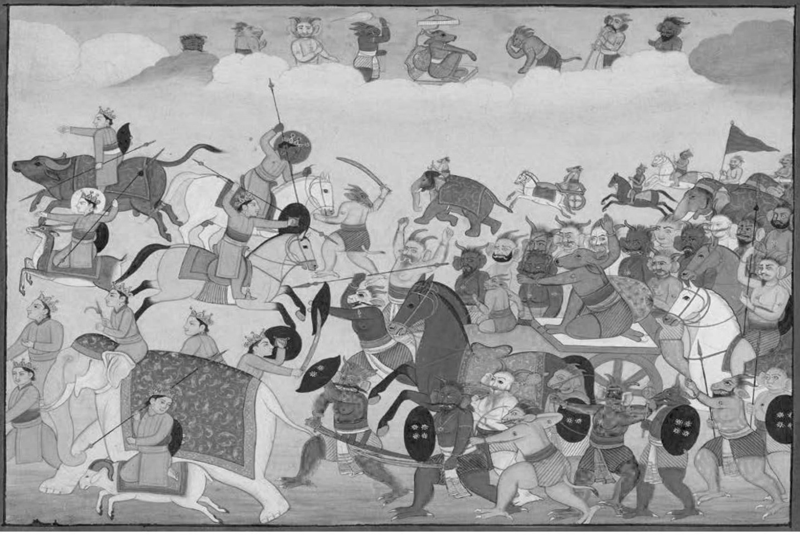
Here ends the Ninth Chapter called 'the Slaying of Niśhumbha' of Devī Māhātmyam in Mārkaṇḍeya Purāṇa during the period of the Manu Savarni.

CHAPTER 10

The Slaying of Śhumbha

The Ṛiṣhi said:
1. ‘Seeing his brother Niśhumbha slain, who was as dear to him as his life, and his army being slaughtered, Śhumbha angrily said. 'O Durga who are puffed up with pride in your strength, don't show Your pride here. Though You are exceedingly haughty, You fight by resorting to the strength of others.'
4. The Devi said: 'I am all alone in the world here. Who else is there besides me? See, O vile one, these Goddesses, who are but My own powers, entering into My own self!'
6. Then all those, Brahmāṇī and the rest, were absorbed in the body of the Devi. Ambikā alone then remained.
7. The Devi said: 'The numerous forms which I projected by My power here - those have been withdrawn by Me, and now I stand alone. Be steadfast in combat.'
9. The Ṛiṣhi said: ‘Then began a dreadful battle between them both, the Devi and Śhumbha, while all the Devas and Asuras looked on.
11. With showers of arrows, with sharp weapons and frightful missiles, both engaged again in a combat that frightened all the worlds. The Lord of Daityas broke the divine missiles, which Ambikā discharged in hundreds, with weapons that repulsed them. With fierce shout of ‘hum’ and the like, the Parameśhvarī playfully broke the excellent missiles that he discharged.
14. Then the Asura covered the Devi with hundreds of arrows, and the Devi in wrath split his bow with Her arrows. And when the bow was split the Lord

Devi Māhātmyam - Chapter 10
of the Daityas took up his spear. With a discus, the Devi split that spear also in his hand.
16. Next the supreme monarch of the Daityas, taking his sword bright like the sun and shining shield bearing the images of a hundred moons, rushed at the Devi at that moment. Just as he was rushing forward, Chandikā split his sword with sharp arrows from Her bow, and also his shield as bright as the solar rays.
18. With his steeds slain, his bow broken, deprived of a charioteer, the Daitya then grasped his terrible mace, being ready to kill Ambikā. With sharp arrows, She split the mace of Śhumbha, who was rushing at Her. Even then, raising his fist, he rushed swiftly at Her. The Daitya-king brought his fist down on the heart of the Devi, and the Devi also with Her Palm smote him on his chest.
21. The Daitya-king, wounded by the blow of Her Palm fell to the Earth, but immediately he rose up again. Seizing the Devi, he sprang up and mounted on high into the sky. There also Chandikā, without any support, fought with him.
23. Then the Daitya Śhumbha and Chandikā fought as never before, with each other in the sky in close contact, which wrought surprise to the Siddhas and Sages.
24. Ambikā then, after carrying on a close fight for a very long time with him, lifted him up, whirled him around and flung him down on the Earth. Flung thus, the evil-natured Śhumbha reaching the Earth and raising his fist, hastily rushed forward desiring to kill Chandikā. Seeing that Lord of all the Daitya-folk approaching, the Devi, piercing him on the chest with a dart, threw him down on the Earth. Pierced by the pointed dart of the Devi he fell lifeless on the ground, shaking the entire Earth with its seas, islands and mountains.

Devi Māhātmyam - Chapter 10
28. When that evil-natured Asura was slain, the Universe became happy and regained perfect peace, and the sky grew clear. Flaming portent-clouds that were in evidence before became tranquil, and the rivers kept within their courses when Śhumbha was stricken down there.
30. When he had been slain, the minds of all the bands of Devas became overjoyed, and the Gandharvas sang sweetly. Others sounded their instruments, and the bands of nymphs danced; likewise favourable winds blew; the sun became very brilliant; the sacred fires blazed peacefully and tranquil became the strange sounds that had risen in different quarters.

Here ends the Tenth Chapter called 'The Slaying of Śhumbha' of Devī Māhātmyam in Mārkaṇḍeya Purāṇa, during the period of the Manu Savarni.

CHAPTER 11

Hymn to Nārāyanī

–‘the refuge of humanity’

The Ṛiṣhi said:
1. ‘When the great Lord of Asuras was slain there by the Devi, Indra and other Devas led by Agni, with their object fulfilled and their cheerful faces illumining the quarters, praised Her, Kātyāyanī:
3. The Devas said: 'O Devi, You who remove the sufferings of Your suppliants, be gracious. Be propitious, O Mother of the Whole World. Be gracious, O Mother of the Universe. Protect the Universe. You are, O Devi, the Ruler of all that is moving and unmoving.

Devi Māhātmyam – Chapter 11
4. You are the Sole Substratum of the World, because You subsist in the form of the Earth. By You, who exist in the shape of water, all this Universe is gratified, O Devi of inviolable valour!
5. You are the Power of Viṣhṇu, and have endless valour. You are the Primeval Māyā, which is the Source of the Universe; by You all this Universe has been thrown into an illusion, O Devi. When propitiated, You become the Cause of Final Emancipation in this World.
6. All forms of Knowledge are Your aspects O Devi; so are All Women in the World, endowed with various attributes. By You alone, the Mother, this World is filled. What praise can there be for You who are beyond all praise?

7) Sarva-bhūtā yadā Devi O Goddess, who to all beings
Bhukti mukti pradāyinī Bestows enjoyment and liberation,
Twam stutā stutaye kā vā What words, however excellent
Bhavantu param‛oktayah Can praise You?

8) Sarvasya buddhi rūpeṇa You abide as intelligence
Janasya hṛidi samsthite In the hearts of all creatures,
Swarg’āpavarga-de Devi O Bestower of Heaven and liberation,
Nārāyaṇi namo-‛stu te Salutations to You, the refuge of humanity.

9) Kalā kāṣhṭh’ādi rūpeṇa You manifest as the course of time,
Pariṇāma-pradāyinī Bringing about changes in things,
Viśhvasy’oparatau śhakte Having the power to destroy the Universe,
Nārāyaṇi namo-‛stu te Salutations be to You, who incarnates as
a human being to save the world.

Devi Māhātmyam – Chapter 11
10) Sarva mañgala māñgalye You are the auspiciousness of all goodness,
Śhive sarv’ārtha sādhike Benevolent Devi, who fulfils every object,
Śharaṇye tryambake Gauri The Giver of Refuge, O Three-eyed Gauri,
Nārāyaṇi namo-‛stu te Salutations be to You, towards whom
humanity is evolving.

11) Sṛiṣhṭi sthiti vināśhānām Creation, sustenance and destruction
Śhakti-bhūte sanātani are Your powers, O Eternal Goddess.
Guṇ‛āśhraye guṇa-maye O source and embodiment of qualities
Nārāyaṇi namo-‛stu te Salutations be to You, O Shakti of Shri Vishnu

12) Śharaṇ‛āgata dīnārta To those that seek refuge in You,
Pari-trāṇa parāyane You give protection and final liberation.
Sarva syārti hare Devi O Devi, who removes the suffering of all,
Nārāyaṇi namo-‛stu te Salutations be to You, O Narayani

13) Hāṁsā yuktā vimāna-sthe Riding in a chariot yoked with swans
Brahmāṇi rūpa dhāriṇī Embodied as the Śhakti of Shri Brahma
Kauśhāmbhaḥ kṣharike Devi O Devi, who sprinkles Kusha grass water.
Nārāyaṇi namo-‛stu te Salutations be to You, O Narayani

14) Triśhūla chandrāhi dhare Carrying a trident, the moon, a snake
Mahā-vṛiṣhabha vāhinī And riding a huge bull,
Māheśhwari swa-rūpeṇa You are the creative power of Shri Śhiva,
Nārāyaṇi namo-‛stu te Salutations be to You, O Narayani

15) Mayūra kukkuṭa vṛite Attended by a peacock and a cockerel
Mahāśhakti dhare-‘naghe Bearing a great spear, without impurity
Kaumārī-rūpa samsthāne Taking the form of the Shakti of Karttikeya
Nārāyaṇi namo-‛stu te Salutations be to You, O Narayani

Devi Māhātmyam – Chapter 11
16) Śhañkha chakra gadā śhārñga You wield the supreme weapons
Gṛihīta param‛āyudhe Of conch, discus, club and bow,
Prasīda Vaiṣhṇavī rūpe Be gracious, O Śhakti of Shri Viṣhṇu
Nārāyaṇi namo-‛stu te Salutations be to You, O Narayani

17) Grihīt‛ogra mahā-chakre Grasping a huge formidable discus,
Danṣhtr‛oddhṛita vasun-dhare Uplifting the Earth with Your tusks,
Varāha-rūpiṇī Śhive O Auspicious Devi, of a boar-like form,
Nārāyaṇi namo-‛stu te Salutations be to You, O Narayani.

18) Nṛisiṁha rūpeṇ‛ogreṇa In the fierce form of a man-lion,
Hantum daityān kṛit’odyame You succeeded in slaying the demons,
Trailokya trāṇa sahite O Benevolent Saviour of the Three Worlds,
Nārāyaṇi namo-‛stu te Salutations be to You, O Narayani.

19) Kirīṭinī mahāvajra With a diadem and a great thunderbolt,
Sahasra nayan‛oj-jvale Dazzling with a thousand eyes,
Vṛitra prāṇa hare ch‛Aindrī, You slew the demon Vritra, O Aindrī,
Nārāyaṇi namo-‛stu te Salutations be to you, 0 Narayani.

20) Śhiva-dūtī swa-rūpeṇa You took the form of Śhiva’s messenger,
Hata daitya mahābale Slaying the mighty hosts of the demons,
Ghora rūpe mahārāve O You of terrible form and loud roar,
Nārāyaṇi namo-‛stu te Salutations be to You, O Narayani.

21) Danṣhtrā-karāla vadane You have a face with fearsome jaws,
Śhiro-mālā vi-bhūṣhaṇe And are adorned with a garland of heads,
Chāmuṇḍe muṇḍa mathane O Crusher of Chaṇḍa and Muṇḍa,
Nārāyaṇi namo-‛stu te Salutations be to you, 0 Narayani.

Devi Māhātmyam – Chapter 11
22) Lakṣhmi lajje mahā-vidye, You are prosperity, modesty and wisdom
Śhraddhe puṣhṭi swadhe dhruve Faith, nourishment, self-establishment
Mahā-rātri mahā-māye The Great Night and Great Illusion,
Nārāyaṇi namo-‛stu te Salutations be to You, O Narayani.

23) Medhe Saraswati vare, Excellent Giver of speech and intelligence
Bhūti bābhravi tāmasi, The Dark-coloured Consort of Shri Vishnu
Niyate tvam prasīdeśhe O Thou, Dispenser of Fate, be propitious.
Nārāyaṇi namo-‛stu te Salutations be to You, O Narayani

24) Sarva swarūpe sarveśhe You are the substratum and ruler of all,
Sarva śhakti samanvite Possessing every power
Bhaye bhyas-trāhi no Devi, Save us from fear and error, O Devi.
Durge Devi namo-‛stu te Salutations to You, O Goddess Durga

25) Etat-te vadanam saumyam May this benign countenance of Yours
Lochana-traya bhūṣhitam Adorned with three eyes,
Pātu naḥ sarva bhūti-bhyaḥ Protect us from all fears of existence
Kātyāyani namo-‛stu te Salutations be to You, O Kātyāyanī

26) Jvālā-karālam atyugram Blazing with terrible ferocity,
Aśheṣh‛āsura sūdanam Completely annihilating the demons,
Triśhūlam pātu no bhīter May Your trident guard us from fear,
Bhadrakāli namo-‛stu te Salutations be to You, O Bhadrakali.

27) Hinasti Daitya-tejāṁsi Your bell saps the prowess of the Daityas,
Svanenā-pūrya yā jagat And fills the world with its ringing,
Sā ghaṇṭā pātu no Devi Guard us, O Devi, as a mother protects
Pāpebhaye naḥ sutāniva Her children from all sins and fears.

Devi Māhātmyam – Chapter 11
28) Asur‛āsṛigva sāpaṅka May Your sword, smeared with the
Charchitaste kar‛ojjvalaḥ Mire-like blood and fat of the Asuras,
Śhubhāya khadgho bhavatu Gleaming with rays, be for our welfare,
Chaṇḍike tvām natā vayam, O Power of divine anger, we bow to You.

Praṇatānāṁ prasīda Twam Be gracious to those who bow to You.
Devi viśhv’ārti-hāriṇī O Remover of the pains of the Universe
Trai-lokya vāsinām īḍye Worshipped by the Three Worlds
Lokānāṁ varadā bhava (v.35) Be the Boon-giver to those worlds

Here ends the portion sung in Anushtubh Metre.

29. When satisfied, You destroy illness but when wrathful You frustrate longed-for desires. No calamity befalls men who have sought You. Those who have sought You become verily a refuge for others.
30. This slaughter that You, O Devi, multiplying Your One Form into many, have now wrought on the great Asuras who hate righteousness, O Ambikā, which other Goddess can do that work? Who is there except You in the sciences, in the scriptures, and in the Vedic sayings, the light the lamp of discrimination? Still You cause this Universe to whirl about again and again within the dense darkness of the depths of attachment.
32. Where Rakshasas and snakes of virulent poison abound, where foes and hosts of robbers exist, where forest conflagrations occur, there and in the mid-sea, You stand and save world.
Viśhveśhvarī Twam paripāsi viśhvaṁ,
Viśhv’ātmikā dhārayasīti viśhvam
Viśhveśha-vandyā bhavatī bhavanti,
Viśhv’āśhrayā ye Twayi bhakti-namrāḥ

Devi Māhātmyam – Chapter 11
33. O Queen of the Universe, You protect the Universe. As the Self of the Universe, You support the Universe. You are the Goddess worthy to be adored by the Lord of the Universe. Those who bow to You with devotion become themselves the refuge of the Universe.
34. O Devi, be pleased and protect us always from fear of foes, as You have done just now by the slaughter of Asuras. And destroy quickly the sins of all worlds and the great calamities which have sprung from the maturing of evil portents.
Praṇatānāṁ prasīda twam Devi viśhv’ārti-hāriṇī
Trai-lokya-vāsinām-īḍye lokānāṁ varadā bhava
35. O Devi who removes the afflictions of the Universe, be gracious to those who bow to You. O You worthy of adoration by the dwellers of the Three Worlds, be boon-giver to the worlds.'
36. The Devi said: ‘O Devas, I am prepared to bestow a boon. Choose whatever boon you desire in Your mind, for the welfare of the world. I shall grant it.'
38. The Devas said: ‘O Queen of all, in this same manner, You must destroy all our enemies and all the afflictions of the Three Worlds.
40. The Devi said: ‘When the twenty-eighth age has arrived during the period of Vaivasvata Manu, two other great Asuras, Śhumbha and Niśhumbha will be born. Then born from the womb of Yaśhodā, in the home of cowherd Nanda, and dwelling on the Vindhya mountains, I will destroy them both. And again having incarnated in a very terrible form on the Earth, I shall slay the Dānavas, who are the descendants of Viprachitti.
44. When I shall devour the fierce and great Asuras descended from Viprachitti, My teeth shall become red like the flower of pomegranate.

Devi Māhātmyam – Chapter 11
45. Therefore when Devas in Heaven and men on the Earth praise Me, shall always talk of Me as Rakta-dantikā- 'red-toothed.'
46. And again when rain shall fail for a period of hundred years, propitiated by the Munis I shall be born on the drought-ridden Earth, but not womb-begotten. Then I shall behold the Munis with a hundred eyes and so mankind shall glorify Me as the Śhatākṣhī -'hundred-eyed.'
48. At that time, O Devas, I shall maintain the whole world with life-sustaining vegetables, born out of My own cosmic body, till rains set in. I shall be famed on the Earth then as Śhākambharī –‘herb-nourishing’.
50. At that very period I shall slay the great Asura named Durgama. Thereby I shall have the celebrated name of Durgā Devī. And again, assuming a terrible form on the mountain Himalaya, I shall destroy the Rakshasas for the protection of the Munis. Then all the Munis, bowing their bodies reverently, shall praise Me, and thereby I shall have the celebrated name of Bhimā Devī –‘awesomely powerful Goddess’.
54. When the Asura named Aruna shall wreak great havoc in the Three Worlds, taking a Collective Bee-Form, consisting of innumerable bees, I shall slay the great Asura for the good of the world. And then people shall laud Me everywhere as Bhrāmarī –‘bee-formed’. Thus whenever trouble arises due to the advent of the Dānavas, I shall incarnate and destroy the foes.'
Here ends the Eleventh Chapter called 'Hymn to Narayani' of Devī Māhātmyam in the Mārkaṇḍeya Purana, during the period of the Manu Savarni.

CHAPTER 12

Eulogy of the Merits

The Devi said:
1. ‘Whoever with a concentrated mind shall pray to Me constantly with these, hymns, I shall without doubt put down every trouble of his; and those who shall laud the story of the destruction of Madhu and Kaitabha, the slaughter Niśhumbha likewise.
4. And those also who shall listen with devotion to this sublime poem on My greatness on the eighth, the fourteenth and on the ninth days of the fortnight with concentrated mind, to them nothing wrong shall happen, nor calamities that arise from wrong doings nor poverty and never separation from beloved ones. He shall not experience fear from enemies, or from robbers and kings, or from weapon, fire and flood.
7. Hence this poem of My greatness must be chanted by men of concentrated minds and listened to always with devotion; for it is the supreme course of well-being.
8. May this poem of My glories quell all epidemic calamities, as also the threefold natural calamities.
9. The place of My sanctuary where this poem is duly chanted every day, I will never forsake and there My presence is certain.
10. When sacrifice is offered, during worship, in the fire-ceremony, and at a great festival, all this poem on My acts must be chanted and heard.
11. I will accept with love the sacrifice and worship that are made and the fire-offering that is offered likewise, whether they are done with due knowledge of sacrifice or not.

Devi Māhātmyam – Chapter 12
12. During autumnal season, when the great annual worship is performed, the man hearing this glorification of mine with devotion shall certainly through My grace, be delivered without doubt from all troubles and be blessed with riches, grains and children.
14. Hearing this glorification and auspicious appearances of mine, and My feats of prowess in battles, a man becomes fearless.
15. Enemies perish, welfare accrues and the family rejoices for those who listen to this glorification of mine.
16. Let one listen to this glorification of mine everywhere, at a propitiatory ceremony, on seeing a bad dream, and when there is the great evil influence of planets.
17. By that means evil portents subside, as also the unfavourable influence of planets, and the bad dream seen by men turns into a good dream.
18. It creates peacefulness in children possessed by the seizes of children i.e., evil spirits, and it is the best promoter of friendship among men when split occurs in their union.
19. It diminishes most effectively the power of all men of evil ways. Verily demons, goblins and ogres are destroyed by its mere chanting.
20. This entire glorification of Mine draws a devotee very near to Me. And by offerings of the finest cattle, flowers, Arghya and incenses, and by perfumes and lamps, by feeding Brahmanas, by oblations, by sprinkling consecrated water, and by various other offerings and gifts, if one worships day and night for a year, the gratification, which is done to Me, is attained by listening but once to this Holy Story of Mine.
24. The chanting and hearing of the story of My manifestations removes sins, grants perfect health and protects one from evil spirits; and when My martial exploit in the form of the slaughter of the wicked Daityas is listened to, men will have no fear from enemies.

Devi Māhātmyam – Chapter 12
26. These hymns uttered by You, by the Divine Sages, and those by Brahmā bestow a pious mind. He who is lost on a lonesome spot in a forest, or is surrounded by forest fire, or who is surrounded by robbers in a desolate spot, or who is captured by enemies, or is being pursued by a lion or tiger, or by wild elephants in a forest, or who, under the orders of a wrathful king, is sentenced to death or imprisonment, or who is tossed about in his boat by a tempest in the vast sea, or who is in the most terrible battle under a shower of weapons, or who is amidst all kinds of dreadful troubles, or is afflicted with pain - such a man on remembering this story of Mine is saved from his strait. Through My Power, lions etc., robbers and enemies, flee to a distance from him who remembers this story of mine.’
31. The Ṛiṣhi said: ‘Having spoken thus, the adorable Chandikā, fierce in prowess, vanished on that very spot even as the Devas were gazing on.
33. Their foes having been killed, all the Devas also were delivered from fear; all of them resumed their duties as before and accepted their shares of sacrifices.
34. When the exceedingly valorous Śhumbha and Niśhumbha, the most fierce foes of the Devas, who brought ruin on the world, and who were unparalleled in prowess, had been slain by the Devi in battle, the remaining Daityas went away to Patala-‘Hell’.
36. Thus, O King, the adorable Devi, although Eternal, incarnating again and again, protects the World.
37. By Her this Universe is deluded, and it is She who creates this Universe. And when entreated, She bestows Supreme Knowledge, and when propitiated, She bestows Prosperity. By Her, Śhrī Mahākālī, who takes the form of the Great Destroyer at the End of Time, all this Cosmic Sphere is pervaded.

Devi Māhātmyam – Chapter 12
39. She indeed takes the form of the Great Destroyer at the proper time. She, the Unborn, indeed becomes this Creation at the time proper for re-creation. She herself, the Eternal Being, sustains the beings at another time.
40. In times of Prosperity, She indeed is Śhrī Lakshmī, who bestows Prosperity in the homes of men; and in times of misfortune, She herself becomes the Goddess of Misfortune, and brings about ruin.
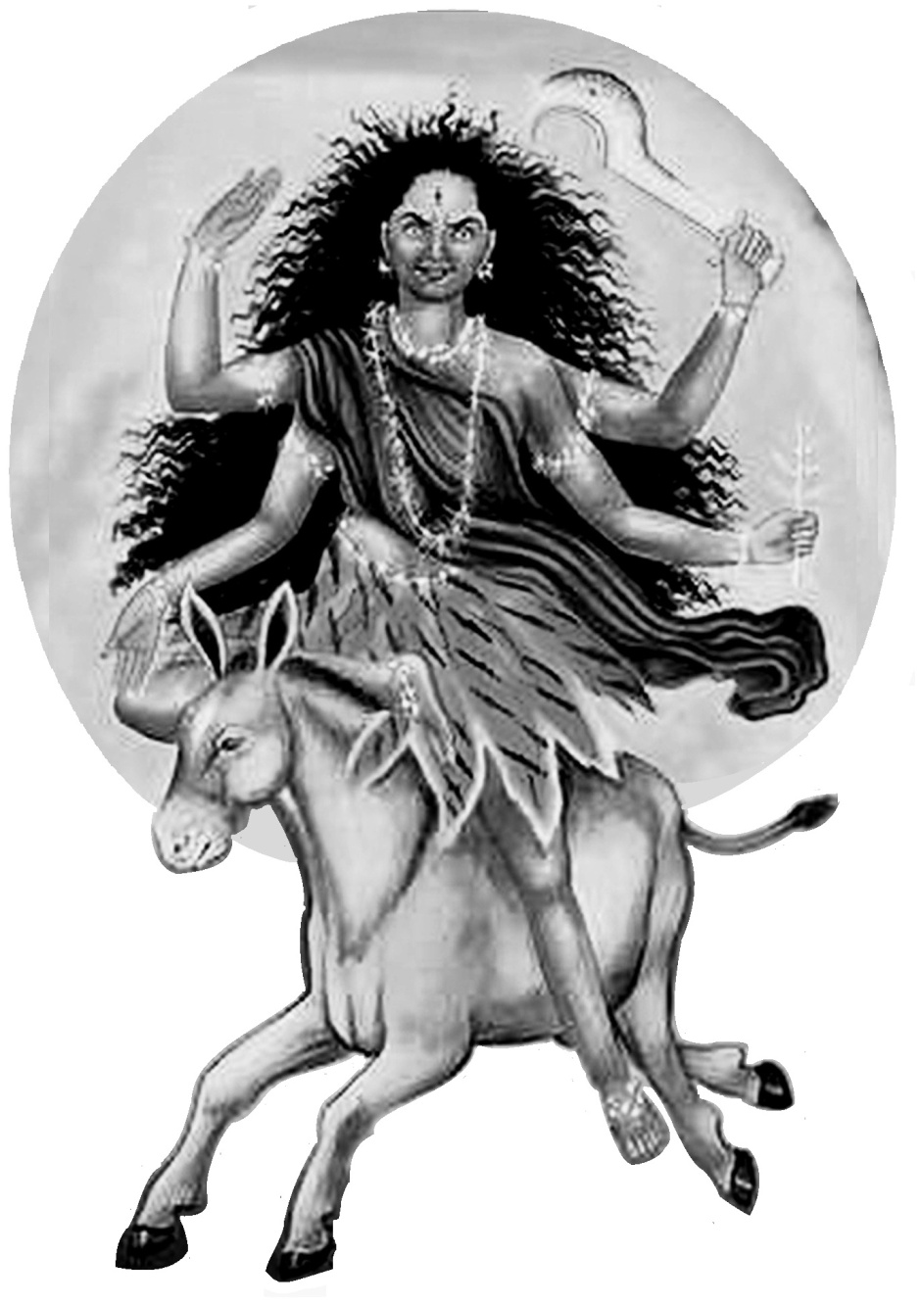
41. When praised and worshipped with flowers, incense, perfumes, etc., She bestows wealth, sons and a mind bent on righteousness and auspiciousness.

Here ends the Twelfth Chapter called ‘Eulogy of the Merits’ of Devī Māhātmyam in the Mārkaṇḍeya Purana, during the period of the Manu Savarni.

Shrī Kāla-rātri –‘Dark night of dissolution’, the aspect worshipped on the seventh night.

CHAPTER 13

The Bestowing of Boons

to King Suratha and the Merchant

The Ṛiṣhi said:
1. ‘I have now narrated to you, O King, this sublime poem on the Glory of the Devi. The Devi is endowed with such majestic power. By Her this world is upheld. Knowledge is similarly conferred by Her, the Illusive Power of Bhagavān Viṣhṇu. By Her, yourself, this merchant and other men of discrimination, are being deluded; and others were deluded in the past, and will be deluded in the future.
5. O Great King, take refuge in Her, the Supreme Īśhvarī. She indeed when worshipped bestows on men Enjoyment, Heaven and Final Release from Transmigration.’
6. Mārkaṇḍeya said to his disciple Bhaguri: ‘O Great Sage, King Suratha who had become despondent due to his excessive attachment and the deprivation of his kingdom, and the Merchant, having heard this speech, prostrated before the illustrious Ṛiṣhi of severe penances and immediately prepared to perform austerities.
9. Both the King and the Merchant, in order to obtain a vision of Ambā, stationed themselves on the sand-bank of a river and practised penances, chanting the supreme Devi-sūktam -‘Hymn to the Devi’.
10. Having made an earthen image of the Devi on the sands of the river, they both worshipped Her with flowers, incense, fire and libation of water.
11. Now abstaining from food, and now restraining in their food, with their minds on Her and with concentration, they both offered sacrifices sprinkled with blood drawn from their own bodies.
12. When they, with controlled minds, propitiated Her thus for three years, Chandikā, the Upholder of the World, was well pleased and spoke to them in visible form.

Devi Māhātmyam – Chapter 13
13. The Devi said: ‘What you solicit, O King, and you, O family’s pride, receive all that from Me. Well-pleased, I bestow those to you both.’
16. Mārkaṇḍeya said: ‘Then the King chose a kingdom, imperishable even in another life and in this life itself, his own kingdom wherein the power of his enemies is destroyed by force.
18. Then the Wise Merchant also, whose mind was full of dispassion for the world, chose the knowledge which removes attachments in the form of ‘mine’ and ‘I’.
19. The Devi said: ‘O King, after slaying your foes in a few days, you shall obtain your own kingdom and it shall last with you there.
22. And, when you are dead, you shall gain another birth from the Deva Vivasvat Sun, and shall be a Manu –‘law-giver’ on Earth by name Savarni.
24. O Best of Merchants, I grant you the boon which you have desired of me. Supreme Knowledge shall be yours, for your Self-realization’.
26. Mārkaṇḍeya said: ‘Having thus granted them both the desired boons, the Devi disappeared forthwith, as they were extolling Her with devotion.
28. Having thus gained the boon from the Devi, Suratha, the foremost of Kshatriyas, shall obtain a new birth through Sūrya and of his wife Savarna, and shall be the Manu eighth named Savarni, shall be the Manu named Savarni.

Here ends the Thirteenth Chapter called ‘The Bestowing of Boons to Suratha and the Vaisya’ of Devī Māhātmyam in the Mārkaṇḍeya Purana, during the period of the Manu Savarni.

Here ends the Devī Māhātmyam of 700 Mantras.

OM TAT SAT OM
‘Om, the Supreme Consciousness is alone the Truth of this Universe’

Notes on the Devī Māhātmyam

Chapter 1. Madhu and Kaitabha.
The Demons Madhu and Kaitabha represent the Left and Right Side delusions. Madhu –‘Honey, sweetness, liquor, springtime’ represents the pleasures of the senses, the Left Side delusion, and Kaitabha –‘Buzzing insect’ represents the incessant activity of the mind and the intellect, the Right Side delusion that ‘we are doing it’. For our ascent and to keep us in the Central Channel Śhrī Viṣhṇu destroys these demons.

Chapters 2-4. The Story of Mahiṣhāsura –‘The Buffalo Demon’.
Mahiṣha is a ‘buffalo’ as well as ‘great, powerful’; Asura is a ‘Demon’. His father Rambha performed Tapas –‘Austerity’ to Śhrī Agni –‘God of Fire’ to get a mighty son who would conquer the Three Worlds (Earth, Sky and Heaven). Mahiṣhāsura was born of a she-buffalo and had a boon that he could only be killed by a woman, which is why the Gods manifested a female form with all their powers (Chapter 2). Mahiṣhāsura represents the animalistic nature within us and the lust for wealth and power that evil-natured people have.

Names for the Gods and Demons
The demons are known by several names in this poem. Often they are referred to as ‘The Enemies of the Devas’ as well as Asuras, Daityas, Dānavas and Danujas.
Aditi, Diti and Danu were sisters all married to Sage Kashyapa – a ‘mind-born’ son of Śhrī Brahmā. Aditi’s 12 children were the Ādityas –‘Descendents of Aditi’ who are the main Devas -‘Gods, resplendent, Divine’, also called Suras -‘Shining’ and Amaras –‘Immortals’. The list varies but includes: Varuna, Mitra, Aryama, Bhaga, Amshuman, Dhata, Indra, Parjanya, Savitr, Tvashtha, Surya, Vishnu, Pushan, Vivasvan.

Diti and Danu gave birth to the Demons. Diti’s children are the Daityas –‘Descendents of Diti’ and Danu’s 100 sons are known as the Dānavas or Danujas –‘Descendents of Danu’. The Dānavas, Daityas and other demons are known as Asuras-‘Demons, opposed to the Gods, not shining.’ Although evil-minded, the Demons are mighty and courageous warriors.

Metres – Shakr’ādya Stuti
Three of the four hymns in the Devī Māhātmyam are in Anushtubh Metre – an easy flowing rhythm – but the Shakrādya Stuti in Chapter 4 is in a more complex metre with verses of 4 x 14 syllable lines sung in 12-time.
1 2 3 4, 1 2 3 4, 1 2 3
Dā di di dā di di dā di di dā di di dā dā
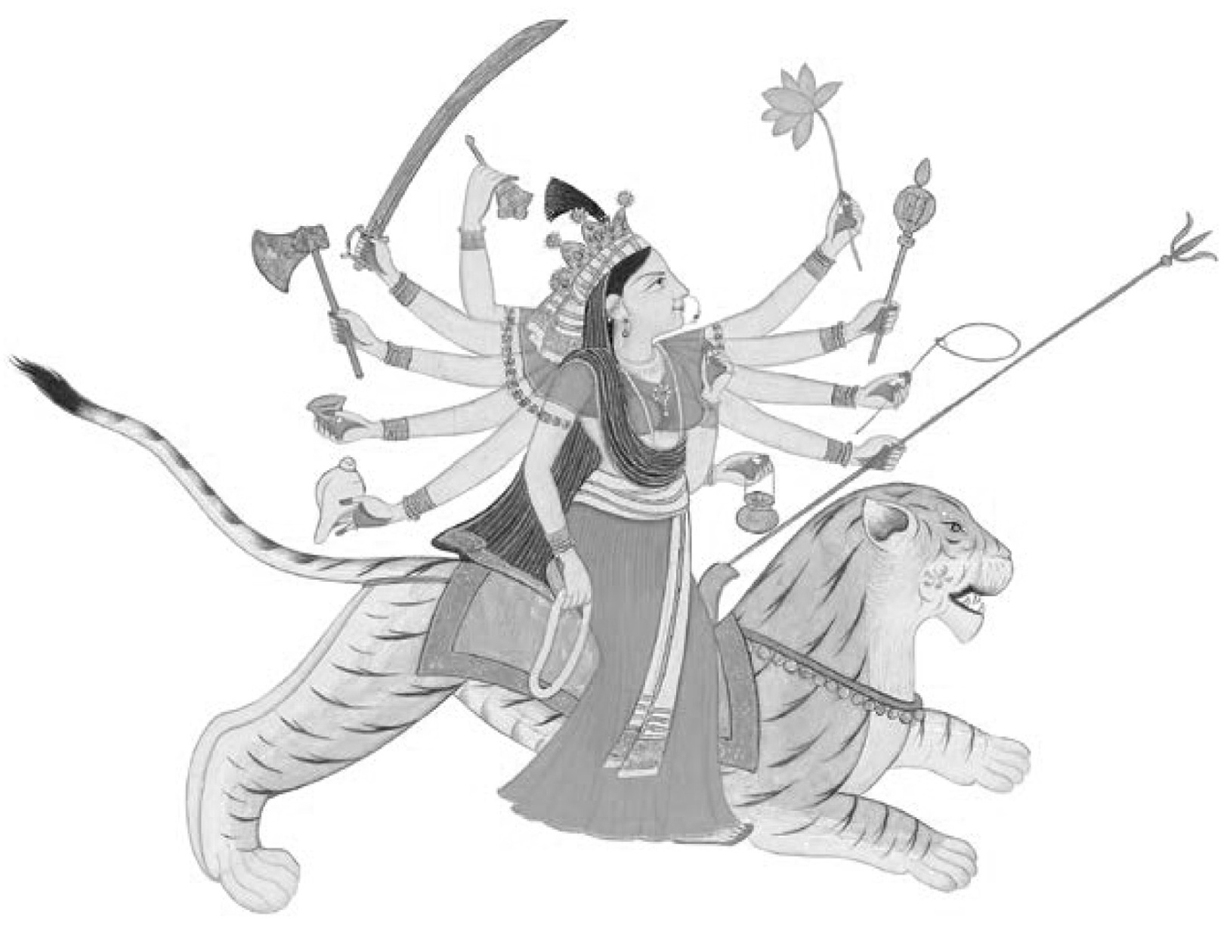
The stress (2 beats) at the end of the line is alternately on the penultimate and last syllable. There are several different tunes/versions available on the internet.

Rig-ved’oktam Devī-sūktam
Auspicious Praise of the Goddess from the Rig Veda

Ahaṁ rudrebhir vasubhiśh charāmy’aham
ādityair uta viśhva-devaiḥ,
Ahaṁ mitrā varūṇ’obhā bibharmy’aham
indr‛āgnī aham aśhvin’obhā. ǁ 1 ǁ
I move as the Gods of disease and disaster, and as those who bless,
I am with the Adityas and all the Deities, supporting both Mitra,
Lord of Earth and Varuṇa, Lord of the Ocean, I am Indra, King of the Gods,
Agni, the Lord of Fire, and the Divine Physician Twins.

Aham Somam-āhanasam bibharmy’aham
Twaṣhṭāram uta Pūṣhaṇam Bhagam,
Aham dadhāmi draviṇam haviṣhmate
suprāvye yajamānāya sunvate. ǁ 2 ǁ
I maintain the pressed-out Soma juice, I direct the Divine Builder, and govern
Pūshan and Bhaga, the Gods of Wealth; I support the well-being of those
who offer oblations attentively and worship righteously.

Aham rāṣhṭrī saṁ-gamanī vasūnām
chikituṣhī prathamā yagñyiyānām,
Tāṁ Mā devā vyadadhuḥ purutrā
bhūri-sthātrāṁ bhūry’āveśhayantīm. ǁ 3 ǁ
I am the Empress of all the Gods, known as the foremost of those to be
worshipped, I am omnipresent, as the Gods, and pervading everywhere,
in every way, at all times.

Mayā so annamatti yo vipaśhyati yaḥ prāṇiti ya ī śhṛiṇ’otyuktam,
Amantavo māṁ ta upakśhiyanti śhrudhi śhruta
śhraddhivaṁ te vadāmi. ǁ 4 ǁ
Through me alone all mortals hear and see, breathe and speak, not knowing
That they abide in Me. Listen as I reveal the truth to you.

Rig-ved’oktam Devi-suktam
Aham-eva swayam-idaṁ vadāmi juṣhṭam
devebhir-uta mānuṣhebhiḥ,
Yaṁ kāmaye-taṁ tam-ugraṁ kṛiṇomi
taṁ-brahmāṇaṁ tam-ṛiṣhiṁ taṁ-sumedhām. ǁ 5 ǁ
Lovingly I care for Gods and men who seek the Self,
Fiercely I destroy lustful people, whether Brahmins, Seers or Scholars

Aham rudrāya dhanurā tanomi
brahma-dviṣhe śharave hantavā u,
Aham janāya samadaṁ kṛiṇomy’ahaṁ
dyāvā-pṛithivī ā viveśha. ǁ 6 ǁ
I draw back the bow for the Lord who destroys evil, so his arrow strikes
the hater of God. I stir up fervour in people;
throughout Heaven and Earth I extend.

Aham suve pitaramasya mūrdhan-mama
yonir-apsvantaḥ samudre,
Tato vi tiṣhṭhe bhuvan’ānu viśhv’otāmaṁ dyāṁ
varṣhmaṇ’opa spṛiśhāmi. ǁ 7 ǁ
I am all from the Father in the Highest Heaven on my head, to the life-yielding
Water of the Oceans. Therefore I pervade this Universe and everything in it
While yet remaining beyond.

Aham-eva vāta ida pravāmy’ārabha-māṇā bhuvanāni viśḥvā,
Paro divā para enā pṛithivyai tāvatī mahinā saṁ babhūva. ǁ 8 ǁ
It is I indeed who like the wind, blow life into this Universe,
Still remaining far above this world in My Divine Splendour.

This praise is recited after the Devī Māhātmyam. Parts of this praise will seem familiar as they also appear in the Devi Atharva Sheersha. (v.1,2,3,7)

Śhrī Lalitā Sahasra-nāma Stotram
‘The Thousand Names of Shri Lalitā’
From the Brahmānda Purāṇa

Om Śhrī Gaṇeśhāya namaḥ
‘Salutations to the Remover of Obstacles’

Om
Śhrī-mātā Śhrī-mahā-rājñī, Śhrīmat-siṁh‛āsan‛eśhvarī,
Chid-agni-kuṇḍa-sambhūtā, Deva-kārya-samudyatā. (1)

Om, Sacred Mother, Great Empress, Supreme Goddess of the Lion-throne;
Born out of the sacred fire-pit of consciousness, You emerge for a Divine purpose.

Udyad-bhānu-sahasrābhā, Chatur-bāhu-samanvitā,
Rāga-swarūpa-paśh‛āḍhyā, Krodh‛ākār‛ānkuśh‛ojjvalā. (2)

Shining like a thousand rising suns, You are endowed with four arms;
Holding a noose as the form of passions, blazing with a goad as the form of anger.

Mano-rūp‛ekshu-kodaṇḍā, Paṇcha-tanmātra-sāyakā,
Nij’āruṇa-prabhā-pūra- majjad-brahmāṇḍa-maṇḍalā. (3)

Wielding a sugar-cane bow in the form of mind, and the five elements as arrows;
You fill the whole Universe with Your own rose-tinted brilliance.

Champak‛āśhoka-punnāga- saugandhika-lasat-kachā,
Kuruvinda-maṇi-śhreṇī- kanat-koṭīra-maṇḍitā. [14] (4)

Your Hair has a Beautiful Fragrance of Champaka, Ashoka and Punnaga Flowers;
And You are adorned with a Crown of the Finest Rubies.

Aṣhṭamī-chandra-vibhrāja- dalika-sthala-śhobhitā,
Mukha-chandra-kalañkābha- mŗiga-nābhi-viśheṣhakā. (5)

Your Forehead is resplendent like the Half-moon on the Eighth Day;
With Your Musk Tilak as a dark spot on the face of the moon.

Śhrī Lalitā Sahasra-nāma
Vadana-smara-māñgalya- gŗiha-toraṇa-chillikā,
Vaktra-lakshmi-parīvāha- chalan-mīn’ābha-lochanā. (6)
The Eyebrows in Your smiling face are the arches to the wedding palace of Cupid;
And Your eyes are like darting fishes in the ocean of beauty of Your face.

Nava-champaka-puṣhpābha- nāsā-ḍaṇḍa-virājitā,
Tārā-kānti-tiras-kāri- nāsā-bharaṇa-bhāsurā. [20] (7)
Your Nose is like a newly opened Champaka blossom;
And the Brilliance of Your Diamond Nose-ring puts the Stars to shame.

Kadamba-mañjari-klŗipta- karṇa-pūra-manoharā,
Tāṭanka-yugalī-bhūta- tapan-oḍupa-maṇḍalā. (8)
The Adornment of Kadamba flowers all around Your ears makes You fascinating;
With the Orbs of the Sun and Moon as Your Ear-rings.
Chorus: (after every eighth verse if sung to the tune of ‘Tere Hi Guna Gate Hai’)
Sākṣhāt Śhrī Ādi Śhakti Mātājī Incarnated as our Holy Mother Shri Mātājī
Śhrī Nirmalā Devyai namo namaḥ (x2) Salutations to You for ever.

Padma-rāga-śhil‛ādarśha- pari-bhāvi-kapola-bhūḥ,
Nava-vidruma-bimba-śhrī- nyak-kāri-radanach-chhadā. (9)
Your Cheeks surpass the Beauty of Mirrors made of Rubies;
And Your Delicate Lips humble the shining beauty of fresh coral or Bimba fruit.

Śhuddha-vidy‛ānkur-ākāra- dvija-pankti-dvay‛ojjvalā,
Karpūra-vītikā-moda- samākarṣhi-digantarā. (10)
Your Shining Teeth are two rows of sprouts of the Pure Knowledge;
The Betel leaves and camphor that You chew, make the whole Universe fragrant.

Nija-sallāpa-mādhurya- vinir-bhatsita-kachchhapī,
Manda-smita-prabhā-pūra- majjat-kāmesa-mānasā. [28] (11)
The Melody of Your Voice puts to shame the Veena of Shri Saraswati;
And into the stream of Your Entrancing Smile the Mind of Shri Siva is drowned.

Śhrī Lalitā Sahasra-nāma
Anākalita-sādŗiśhya- chibuka-śhrī-virājitā,
Kāmeśha-baddha-māñgalya- sūtra-śhobhita-kandharā. (12)
Your Chin is a splendid adornment which has no comparison;
And beautifying Your Neck is the Mangala-sutra tied by Shri Shiva Himself.

Kanak’āngada-keyūra- kamanīya-bhujānvitā,
Ratna-graiveya-chintāka- lola-muktā-phal’ānvitā. (13)
Around Your lovely arms are various bangles and ornaments of gold;
And gem-encrusted pendants and pearl necklaces encircle Your neck.

Kāmeśhwara-prema-ratna- maṇī-prati-paṇa-stanī,
Nābhy-ālavāla-romāli- latā-phala-kucha-dvayī. (14)
Your Breasts are an expression of the Precious Jewel of the Love of Shri Shiva,
And hang like fruits on the creeper-like line of hair rising from Your navel.

Lakshya-roma-latādhāra- tā-samunneya-madhyamā,
Stana-bhāra-dalan-madhya- paṭṭa-bandha-vali-trayā. [36] (15)
Your Waist is so slender it can be adjudged only from the line of hair,
The Three Folds on Your stomach form a support for the weight of Your breasts.

Aruṇ‛āruṇa-kausumbha- vastra-bhāswat-kaṭī-taṭī,
Ratna-kinkiṇikā-ramya- raśhanā-dāma-bhūṣhitā. (16)
Your Hips are resplendent in a Sari as red as the Sun,
With a Golden Belt decorated with Tiny Bells.
Chorus:
Kāmeśha-gñyāta-saubhāgya- mārda-voru-dvay‛ānvitā,
Māṇikya-mukuṭ‛ākāra- jānu-dvaya-virājitā. (17)
The Beauty and Smoothness of Your thighs is known only to Lord Shiva,
And Your Two Knees are like Crowns of Precious Jewels.

Indra-gopa-parikshipta- smara-tūṇābha-jañghikā,
Gūḍha-gulphā Kūrma-pŗiṣhtha- jayiṣhṇu-prapad‛ānvitā. (18)
Your Calves are the Quivers of the God of Love covered with sparkling jewels,
With Hidden Ankles, and Fore-feet shaped like tortoise-shells.

Śhrī Lalitā Sahasra-nāma
Nakha-dīdhiti-samchhanna- namaj-jana-tamo-guṇā,
Pada-dvaya-prabhājāla- parākŗita-saroruhā. [45] (19)
The Brilliance of Your Toenails dispels the darkness of Tamo Guna of those
who bow to You; And Your Holy Feet defeat the Lotus in Radiant Beauty.

Siñjāna-maṇi-mañjīra- maṇḍita Śhrī-pad‛āmbujā,
Marālī-manda-gamanā, Mahā-lāvaṇya-śhevadhiḥ. (20)
Your Sacred Lotus-Feet are adorned with jingling anklets,
And Your Gait is graceful like a swan, O Great Treasure-house of Beauty.

Sarv‛āruṇ‛ānavady‛āñgī, Sarv‛ābharaṇa-bhūṣhitā,
Śhiva-kāmeśhwar‛āñkasthā, Śhivā Swādhīna-vallabhā. (21)
Wholly rosy, Your body is faultlessly beautiful, adorned with every ornament;
Seated on the thigh of Lord Shiva, You are His Other Half,
and He is completely Your own.

Sumeru-madhya-sŗiñgha-sthā, Śhrīman-nagara-nāyikā,
Chintāmaṇi-gŗuhānta-sthā, Pañcha-brahm‛āsana-sthitā. (22)
Residing on the Middle Peak of Mount Meru, You are Queen of the Auspicious City,
Occupying the Mansion of Wish-fulfilling Gems,
on a Couch of the Five Aspects of God.

Mahā-padmāṭavi-samsthā, Kadamba-vana-vāsinī,
Sudhā-sāgara-madhya-sthā, Kām‛ākshī Kāma-dāyinī. [63] (23)
You dwell in the Great Lotus Grove, residing in the Forest of Kadamba trees,
Standing amidst the Ocean of Nectar, You are the Lovely-eyed,
Fulfiller of all desires.

Devarṣhi-gaṇa-sañghāta- stūyamān-ātma-vaibhavā,
Bhaṇḍāsura-vadh‛odyukta- śhakti-senā-sam-anvitā. (24)
Your Greatness is extolled by the assembly of Gods and Sages,
As You emerge with an army of Shaktis to destroy Bhandāsura.

Śhrī Lalitā Sahasra-nāma
Sampat-karī-sam-ārūḍha- sindhura-vraja-sevitā,
Aśhwārūḍh‛ādhi-ṣhṭhit‛āswa- koṭi-koṭibhi-rāvŗitā. (25)
Followed by a herd of elephants (sense impressions) controlled by Sampat-kari,
And crores and crores of horses (sense objects) led by Aśhva-rudha.

Chakra-rāja-rath‛ārūḍha- sarv‛āyudha-pariśh-kŗitā,
Geya-chakra-rath‛ārūḍha- mantriṇī-pari-sevitā. (26)
You are mounted on the Chakra-rāja chariot brandishing all kinds of weapons,
And followed by Shri Mantrinī on the Geya-chakra chariot.

Kiri-chakra-rath‛ārūḍha- daṇḍa-nāthā-puraskŗitā,
Jvālā-mālini-kākshipta- vahni-prākāra-madhya-gā. [71] (27)
Ahead rides Danda-nātha mounted on the Kiri-chakra chariot,
And you are surrounded by a fortress of fire created by Jvālā-mālinī.

Bhaṇḍa-sainyā-vadh‛od-yukta- śhaktī-vikrama-harṣhitā,
Nityā-par‛ākram‛āṭopa- nirīkshaṇa-sam-utsukā. (28)
You are Joyful at the sight of the Shaktis about to destroy the army of Bhandāsura, And You rejoice at the Valour of the Nityā Goddesses.

Bhaṇḍa-putra-vadh‛od-yukta- Bālā-vikrama-nanditā,
Mantriṇy‛ambā-virachita- viṣhāñga-vadha-toṣhitā. (29)
You are Pleased with the Courage of Shri Bālā in killing the sons of Bhanda,
And Mother Mantrinī’s destruction of Vishānga (hatred) gives you satisfaction.

Viśhukra-prāṇa-haraṇa- vārāhī-vīrya-nanditā,
Kāmeśhwara-mukhāloka- kalpita-śhrī-gaṇeśhvarā. (30)
Brave Vārāhī’s taking the life of Vishukra (impurity) gives You joy,
O You who created Shri Ganesha by a mere glance at the face of Shri Sadāshiva.

Mahā-gaṇeśha-nirbhinna- vighna-yantra-praharṣhitā,
Bhaṇd‛āsurendra-nirmukta- śhastra-praty‛astra-varṣhiṇī. (31)
You are overjoyed at Shri Ganesha’s breaking of the obstacle-creating Yantra,
And You rain weapons on the demon-king Bhanda as he releases his missiles.

Śhrī Lalitā Sahasra-nāma
Kar‛āñguli-nakh‛otpanna- nārāyaṇa-daśh‛ākŗitiḥ,
Mahā-pāśhupat‛āstrāgni- nirdagdh‛āsura-sainikā. (32)
From Your fingernails spring forth the ten incarnations of Shri Vishnu,
And the fire of Your Mahā-pashupata missile destroys the army of demons.
3

Kāmeśhvar‛āstra-nirdagdha- sa-bhaṇḍāsura-śhūnyakā,
Brahm‛opendra-mahendr‛ādi- deva-samstuta-vaibhavā. (33)
Destroying Bhandāsura and his city Shūnyakā with Your Kāmeshwara missile,
Your glory is praised by Shri Brahmā, Vishnu, Shiva and the other Gods.

Hara-netr‛āgni-sam-dagdha- kāma-samjīvan-auṣhadhiḥ,
Śhrīmad-vāg-bhava-kūtaika- swarūpa-mukha-pañkajā. (34)
You are the medicine that gave back life to the God of Love when He was
destroyed by the fire from the eyes of Shri Shiva, Your Lotus Face is first part
of the 15-syllabled Mantra as the source of speech.

Kaṇṭh‛ādhaḥ-kaṭi-paryanta- madhya-kūṭa-swarūpiṇī,
Śhakti-kūtaika-tāpanna- kaṭyadho-bhāga-dhariṇī. [87] (35)
From neck to waist You form the Middle part of the 15-syllabled mantra.
And below the waist, the third creative portion of the 15-syllabled mantra.

Mūla-mantr‛ātmikā Mūla- kūṭa-traya-kalebarā,
Kul‛āmŗit‛aika-rasika, Kula-sañketa-pālinī. (36)
You are the Soul of the Root Mantra, Your Body being the Three Portions of
the Root Mantra; You relish the nectar of the Kula, ie. the Six Chakras
below Sahasrara, and You protect their boundaries.

Kul‛āñganā Kul‛ānta-sthā, Kaulinī Kula-yoginī,
Akulā Samay‛ānta-sthā, Samay‛āchāra-tatparā. (37)
O Chaste Lady, residing in the Sacrum bone, whose creation is the chakras,
who knows all the secret techniques of the path to Self-realisation; You are beyond all categories and reside in the Sahasrara, and are to be found through
inner worship. You are devoted to those who worship You internally.

Śhrī Lalitā Sahasra-nāma
Mūlādhār‛aika-nilayā Brahma-granthi-vibhedinī,
Maṇipur‛āntar-uditā Viṣhṇu-granthi-vibhedinī. (38)
Residing first in the Mūlādhāra, You break the knot of Brahma (below the Nābhī)
After rising inside the Nābhi, You break the knot of Vishnu (below the Heart).

Agñyā-chakr‛āntarala-sthā, Rudra-granthi-vibhedinī,
Sahasrār‛āmbuj‛ārūḍhā, Sudhā-sār‛ābhi-varṣhiṇī. [106] (39)
After establishing at Agñyā Chakra, You break the knot of Rudra (Shri Shiva)
Ascending on the thousand-petalled lotus, You rain a shower of Divine Nectar.

Taḍillata-sama-ruchiḥ, ṣhat-chakr‛opari-samsthitā,
Mahā-śhaktiḥ Kuṇḍalinī, Bisa-tantu-tanīyasī. (40)
As brilliant as lightning, You remain stationed above the six chakras,
The great energy, coiled and resting in the Sacrum bone, as slender as a lotus stalk.

Bhavānī Bhāvan‛āgamyā, Bhav‛āraṇya-kuṭhārikā,
Bhadra-priyā Bhadra-mūrtir Bhaktā-saubhāgya-dāyinī. (41)
The Life of the Universe, approached through contemplation, You cut
down the forest of rebirths; Fond of the auspicious, of auspicious form,
You give all good qualities to Your devotees.

Bhakti-priyā Bhakti-gamyā, Bhakti-vaśhyā Bhay‛āpahā,
Śhāmbhavī Śhārad‛ārādhyā, Śharvaṇī Śharma-dāyinī. (42)
Fond of devotion, attained through devotion, obedient to the demands of devotees, completely removing their fear; Compassionate Wife of Shri Shiva, worshipped by Shri Saraswati, You are the Shakti of Shri Shiva, who confers happiness.

Śham-karī Śhrī-karī Sādhvī, Śharach-chandra-nibh’ānanā,
Śhāt-odarī Śhānti-matī, Nir-ādhārā Nir-añjanā. [133] (43)
Creator of auspiciousness, maker of holiness and splendour, most virtuous and chaste, Your face is radiant like the autumn moon; Slender-waisted,
whose nature is peace, You are unsupported, and unstained by any blemish.

Śhrī Lalitā Sahasra-nāma
Nirlepā Nirmalā Nityā, Nir-ākārā Nir-ākulā,
Nirguṇā Niṣhkalā Śhāntā, Niṣhkāmā Nir-upaplavā. (44)
Without impurity, immaculate and eternal, without form, ever calm and steady; Beyond attributes, indivisible, and ever peaceful, desireless, and indestructible.

Nitya-muktā Nir-vikarā, Niṣh-prapañchā Nir-āśhrayā,
Nitya-śhuddhā Nitya-buddhā, Nir-avadyā Nir-antarā. (45)
Ever free, changeless, beyond the material world, without any basis or shelter;
Eternally pure, ever awakened, beyond any blame, and undifferentiated.

Niṣh-kāraṇā Niṣh-kalañkā, Nir-upādhir Nir-īswarā,
Nīrāgā Rāga-mathanī, Nirmadā Mada-nāśhinī. (46)
You exist without any previous cause, faultlessly Brilliant, Absolute, and Supreme;
Free from passion, You crush the passions; unintoxicated, You destroy intoxication.

Nischintā Nir-ahamkarā, Nir-mohā Moha-nāśhinī,
Nirmamā Mamatā-hantrī, Niṣhpāpā Pāpa-nāśhinī. [167] (47)
Being beyond thought, You have no ego; being without illusion, You destroy illusions; Having no selfishness, You destroy selfishness;
being Sinless, You destroy wickedness.

Niṣh-krodhā Krodha-śhamanī, Nir-lobhā Lobha-nāśhinī,
Niḥ-samśhayā Samśhaya-ghnī, Nir-bhavā Bhava-nāśhinī. (48)
Being without anger, You neutralise anger; being without avarice, You destroy greed,
Being without doubt, You remove doubt;
being unborn, You destroy the cycle of births.

Nir-vikalpā Nir-ābādhā, Nirbhedā Bheda-nāśhinī,
Nir-nāśhā Mŗityu-mathanī, Niṣhkriyā Niṣh-parigrahā. (49)
Free of mental activity, undisturbed; beyond duality, You destroy dualism;
Indestructible, You eradicate death; beyond action, You have no support or property.

Śhrī Lalitā Sahasra-nāma
Nistulā Nīla-chikurā, Nirapāyā Niratyayā,
Dur-labhā Dur-gamā Durgā, Duḥkha-hantrī Sukha-pradā. (50)
Incomparable Goddess, black-haired; who cannot be harmed, or ever transgress;
Hard to attain, hard to reach, You are the Goddess who protects us from all evil,
removing sorrows, and granting happiness.

Duṣhṭa-dūrā Dur-āchāra- śhamanī Doṣha-varjitā,
Sarva-gñyā Sāndra-karuṇā, Sam’ānādhika-varjitā. [198] (51)
Unattainable by the unrighteous, You annul wrong deeds, being free of faults;
All-knowing, and intensely compassionate, You have none to equal You.

Sarva-śhakti-mayī Sarva- māñgalā Sad-gati-pradā,
Sarveśhwarī Sarva-mayī, Sarva-mantra-swarūpiṇī. (52)
All power and energy are You, all auspiciousness, and our guide to the right path;
Supreme Ruler of everything, everything is in You, and all mantras are Your forms.

37
Sarva-yantr’ātmikā Sarva- tantra-rūpā Manon-manī,
Maheśhwarī Mahādevī, Mahā-lakshmī Mŗiḍa-priyā. (53)
You are the Essence of all Yantras, the Subject of all sacred treatises,
and You uplift the mind; The Great Goddess, Shakti of Shri Sadashiva,
the Power of Shri Vishnu, the Beloved of Shri Shiva.

Mahā-rūpā Mahā-pūjyā, Mahā-pātaka-nāśhinī,
Mahā-māyā Mahā-sattwā, Mahā-śhaktir Mahā-ratiḥ. (54)
You are the Mightiest Form, the Highest Object of worship, and You destroy the greatest of sins; You are the Great Illusory Power, as well as the Highest Reality;
You are the Supreme Energy, and the Greatest Bliss.

Mahā-bhogā Mahaiswaryā, Mahā-viryā Mahā-balā, [222]
Mahā-buddhir Mahā-siddhir, Mahā-yogeśhwar’eśhwarī. (55)
You are the Highest Enjoyment, the Supreme Ruler, of great courage, and great strength; The Greatest Wisdom and the Highest Attainment, the Goddess of the greatest of yogis.

Śhrī Lalitā Sahasra-nāma
Mahā-tantrā Mahā-mantrā, Mahā-yantrā Mahāsanā,
Mahā-yaga-kram-ārādhyā, Mahā-bhairava-pūjitā. (56)
The Highest Technique, the Greatest Mantra, the Most Powerful Yantra,
and the Highest Throne; You are the Object of the highest ceremonies,
and are worshipped by the eternal form of Lord Shiva.

Maheśhvara-mahā-kalpa- mahā-tāṇḍava-sākshiṇī,
Mahā-kāmeśha-mahiṣhī, Mahā-tripura-sundarī. (57)
You witness the mighty dance of Lord Shiva at the end of the great cycle of time;
Queen of Shri Shiva, You are the Great Empress of the three worlds.

Chatuḥ-ṣhaṣhṭy‛upa-chārāḍhyā, Chatuḥ-ṣhaṣhṭi-kalā-mayī,
Mahā-chatuḥ-ṣhaṣhti-koti- yoginī-gaṇa-sevitā. (58)
Worshipped with the sixty-four offerings, You are the essence of the sixty-four arts;
And are the Great One served by sixty-four crores of yoginīs.

Manu-vidyā Chandra-vidyā, Chandra-maṇḍala-madhya-gā,
Chāru-rūpā Chāru-hāsā, Chāru-chandra-kalā-dharā. [243] (59)
You are the lore of mantras, the knowledge of the Chandra, and stand at the
centre of the orb of the moon (Sahasrara); Of beautiful form, with a beautiful
smile, You wear the moon in its beautiful crescent phase.

Char‛āchara-jagan-nāthā, Chakra-rāja-niketanā,
Pārvatī Padma-nayanā, Padma-rāga-sama-prabhā. (60)
Mistress of all that moves or moves not, dwelling in the king of chakras (Sahasrara);
Daughter of the Mountain, lotus-eyed, You gleam like ‘lotus of love’ rubies.

Pañcha-pret‛āsan‛āsīnā, Pañcha-brahma-swarūpiṇī,
Chin-mayī Param-ānandā, Vigñyāna-ghana-rūpiṇī. (61)
Seated on a throne of five corpses, the five forms of God are manifestations of You;
You are Consciousness, the Supreme Bliss, and Your Form is Knowledge Solidified.

Śhrī Lalitā Sahasra-nāma
Dhyāna-dhyātŗi-dhyeya-rūpā, Dharm‛ādharma-vivarjitā,
Viśhwa-rūpā Jāgariṇī, Swapantī Taijas-ātmikā. (62)
You manifest as the Meditation, the Meditator and the Object of Meditation, and
You are Free of any right or wrong conduct; The ‘Universal’ is Your form in the Waking State, and ‘Full of Light’ in the Dreaming State.

Suptā Prāgñy‛ātmikā Turyā, Sarv‛āvasthā-vivarjitā,
Sŗiṣhṭi-kartrī Brahma-rūpā, Goptrī Govinda-rūpiṇī. [267] (63)
You are ‘Wisdom’ in the Deep Sleep State, and the Fourth State of Pure Spirit;
and You are beyond all the States of Consciousness; You create this Universe,
in the Form of Shri Brahmā, and You protect it, in the Form of Shri Vishnu.

Saṁhāriṇī Rudra-rūpā, Tirodhāna-karīśhvarī,
Sadā-śhiv‛ānu-graha-dā, Pañcha-kŗitya-parāyaṇā. (64)
You destroy this World, in Your Form as Shri Shiva, withdrawing it into Yourself;
Eternal Spirit, You recreate this Universe, ever intent on the five functions of the Divine.

Bhānu-maṇḍala-madhya-sthā, Bhairavī Bhaga-mālinī,
Padmāsanā Bhagavatī, Padma-nābha-sahodarī. (65)
Occupying the Orb of the Sun, You are Shri Bahairavī, adorned with All Good Qualities; Seated on a Lotus, endowed with the Divine qualities, You are the Sister
(share the abdomen with) the Lotus-navelled Shri Vishnu.

Unmeṣha-nimiṣh‛otpanna- vipanna-bhuvan‛āvalī,
Sahasra-śhīrṣha-vadanā, Sahasr‛ākshī Sahasra-pāt. (66)
The Universe arises and disappears with the opening and closing of Your Eyes;
You have a Thousand Heads and Faces, a Thousand Eyes, and a Thousand Feet.
9

Ā-brahma-kiṭa-jananī, Varṇ‛āśhrama-vidhāyinī,
Nij‛āgñyā-rūpa-nigamā, Puṇy‛āpuṇya-phala-pradā. [288] (67)
O Mother of all from Brahmā to the smallest worm, You ordain the four castes
and four stages of life; The Vedas are Your commands, O Giver of the fruits
of auspicious or wicked acts.

Śhrī Lalitā Sahasra-nāma
Śhruti-sīmanta-sindūrī- kŗita-pādābja-dhūlikā,
Sakal‛āgama-saṁdoha- śhukti-saṁpuṭa-mauktikā. (68)
The dust from Your Lotus Feet is the red spot adorning the forehead of the scriptures;
And You are the pearl at the heart of all the sacred texts.

Puruṣh‛ārtha-pradā Pūrṇā, Bhoginī Bhuvaneśhvarī,
Ambik‛ānādi-nidhanā, Hari-brahm’endra-sevitā. (69)
Giving the four fruits of life, ever complete, you are the enjoyer of the highest bliss, and the Supreme Ruler of the Universe; O Mother, without beginning or end,
You are served by Shri Vishnu, Brahmā and Indra.

Nārāyaṇī Nāda-rūpā, Nāma-rūpa-vivarjitā,
Hrīṁ-kārī Hrīṁ-matī Hŗidyā, Heyopādeya-varjitā. (70)
Śhri Mahalakshmi, our only refuge, of the form of sound, You are free of
any name or form; You are the sacred syllable Hrīm, the epitome of modesty,
residing in the heart, neither rejecting nor accepting anything.

Rāja-rāj‛ārchitā Rājñī, Ramyā Rājīva-lochanā,
Rañjanī Ramaṇī Rasyā, Raṇat-kiṇkiṇi-mekhalā. [312] (71)
Worshipped by Shri Kubera, O Empress, beautiful, with eyes like lotuses;
Joy-giving, enchanting, the bliss to be tasted, You wear a belt of tinkling bells.

Ramā Rākendu-vadanā, Rati-rūpā Rati-priyā,
Raksh‛ākarī Rākshasa-ghnī, Rāmā Ramaṇa-lampaṭā. (72)
You are Shri Lakshmi, with a face like the full moon, pleasure is one of Your forms,
and You revived the God of Love through fondness for His wife; O Protectress,
Destroyer of demons, You are the epitome of virtuous womanhood,
desiring the company of Your husband.

Kāmyā Kāma-kalā-rūpā, Kadamba-kusuma-priyā,
Kalyāṇī Jagatī-kandā, Karuṇā-rasa-sāgarā. (73)
Pure desire leads to You, who are the spark of desire that gives rise to this creation;
Fond of Kadamba blossoms; You are everything auspicious,
the Root of the world; the Ocean of Compassion.

Śhrī Lalitā Sahasra-nāma
Kalā-vatī Kal‛ālāpā, Kāntā Kādambarī-priyā,
Varadā Vāma-nayanā, Vāruṇī-mada-vihvalā. (74)
Endowed with the sixty-four arts, and speaking sweetly, beautiful, fond of honey; Bestower of boons, lovely-eyed, You are intoxicated with the bliss of Vāruni nadi.

Viśhw‛ādhikā Veda-vedyā, Vindhy‛āchala-nivāsinī,
Vidhātrī Veda-jananī, Viṣhṇu-māyā Vilāsinī. [340] (75)
You transcend this Universe, being the sacred knowledge to be known, O Dweller
in the Vindhya mountains; As the Shakti of Shri Brahmā, You are the Mother of all sacred knowledge; as the creative power of Shri Vishnu, the Universe is Your sport.

Kshetra-swarūpā Kshetreśhī, Kshetra-kshetra-gñya-pālinī,
Kshaya-vŗiddhi-vinir-muktā, Kshetra-pāla-sam-architā. (76)
This field (body and psyche) is Your form, and You rule over it, protecting both
the field and the witnessing Spirit; Completely free of both growth or decay;
You are the One worshiped by Lord Shiva, the Protector of this life.

Vijayā Vimalā Vandyā, Vandāru-jana-vatsalā,
Vāg-vādinī Vāmakeśhī, Vahni-maṇḍala-vāsinī. (77)
You are Victorious, Immaculate, the Goddess to be saluted, loving Your
devotees as Your own children; The Source of Speech, Ruler of the Left Side,
You reside in the circle of fire.

Bhakti-mat-kalpa-latikā, Paśhu-pāśha-vimochinī,
Saṁ-hŗit-āśheṣha-pāṣhaṇḍā, Sad-āchāra-pra-vartikā. (78)
You fulfill the desires of Your devotees, and release us from the bonds
of animal nature; Destroying all disbelief in the scriptures, You teach us
the way of a good life.

Tāpa-tray’āgni-samtapta- samāhlādana-chandrikā,
Taruṇī Tāpas’ārādhyā, Tanu-madhyā Tamō‛pahā. [361] (79)
Your moon-like radiance soothes those afflicted by the three tormenting fires;
Ever young, worshipped through renunciation, of slender waist,
the Remover of darkness.

Śhrī Lalitā Sahasra-nāma
Chitis-tat-pada-lakshy‛ārthā, Chid-eka-rasa-rūpiṇī,
Swātm‛ānanda-lavī-bhūta- brahm‛ādy‛ānanda-santatiḥ. (80)
Pure Consciousness, denoted by the word ‘tat’, Your form is only consciousness;
The bliss of Brahmā and the other gods is merely a tiny speck of Your joy.

Parā Pratyak-chitī-rūpā, Paśhyantī Paradevatā,
Madhyamā Vaikharī-rūpā, Bhakta-mānasa-hamsikā. (81)
You are beginning of Speech, as the spirit within, the perceiving stage, as the
Supreme Deity; You are the middle stage of speech, and the form of utterance,
You are the swan of discrimination on the lake of the minds of devotees.

Kāmeśhvara-prāṇa-nāḍī, Kŗita-gñyā Kāma-pūjitā,
Śhŗiñgāra-rasa-sampūrṇā, Jayā Jālan-dhara-sthitā. (82)
You are the channel of life energy for Shri Shiva, the Knower of all deeds,
worshipped at the holy city of Kāmarūpa; Full of the highest bliss, You are the
victorious Goddess, whose place is Jālandhara, the water-bearer.

Oḍyāṇa-pīṭha-nilayā, Bindu-maṇḍala-vāsinī,
Rahoyāga-kram‛ārādhyā, Rahas-tarpaṇa-tarpitā. [382] (83)
You reside at the holy seat of Odyana, and in the circle of Bindu at the centre
of the Shri Chakra; You are worshipped by secret (inner) ceremonies,
and are pleased by inner surrendering.

Sadyah-prasādinī Vīśhva- sākshiṇī Sākshi-varjitā,
Ṣhaḍ-añga-devatā-yuktā, Ṣhāḍ-guṇya-pari-pūritā. (84)
You bestow grace easily, O Witness of the Universe, whom none can witness;
Accompanied by the deities of the six limbs, You are full of the six divine attributes.

Nitya-klinnā Nir-upamā, Nirvāṇa-sukha-dāyinī,
Nityā-ṣhoḍaśhikā-rūpā, Śhrī-kaṇṭh‛ārdha-śharīriṇī. (85)
Eternally compassionate, without equal, You grant the bliss of liberation;
The sixteen Nitya Goddesses are Your forms, You are the half-body of Lord Shiva.

Śhrī Lalitā Sahasra-nāma
Prabhāvatī Prabhā-rūpā, Prasiddhā Parameśhvarī,
Mūla-prakŗitir-avyaktā, Vyakt‛āvyakta-swarūpiṇī. (86)
Full of light, as light is Your form, You are the Established, Supreme Ruler
of the Universe; You are the Kundalini Shakti, imperceptible,
both the manifest and the unmanifest are Your forms.

Vyāpinī Vividh-ākārā, Vidy‛āvidyā-swarūpiṇī,
Mahākāmeśha-nayana- kumud‛āhlāda-kaumudī. [403] (87)
All-pervading, of manifold forms, You manifest as true knowledge and false;
Shri Shiva’s eyes blossom at the sight of You like lotuses under the full moon.

Bhakta-hārda-tamo-bheda- bhānu-mad-bhānu-saṇtatih,
Śhiva-dūtī Śhiv‛ārādhyā, Śhiva-mūrtiḥ Śhivam-karī. (88)
You are the radiance of the Sun dispelling the darkness in the hearts of devotees;
Lord Shiva is Your messenger, He worships You, He is an embodiment of You,
O Creator of all auspiciousness.

Śhiva-priyā Śhiva-parā, Śhiṣhteṣhtā Śhiṣhta-pūjitā,
Aprameyā Swa-prakāśhā, Mano-vāchām-agocharā. (89)
Beloved of Lord Shiva, who is beyond Shri Shiva, O Highest Wisdom, worshipped
by the wise; Immeasurable, Self-luminous, beyond the reach of mind and speech.

Chit-śhaktiśh Chetana-rūpā, Jaḍa-śhaktir Jaḍ‛ātmikā,
Gāyatrī Vyāhŗitiḥ Sandhyā, Dvija-vŗinda-niṣhevitā. (90)
You are the Power of Consciousness, thought is Your form, You are the Power of the Universe and the Essence of Creation; You are the sacred Gayatri mantra, the utterance thereof, and the dusk when it is to be said,
accompanied by the worship of the twice-born Men of God.

Tattw‛āsanā Tat Twam Ayī, Pañcha-koṣh‛āntara-sthitā,
Niḥ-sīma-mahimā Nitya- yauvanā Mada-śhālinī. [431] (91)
You are seated in the principles, being the Brahman, the Śhakti, and the manifestation, standing within the five sheaths; Of unbounded greatness,
Eternally youthful, You are full of rapturous delight.

Śhrī Lalitā Sahasra-nāma
Mada-ghūrṇita-rakt‛ākshī, Mada-pāṭala-gaṇḍa-bhūh,
Chandana-drava-digdh‛āñgī, Chāmpeya-kusuma-priyā. (92)
Your reddened eyes are rolled in rapture, and Your cheeks are flushed with delight;
Your body is anointed with sandal paste, and You are fond of Champaka flowers.

Kuśhalā Komal‛ākārā, Kuru-kullā Kuleśhvarī,
Kula-kuṇḍālayā Kaula- mārga-tatpara-sevitā. (93)
O Skillful Goddess, of tender form, Shri Kuru-kulla, Ruler of Sushumna Nadi;
You reside in the Mūlādhār, and are served by those devoted to the Kaula path.

Kumāra-gaṇa-nāth’āmbā, Tuṣhṭiḥ Puṣhṭir-matir-dhŗitiḥ,
Śhāntiḥ Swasti-matī Kāntir, Nandinī Vighna-nāśhinī. (94)
Mother of Shri Karttikeya and Ganesha, You are Enjoyment, Nourishment,
Intelligence and Steadfastness; You are Peace, Good Fortune, Love,
O Joy-giving Destroyer of obstacles.
Tejovatī Tri-nayanā, Lolākshī-kāma-rūpiṇī,
Mālinī Hamsinī Mātā, Malay’āchala-vāsinī. [458] (95)
Bearer of light, with three eyes, O beautiful lady, all loveliness and desire personified;
Adorned with a garland, Swan-like, Mother; You reside in the Malaya mountains.

Su-mukhī Nalinī Su-bhrūḥ, Śhobhanā Sura-nāyikā,
Kāla-kaṇṭhī Kānti-matī, Kshobhiṇī Sūkshma-rūpiṇī. (96)
O Beautiful-faced, Lotus, of lovely eyebrows; beautiful, Queen of the Devas;
Wife of Shri Shiva, of all loveliness, You agitate this creation, and are of Subtle form.
Vajreśhvarī Vāma-devī, Vayō'vasthā-vivarjita,
Siddheśhvarī Siddha-vidyā, Siddha-mātā Yaśhaswinī. (97)
Mighty Goddess, beautiful Goddess, Devoid of any changes of age; Ruler of the
Self-realised, You are their Knowledge, and their Mother, of great fame and glory.

Viśhuddhi-chakra-nilaya- "rakta-varṇā Tri-lochanā,
Khaṭvāñg‛ādi-pra-haraṇā, Vadan‛aika-samanvitā. (98)
Residing at Vishuddhi chakra, You are red coloured, and three-eyed;
With a skull-topped club and other weapons, and having one face.

Śhrī Lalitā Sahasra-nāma
Pāyas‛ānna-priyā Tvak-sthā, Paśhu-loka-bhayañ-karī,
Amŗit‛ādi-mahāśhakti- samvŗitā Ḍākin‛īśhwarī. [484] (99)
Fond of food made with milk, You invest the skin, and create fear in those of
bestial nature; You are surrounded by Amruta and other great potencies
(the sixteen vowels), and are known as Goddess Dākinī.

Anāhat‛ābja-nilayā, Śhyām‛ābhā Vadana-dvayā,
Danṣhṭr‛ojjval‛āksha-māl‛ādi- dhara Rudhira-samsthitā. (100)
Dwelling in the Anāhata Lotus, You are dark-hued and brilliant, with two faces;
Of gleaming tusks, adorned with a garland of letters, You invest the blood.

Kāla-rātry‛ādi-śhakty‛augha- vŗitā Snigdh‛audana-priyā,
Mahā-vīrendra-varadā, Rākiṇy‛ambā-swarūpiṇī. (101)
Surrounded with Shaktis such as Kālarātrī (letters ka to ṭha), fond of food made
with ghee; Giver of boons to the greatest of heroes, Your form is Mother Rākiṇī.

Maṇipūr‛ābja-nilayā, Vadana-traya-samyutā,
Vajr‛ādik‛āyudh-opetā, Ḍāmary‛ādi-bhir-āvŗitā. (102)
Abiding in the Maṇipūra Lotus, and endowed with three faces,
Equipped with the thunderbolt and other weapons, surrounded with Shaktis
starting with ḍāmarī (letters ḍa to pha)

Rakta-varṇā Mamsa-niṣhṭhā, Guḍ‛ānna-prīta-mānasā,
Samasta-bhakta-sukhadā, Lākiny‛ambā-swarūpiṇī. [503] (103)
Red-coloured, You are placed in the flesh, highly pleased with offerings made with Jaggery; Granting happiness to all Your devotees, Your form is Mother Lākinī.

Swādhiṣhṭhān‛āmbuja-gatā, Chatur-vaktra-manoharā,
Śhūlādy‛āyudha-sampannā, Pīta-varn‛āti-garvitā. (104)
Residing in the Swādhiṣhthāna Lotus, You are fascinating with four faces;
Replete with trident and other weapons, You are yellow-coloured and very proud.

Śhrī Lalitā Sahasra-nāma
Medo-niṣhthā Madhu-prītā, Bandhiny‛ādi-samanvitā,
Dadhyann‛āsakta-hŗidayā, Kākinī-rūpa-dhāriṇī. (105)
Investing the fat, fond of honey, surrounded by Goddesses starting with Bandhinī;
Gladdened by offerings made with curds, You take the form of Goddess Kākinī.

Mūlādhār‛āmbuj‛ārūḍhā, Pañcha-vaktr‛āsthi-samsthitā,
Añkuśh‛ādi-praharaṇā, Varad‛ādi-niṣhevitā. (106)
Mounted on Mūlādhāra Lotus, with five faces, and residing in the bone tissue;
Holding a goad and other weapons, You are served by Varadā and other Yoginīs.

Mudgaudan‛āsakta-chittā, Sākiny‛ambā-swarūpiṇī,
Āgñyā-chakr‛ābja-nilayā, Śhukla-varṇā ṣhad-ananā. [523] (107)
Propitiated with offerings made of gram, Your form is Mother Sākinī;
You reside in Āgñyā chakra Lotus, white-coloured, and six-faced.

Majjā-samsthā Hamsavatī- mukhya-śhakti-samanvitā,
Haridr’ānn‛aika-rasikā, Hākinī-rūpa-dhāriṇī. (108)
Controlling the marrow and brain tissue, adorned with powers, firstly letter Ha;
With a special taste for food made with turmeric, Your form is Goddess Hākinī.

Sahasra-dala-padma-sthā, Sarva-varṇ‛opa-śhobhitā,
Sarv‛āyudha-dharā Śhukla- sam-sthitā Sarvato-mukhī. (109)
Standing in the thousand-petalled lotus, supremely beautiful radiating all colours;
Bearing every weapon, You invest the reproductive seed, facing in every direction.

Sarv‛audana-prīta-chittā, Yakiny‛amba-swarūpiṇī,
Swāhā Swadhā Matir Medhā, Śhrutiḥ Smŗitir Anuttamā. (110)
Pleased with every type of food offering, Your form is Mother Yakinī;
You are swāhā and swadhā, the offerings to the sacred fire, Wisdom, Intelligence,
the sacred texts and divine law, and You are without a superior.

Puṇya-kīrtiḥ Puṇya-labhyā, Puṇya-śhravaṇa-kīrtanā,
Pulomaj‛ārchitā Bandha- mochanī Bandhur‛ālakā. [547] (111)
Famous for auspicious exploits, You are attained by the righteous, even listening
to stories of Your greatness confers merit; Worshiped by Shri Indranī, You liberate
us from bondage, having beautiful wavy locks.

Śhrī Lalitā Sahasra-nāma
Vimarśha-rūpiṇī Vidyā, Viyad-ādi-jagat-prasūḥ,
Sarva-vyādhi-praśhamanī, Sarva-mŗityu-nivāriṇī. (112)
You are the First Manifestation of Consciousness, the Perceptive Knowledge,
and You give birth to this world of ether and other elements; Curing all ailments,
You ward off all forms of death.

Agra-gaṇy‛āchintya-rūpā, Kali-kalmaṣha-nāśhinī,
Kātyāyanī Kāla-hantrī, Kamal‛āksha-niṣhevitā. (113)
To be known as the Foremost, whose form is beyond thought, You destroy the
worst sins of Kali Yuga; You are Shri Kātyāyani, remover of time and death,
worshipped by the Lotus-eyed Lord Vishnu.

Tāmbūla-pūrita-mukhī, Dāḍimī-kusuma-prabhā,
Mŗig‛ākshī Mohinī Mukhyā, Mŗiḍānī Mitra-rūpiṇī. (114)
Your mouth is full of red betel juice, brilliant red like pomegranate flowers,
With fawn-like eyes, You are the Enchantress, giving happiness,
and having the form of a friend.

Nitya-tŗiptā Bhakta-nidhir, Niyantrī Nikhil‛eśhvarī,
Maitry‛ādi-vāsanā-labhyā, Mahā-pralaya-sākshiṇī. [571] (115)
Ever contented, the Treasure of Your devotees, You control this Universe,
O Ruler of all existence; Attained by those with intense desire for oneness,
You are the Witness of the great final dissolution.

Parā-śhaktiḥ Parā-niṣhṭhā, Pra-gñyāna-ghana-rūpiṇī,
Mādhvī-pānālasā Mattā, Matŗika-varṇa-rūpiṇī. (116)
You are the Supreme Power, the Highest Aim, and the Purest Wisdom in solid form,
Intoxicated like one drinking wine, You are lost in rapture, taking the form
of the sounds and letters.

Mahā-kailāsa-nilayā, Mŗiṇāla-mridu-dorlatā,
Mahanīyā Dayā-mūrtir, Mahā-sām-rājya-śhālinī. (117)
Residing on the peak of Mount Kailās, Your creeper-like arms are as soft
as lotus-stalks; You are to be worshipped, as the Embodiment of compassion,
O Empress of supreme dominion.

Śhrī Lalitā Sahasra-nāma
Ātma-vidyā Mahā-vidyā, Śhrī-vidyā Kāma-sevitā,
Śhrī-ṣhoḍaśh‛āksharī-vidyā, Trikūṭā Kāma-koṭikā. (118)
You are Self-knowledge, the Highest Knowledge, the Most Auspicious Knowledge,
who is to be worshipped with love; You are the Knowledge of the sacred sixteen
syllabled mantra, with its three groups, attained by those with the highest desire.

Kaṭāksha-kiṁkarī-bhūta- kamalā-koṭi-sevitā, (119)
Śhiraḥ-sthitā Chandra-nibhā, Bhālasth‛endra-dhanuṣh-prabhā.
A glance from Your eyes has the power to make slaves of ten million Lakshmīs;
On the head, You are luminous like the moon; placed on the forehead,
shining with all the colours of the rainbow.

Hŗidaya-sthā Ravi-prakhyā, Trikoṇ‛āntara-dīpikā,
Dākshāyaṇī Daitya-hantrī, Daksha-yagñya-vināśhinī.[600] (120)
In the heart, You are effulgent like the sun, You are the flame inside the Triangle
of Mūlādhār; You are Shri Sati- the Daughter of Daksha and First Wife of Lord
Shiva, the Slayer of the Asuras, and the Destroyer of King Daksha’s sacrifice.

Darāndolita-dīrgh‛ākshī, Dara-hās‛oj-jvalan-mukhī,
Guru-mūrtir Guṇa-nidhir, Gomātā Guha-janma-bhūḥ. (121)
With large eyes darting hither and thither, Your face is dazzling with a wide smile;
You are in the form of the Guru, the Treasury of all virtues, the Mother of this Earth,
and You gave birth to Shri Karttikeya.

Deveśhī Daṇḍa-nītisthā, Dahar-ākāśha-rūpiṇī,
Pratipan-mukhya-rākānta- tithi-maṇḍala-pūjita. (122)
Queen of the Devas, residing in moral principles, Your form is the ether in the heart;
You are worshipped as the fifteen phases of the moon, from new to full.

Kal‛ātmikā Kalā-nāthā, Kāvy‛ālāpa-vinodinī,
Sa-chāmara-ramā-vāṇī- savya-dakshiṇa-sevitā. [614] (123)
The Inspiration of all arts, the Master of all arts, You enjoy listening to poetry and literature; Shri Lakshmi and Saraswatī stand on Your left and right with fans.
47

Śhrī Lalitā Sahasra-nāma
Ādi-śhaktir Amey‛ātmā, Paramā Pāvan‛ākŗitiḥ,
Aneka-koṭi-brahmāṇḍa- jananī Divya-vigrahā. (124)
Primordial energy, of immeasurable Spirit, Supreme Mother, whose form purifies;
You are the Mother of endless millions of Universes, of divinely resplendent form.

Klīṁ-kārī Kevalā Guhyā, Kaivalya-pada-dāyinī,
Tripurā Tri-jagad-vandyā, Tri-mūrtir Tri-daśh‛eśhvarī. (125)
Creating the bija mantra klīm, Alone, Mysterious; Bestowing of the highest state
of liberation; Existing before the three gunas, adored by the three worlds, of the
form of Brahma, Vishnu and Shiva, and the Ruler of the thirty Devas.

Try‛aksharī Divya-gandh‛āḍhyā, Sindūra-tilak‛ānchitā,
Umā Śhailendra-tanayā, Gaurī Gandharva-sevitā. (126)
Three-eyed, with a heavenly scent, adorned with red Sindur on the forehead;
You are Shri Umā, the Daughter of the King of Mountains, with a shining golden
form, attended by heavenly musicians.

Viśhva-garbhā Svarṇa-garbhā, Varadā Vāg-adhīśhvarī, [640]
Dhyāna-gamy‛āparich-chhedyā, Gñyāna-dā Gñyāna-vigrahā. (127)
Containing the Universe within, You are the ‘Golden egg’ of creation, the Grantor
of boons, and the Foremost Goddess of Speech; Approached through meditation,
Unbounded, You are the Giver of Knowledge, as Knowledge is Your form.

Sarva-vedānta-saṁ-vedyā, Saty‛ānanda-sva-rūpiṇī,
Lopā-mudr‛ārchitā Līlā- klŗipta-brahmāṇḍa-maṇḍalā. (128)
You are to be known through all the sacred teachings, the Bliss of Reality is
Your form; Worshipped by the wife of Sage Agastya, You create innumerable
Universes for Your sport.

Adŗiśhyā Dŗiśhya-rahitā, Vigñyātrī Vedya-varjitā,
Yoginī Yoga-dā Yogyā, Yog‛ānandā Yugan-dharā. (129)
Invisible, having nothing of the senses, You are the Knower but without
anything knowable; You have all magical powers, You grant Yoga and
You are the One to be connected to, You are the Bliss of Divine Union,
and the Upholder of the ages of time.

Śhrī Lalitā Sahasra-nāma
Ichchhā-śhaktī-gñyānā-śhaktī- krīya-śhaktī-sva-rūpiṇī,
Sarv‛ādhārā Su-pratiṣhṭhā, Sad-asad-rūpa-dhārinī. (130)
The Powers of Desire, Knowledge and Action are Your forms; You are the Support of everything, firmly established, upholding both the real and unreal forms.

Aṣhṭa-mūrtir Ajā Jetrī, Loka-yātrā-vidhāyinī,
Ekākinī Bhūma-rūpā, Nir-dvaitā Dvaita-varjitā. [668] (131)
Having eight forms, unborn, ever victorious, the Controller of the procession of the worlds; Solitary, but of many forms, undivided and free of all duality.

Anna-dā Vasu-dā Vŗiddhā, Brahm‛ātmaikya-sva-rūpiṇī,
Bŗihatī Brāhmaṇī Brahmī, Brahm‛ānandā Bali-priyā. (132)
Giver of sustenance, Giver of wealth, the Eldest of the Universe, embodying the Oneness of the Spirit with the Formless Brahman; Very great, full of spiritual
knowledge, the Shakti of Shri Brahmā, You are the Highest Bliss of the Brahman,
and fond of those who are strong.

Bhāṣhā-rūpā Bŗihat-senā, Bhāv‛ābhāva-vivarjitā,
Sukh‛ārādhyā Śhubha-karī, Śhobhanā-sulabh‛āgatiḥ. (133)
Language is Your form, Your armies are mighty, You are free of both existence
and non-existence; Easily worshipped, Beneficent, You are the easiest and most
auspicious path to Self-realisation.

Rāja-rājeśhvarī Rājya- dāyinī Rājya-vallabhā,
Rājat-kŗipā Rāja-pīṭha- niveśhita-nij‛āśhritā. (134)
Ruler of the kings of kings, giver of kingdoms, dearly loved by those
of royal nature; Of shining compassion, You place those who seek refuge
in You on the thrones of kings.

Rājya-lakshmīḥ Kośha-nāthā, Chatur-añga-baleśhvarī,
Sām-rājya-dāyinī Satya-sandhā Sāgara-mekhalā. [694] (135)
You are the Prosperity of kings, the Master of the treasury, the Ruler of the four divisions of the army; Giver of empires, Abode of truth, girdled with the ocean.

Śhrī Lalitā Sahasra-nāma
Dīkshitā Daitya-śhamanī, Sarva-loka-vaśhaṁ-karī,
Sarvārtha-dātrī Sāvitrī, Sach-chid-ānanda-rūpiṇī. (136)
Initiated in all knowledge, the Neutraliser of demons, having all the worlds under
Your sway; Fulfilling all purposes, You are the Creatrix, whose form is
Existence, Consciousness and Bliss.

Deśha-kāl‛āparich-chhinnā, Sarva-gā Sarva-mohinī,
Saraswatī Śhāstra-mayī, Guhāmbā Guhya-rūpiṇī. (137)
Unlimited by space or time, Present in everything, You create illusion for the
whole Universe; O Goddess of learning, Essence of the Holy Books,
Mother of Karttikeya, Your form is hidden from us.

Sarv‛opādhi-vinir-muktā, Sadā-śhiva-pati-vratā,
Saṁ-pra-dāyeśhvarī Sādhvī, Guru-maṇḍala-rūpiṇī. (138)
Free of all limitations and conditionings, You are the faithful wife of Shri Sadāshiva;
Achieved by traditional paths, You are Truth and Goodness, as the cycle of Gurus.

Kulot-tīrṇā Bhag‛ārādhyā, Māyā Madhu-matī Mahī,
Gaṇāmbā Guhyak‛ārādhyā, Komal‛āñgī Guru-priyā. [722] (139)
Beyond the senses, worshipped as the Power of the Sun, You are the illusory
Creative Power, whose nature is intoxicating bliss, Mother Earth; Mother of
the Ganas, worshipped by the Devas, delicate limbed, fond of true Gurus.

Swa-tantrā Sarva-tantreśhī, Dakshīṇā-mūrti-rūpiṇī,
Sanak‛ādi-sam-ārādhyā, Śhiva-gñyāna-pradāyinī. (140)
Self-dependent, Ruler of all techniques, embodied as Lord Shiva’s silent form,
Worshipped by Sanaka and other sages, giving the auspicious knowledge of God.

Chit-kalā-‛‛nanda-kalikā, Prema-rūpā Priyaṁ-karī,
Nāma-pārāyaṇa-prītā, Nandi-vidyā Naṭeśhvarī. (141)
You are the grain of consciousness, the portion of bliss, manifesting as love,
creating affection; Pleased with the recitation of the names of God, You are the
Knowledge that gives joy, and the Shakti of Lord Shiva in His great dance.

Śhrī Lalitā Sahasra-nāma
Mithyā-jagad-adhi-ṣhṭhānā, Mukti-dā Mukti-rūpiṇī,
Lāsya-priyā Laya-karī, Lajjā Rambh‛ādi-vanditā. (142)
You are the basis of this illusory world, and the Giver of liberation, being liberation personified; Fond of dance, You are the Dissolver, giving Nirvikalpa Samadhi and
full of bashful modesty, worshipped by Rambhā and other celestial maidens.

Bhava-dāva-sudha-vŗiṣhtiḥ, Pāp‛ārāṇya-davānalā,
Daur-bhāgya-tūla-vātūlā, Jarādhv‛āntara-viprabhā. [745] (143)
The shower of Your divine nectar extinguishes the forest-fire of our mental activity,
You are the fire which burns out the forest of our sins; You are the wind which scatters our misfortunes like cotton, and You are the sunlight which dispels
the darkness of old age from the soul.

Bhāgyābdhi-chandrikā Bhakta- chitta-keki-ghan‛āghanā,
Roga-parvata-dambholir, Mŗityu-dāru-kuṭhārikā. (144)
You are the moon creating a high tide of good fortune, and the rain clouds which
make Your devotees’ minds dance with joy like peacocks; the Thunderbolt which
destroys a mountain of ailments, and the Axe which fells the tree of death.

Maheśhvarī Mahā-kālī, Mahā-grasā Mahā-śhanā,
Aparṇā Chaṇḍikā Chaṇḍa- muṇḍ‛āsura-niṣhūdinī. (145)
Mighty Goddess, great dark Destroyer, who consumes the whole Universe, the mightiest morsel; Who ate not even a leaf, O Goddess who is all fired-up,
to destroy the demons Chanda and Munda.

Kshar‛ākshar‛ātmikā Sarva- lokeśhī Viśhva-dhāriṇī,
Tri-varga-dātrī Su-bhagā, Try‛ambakā Tri-guṇ‛ātmikā. (146)
The Indwelling Spirit of everything destructible or eternal, You are the Ruler
of all the worlds, the Upholder of the Universe; You give the three blessings,
and all divine qualities, O Three-eyed Mother of the Three Gods,
the Three Moods of Creation spring from You.

Śhrī Lalitā Sahasra-nāma
Swarg‛āpa-varga-dā Śhuddhā, Japā-puṣhpa-nibh‛ākŗitiḥ,
Ojovatī Dyuti-dharā, Yagñya-rūpā Priya-vratā. [771] (147)
You give both temporal and eternal joy, O Pure Goddess, who gleams like the
rosy Japa blossom; You are Vitality, clothed in splendour, the fire ceremony is
Your form, and You are fond of religious practices.

Dur-ārādhyā Dur-ādharṣhā, Pāṭali-kusuma-priyā,
Mahatī Meru-nilayā, Mandāra-kusuma-priyā. (148)
Hard to propitiate, and hard to please, You are fond of Pātali flowers; You are
the great Object of Worship, residing on Mount Meru, and fond of Mandara flowers.

Vīr‛ārādhyā Virāḍ-rūpā, Vi-rajā Viśhwato-mukhī,
Pratyag-rūpā Par‛ākāśhā, Prāṇa-dā Prāṇa-rūpinī. (149)
Worshipped by the courageous, You are the vast form of the Universe,
free of passion, and facing in every direction; Introspection is Your nature,
O Subtlest Supreme, You give breath, as life-breath is Your form.

Mārtaṇḍa-bhairav‛ārādhyā, Mantriṇī-nyasta-rājya-dhūḥ,
Tri-pureśhī Jayat-senā, Nis-trai-guṇyā Par‛āparā. (150)
Worshipped by Shri Bhairava in the form of the Sun, You entrust the running of this Universe to Your Shaktis; Goddess of the three cities, whose army is ever victorious, You are without the three attributes, being both beyond and within.

Satya-gñyān‛ānanda-rūpā, Sāmarasya-parāyaṇā,
Kapardinī Kalā-mālā, Kāma-dhuk Kāma-rūpiṇī. [796] (151)
You manifest as Truth, Knowledge and Bliss, as the highest state of equanimity;
Wife of Ganga-bearing Lord Shiva, You are the tradition of the arts, and You
fulfill all desires, as the form of all beauty and love.

Kalā-nidhiḥ Kāvya-kalā, Rasa-gñyā Rasa-śhevadhiḥ,
Puṣhṭā Purātanā Pūjyā, Puṣhkarā Puṣhkar’ekshaṇā. (152)
Treasury of all arts, You are the Art of poetry and literature, knowing the
sentiments expressed in dance and acting, the Inexhaustible Treasure-house
of experience; Well-nourished, Ancient, the Object of worship,
You are the Lotus of the heart, and Lotus-eyed.

Śhrī Lalitā Sahasra-nāma
Param-jyotiḥ Param-dhāmā, Param-āṇuḥ Parāt-parā,
Pāśha-hastā Pāśha-hantrī, Para-mantra-vibhedinī. (153)

You are the Supreme Brilliance, the Highest Abode, the Minutest Atom, and You
are beyond the beyond; Holding the noose in Your hand, You are the Remover
of all attachments, You destroy any mantras used against Your devotees.

Mūrt‛āmūrt‛ānitya-tŗiptā, Muni-mānasa-hamsikā,
Satya-vratā Satya-rūpā, Sarv‛āntar-yāminī Satī. (154)

You are form, and formless, and satisfied with temporal offerings,
You are the Swan of discrimination on the sacred lake of the minds of sages;
Devoted to the truth, the Embodiment of truth, You are the Inner Controller
of everything, being all Truth and Goodness.

Brahmāṇī Brahma-jananī, Bahu-rūpā Budh‛ārchitā,
Prasavitrī Prachaṇd‛āgñyā, Pratiṣhṭhā Prakaṭ‛ākŗitiḥ. (155)

O Shakti of Shri Brahmā, Mother of the Formless, You have manifold forms,
and are Worshipped by the wise; You are the Creatrix, very angry, the Authority,
and Foundation of everything, and the forms that we experience.

Prāṇeśhvarī Prāṇa-dātrī, Pañchāśhat-pīṭha-rūpiṇī,
Viśhŗiṇ-khalā Vivikta-sthā, Vīra-mātā Viyat-prasūḥ. (156)

Ruler of life, Giver of life, the fifty places of worship are Your forms; Unfettered,
residing in Holy places, the Mother of the courageous, the Creatrix of space.

Mukundā Mukti-nilayā, Mūla-vigraha-rūpiṇī,
Bhāva-gñyā Bhava-roga-ghnī, Bhava-chakra-pravartinī. (157)

Giver of liberation, Abode of liberation, the principal shapes are Your form;
Knower of our meditations, who destroys the ailments of this existence,
You turn the wheel of rebirth.

Śhrī Lalitā Sahasra-nāma
Chhandaḥ-sārā Śhāstra-sārā, Mantra-sārā Talodarī,
Udāra-kīrtir Uddāma-vaibhavā Varṇa-rūpiṇī. (158)
You are the Core of the Vedas, the Essence of the scriptures, and the Power of
sacred speech, whose inside is like a calm ocean; Of exalted fame, of unlimited
splendour, all appearances, colours, sounds and letters are Your forms.

Janma-mŗityu-jarā-tapta- jana-viśhrānti-dāyinī,
Sarv‛opaniṣhad-ud-ghuṣhṭā, Śhānty‛atīta-kal‛ātmikā. [853] (159)
You give rest to those burned by the concerns of life, death and old age;
Highly praised in the Upanishads, Your Nature is the highest state of non-duality.

Gambhīrā Gagan‛ānta-sthā, Garvitā Gāna-lolupā,
Kalpanā-rahitā Kāṣhṭhā, ‛kāntā Kānt‛ārdha-vigrahā. (160)
Of unfathomable depth, residing in the space of the heart, very proud,
and delighting in music; Free of thought, the Highest Goal, You are the
Destrotyer of sin, and Your body is half of Shri Shiva.

Kārya-kāraṇa-nir-muktā, Kāma-keli-tarañ-gitā,
Kanat-kanaka-tāṭankā, Līlā-vigraha-dhāriṇī. (161)
Free of cause and effect, You are the waves of desire that create the Universe;
With shimmering golden ear-rings, You create this world of forms for Your sport.

Ajā Kshaya-vinir-muktā, Mugdhā Kshipra-prasādinī,
Antar-mukha-sam-ārādhyā, Bahir-mukha-su-dur-labhā. (162)
Unborn, and free of all decay, Innocent Goddess, who is quickly pleased;
Worshipped by those who look inwards, You are hard to attain for
those with outward attention.

Trayī Trivarga-nilayā, Tri-sthā Tripura-mālinī,
Nir-āmayā Nir-ālaṁbā, Sw‛ātmā-rāmā Sudhā-sŗitiḥ. [879] (163)
Three-natured, resting in the three blessings, in the three Gods, You wear the head
of the demon Tripura as a garland; Without sickness, without support,
You rejoice in Your Own nature, which is a stream of Divine Nectar.

Śhrī Lalitā Sahasra-nāma
Saṁsāra-panka-nir-magna-sam-uddharaṇa-paṇditā,
Yagñya-priyā Yagñya-kartrī, Yajamāna-swarūpiṇī. (164)
You are expert in rescuing those drowning in the morass of worldly existence;
Fond of sacrifices, Performer of sacrifices, Shri Shiva as the Protector of
sacrifices is Your form.

Dharm’ādhārā Dhan’ādhyakshā, Dhana-dhānya-vivardhinī,
Vipra-priyā Vipra-rūpā, Viśhwa-bhramaṇa-kāriṇī. (165)
Support of righteousness, Overseer of wealth, You increase wealth and
sustenance; Fond of religious scholars, the Godly-natured are Your form,
O Goddess who causes the whole Universe to turn.

Viśhwa-grāsā Vidrum-ābhā, Vaiṣhṇavī Viṣhṇu-rūpiṇī,
Ayonir Yoni-nilayā, Kūṭa-sthā Kula-rūpiṇī. (166)
Consumer of the Universe, shining like coral, You are the Śhakti of Shri Vishnu,
Shri Vishnu is one of Your forms; Having no origin, You reside in the triangular
womb, standing at the peak, the lower chakras are also Your forms.

Vīra-goṣhṭhī-priya Vīrā, Naiṣh-karmyā Nāda-rūpiṇī,
Vigñyāna-kalanā Kalyā, Vidagdhā Baindav’āsanā. [905] (167)
Fond of the outpourings of the courageous, O Warrior Goddess, beyond all action,
sacred Sound is Your form; Adept in the Highest Knowledge, Creative, Skilful,
You are seated in the central spot of the Shri Chakra.

Tattw’ādhikā Tattwa-mayī, Tattwam-artha-rūpinī,
Sāma-gāna-priyā Saumyā, Sadā-śhiva-kuṭumbinī. (168)
Transcending the 24 principles of creation, Reality is Your nature, the meanings
of ‘truth’ are Your forms; Fond of the chanting of hymns, You are gentle and
moon-like, the Shakti of Shri Sadashiva.
Savyāpa-savya-mārga-sthā, Sarvāpad-vini-vāriṇī,
Swasthā Swabhāva-madhurā, Dhirā Dhira-samarchitā. (169)
Residing in the left and right paths, You remove all misfortunes;
Established in Your Self, which is naturally blissfulful, You are steadfast,
and are worshipped by the wise and brave.

Śhrī Lalitā Sahasra-nāma
Chaitany’ārghya-sam-ārādhyā, Chaitanya-kusuma-priyā,
Sadoditā Sadātuṣhṭā, Taruṇ-āditya-pāṭalā. (170)
Worshipped by the waters of Divine Vibrations, Fond of the blossoms of
consciousness; ever shining, ever satisfied, glowing rosily like the new-risen Sun.

Dakshiṇ’ādakshiṇ’ārādhyā, Dara-smera-mukh’āmbujā,
Kaulinī-kevalā ‛nardhya -kaivalya-pada-dāyinī. [926] (171)
Worshipped by both the adept and the simple, Your Lotus-like face is radiantly
smiling; You are the Sole Goddess worshipped through the Chakras,
bestowing the priceless gift of complete one-ness with Your Nature.

Stotra-priyā Stuti-matī, Śhruti-saṁstuta-vaibhavā,
Manasvinī Māna-vatī, Maheśhī Mañgal‛ākŗitiḥ. (172)
Fond of praise, You are everything praiseworthy, Your greatness is extolled in
the scriptures; You control the mind, being the essence of mind,
O Great Goddess, of Auspicious form.

Viśhwa-mātā Jagad-dhātrī, Viśhāl‛ākshī Virāgiṇī,
Pra-galbhā Param‛odārā, Par‛āmodā Mano-mayī. (173)
Mother of the Universe, Support of the World, Wide-eyed, and Free of attachments;
Very Powerful, Supremely Generous, You are the Highest Joy, pervading the mind.

Vyoma-keśhī Vimāna-sthā, Vajriṇī Vāmak‛eśhvarī, [945]
Pañcha-yagñya-priyā Pañcha-preta-mañch‛ādhi-śhāyinī. (174)
The Sky is Your Hair, You occupy the cosmic vehicle, and wield the thunderbolt,
and You are the Supreme Ruler of the Devas; Fond of the five-fold worship,
You recline on the couch of five corpses (five forms of God).

Paṇchamī Pañcha-bhūteśhī, Pañcha-saṁkhy‛opa-chārinī, (175)
Śhāśhwatī Śhāśhwat‛aiswaryā, Śharma-dā Śhambhu-mohinī.
You are the Supreme Spirit, and Ruler of the five elements, Worshipped with the five offerings; Ever-present, Eternal Supreme Ruler, Giver of Happiness,
You cause delusion even to Lord Shiva Himself.

Śhrī Lalitā Sahasra-nāma
Dharā Dhara-sutā Dhanyā, Dharmiṇī Dharma-vardhinī,
Lok‛ātītā Guṇ‛ātītā, Sarv‛ātītā Śham‛ātmikā. (176)
You are the Earth, Daughter of the Mountain, possessing wealth and righteousness, You promote righteousness in Your devotees;
Beyond the three worlds, beyond the three attributes, beyond everything,
Your Essence is Peace and Bliss.

Bandhūka-kusuma-prakhyā, Bālā Līla-vinodinī,
Su-mañgalī Sukha-karī, Suveṣh’āḍhyā Su-vāsinī. (177)
Shining like the red Banduka flower, You are child-like, with the sport of Creation
as Your play; Beautifully Auspicious, You create happiness, in glorious robes,
You are beautifully dressed as a married woman.

Su-vāsiny’archana-prītā, "śhobhanā Śhuddha-mānasā,
Bindu-tarpaṇa-santuṣhṭā, Pūrva-jā Tri-pur’āmbikā. [966] (178)
Pleased by the worship of married ladies, and very Beautiful, Your mind is the
Highest Purity; Pleased by offerings to the Central Dot of the Śhrī Chakra,
You are the First-born, and Mother of the three worlds.

Daśha-mudra-sam-ārādhyā, Tripurā-śhrī-vaśham-karī,
Gñyāna-mudrā Gñyāna-gamyā, Gñyāna-gñyeya-sva-rūpiṇī. (179)
Worshipped with the ten hand-gestures, You control the Goddess of Tripurā-Śhrī;
As the mudra of knowledge, You are approached through Knowledge,
Knowing and what is to be known are both Your forms.

Yoni-mudrā Tri-khaṇḍeśhī, Tri-guṇ‛āmbā Trikoṇa-gā,
Anagh‛ādbhuta-chāritrā, Vāñchhit‛ārtha-pradāyinī. [978] (180)
As the mudras of Mūlādhāra, and of Ultimate Unity, You are the Mother of the
three attributes, residing in the triangle of Mūlādhāra; Beyond sin or sorrow,
Your character and conduct are wonderful beyond human understanding,
and You grant the fulfillment of all desires.

Śhrī Lalitā Sahasra-nāma
Abhyās‛ātiśhaya-gñyātā, Ṣhaḍ-adhv‛ātīta-rūpiṇī,
Avyāja-karuṇā-mūrtir, Agñyāna-dhvānta-dīpikā. (181)
Known through constant meditation, You are the Form at the end of the six paths
of devotion; the Embodiment of disinterested love, You are the lamp which
dispels the darkness of ignorance.

Ābāla-gopa-viditā, Sarv’ān-ullañghya-śhāsanā,
Śhrī-chakra-rāja-nilayā, Śhrīmat-tripura-sundarī. (182)
Known by all from small children to Shri Kriṣhṇa, Your commands are never transgressed; Residing in the Royal Shri Chakra, You are the Beautiful Goddess
endowed with all glory, who is pre-existent to the three divisions of creation.

Śhrī-śhivā Śhiva-śhakty‛aikya- rūpiṇī Lalit‛āmbikā. [1000] Om
You are the Goddess and the God, embodying the Oneness of Shiva and Shakti,
O Mother Lalitā, most charming Goddess whose sport is this entire Universe.

Sākshāt Śhrī Ādi Śhakti Mātājī Śhrī Nirmalā Devyai namo namaḥ
Who is incarnated in person as our Holy Mother Shri Mātājī Nirmalā Devī.
Salutations to You eternally.
ooOoo

Note on the Shri Lalita Sahasra-nama Stotram:

The Śhrī Lalitā Sahasra-nāma expounds the highest spiritual knowledge, known as Śhrī Vidyā. This is the *Tantra of the Supreme Goddess, which we have been fortunate enough to have been taught at first hand by Her Supreme Holiness Shri Mataji Nirmala Devi.

This poem describes Shri Mataji’s qualities and Her incarnation with remarkable precision and Shri Mataji’s 108 Names were selected from these 1000 names. On several occasions She used these names for havans and recommended Sahaja Yogis to recite it – it helps to develop the essential quality of Bhakti-‘devotion’ in the Heart.

*Tantra is the technique of raising the Kundalini through the Chakras to give Self-realisation and connection to the Divine.

Devi Atharva Sheersha

The Highest Praise of the Goddess

Om Śhrī Gaṇeśhāya namaḥ
Salutations to the Remover of Obstacles

Om Sarve vai devā devīm upa-tasthuḥ
‘Kāsi Twam Mahā-devīti?’
Om, All the Devas reverently approached that Devi, and asked (1)

‘Who are You, O Great Goddess?’

Sā-‛bruvad: Aham brahma-swarūpiṇī,
Mattaḥ prakṛiti puruṣh‛ātmakam jagat,

Śhūnyam ch‛āśhūnyam cha. (2)

Replying She said ‘I am the Personification of the Formless Consciousness,

From Me the Ādi Shakti and the Animating Spirit are born,
I am both the Emptiness and Non-emptiness.

Aham ānand‛ān-ānandau, Aham vigñyān‛āvigñyāne,
Aham brahm‛ābhrahmaṇī veditavye,
Aham pañcha-bhūtāni apañcha-bhūtāni,
Aham akhilam jagat. (3)

I am Joy and beyond Joy; I am All Knowledge and beyond Knowledge.

I am Brahman, the Supreme Consciousness and yet unknowing the Brahman,

And the understanding of the difference between the two,
I am the five gross elements and beyond the five elements,
I am this whole manifested Universe.

Vedo-‛ham avedo-‛ham, Vidy’āham avidy’āham,
Aj‛āham anaj‛āham, Adhaśh ch‛ordhva cha tiryak ch‛āham, (4)

I am the sacred scriptures and yet beyond all scriptures,
I am the pure knowledge and the illusory ideas that men fall into,
I am Unborn and yet take birth again and again; Below, above and beyond am I.

Devi Atharva Sheersha
Aham rudrebhir vasubhiśh charāmi,
Aham ādityair uta viśhva-devaiḥ,
Aham mitrā varūṇāv ubhau bibharmi,
Aham indr‛āgnī aham aśhvināv ubhau. (5)

I move as the Rudras who send disease and disaster, and the Vasus who bless,
I am the Adityas and indeed all the Deities, I am Mitra, the ‘Friend’, as well
as Varuṇa, Lord of the Ocean, I am Indra, King of the Gods, Agni, the Lord
of Fire, and the Divine Physicians, the Ashvin twins.

Aham Somam Twaṣhṭāram Pūṣhaṇam Bhagam dadhāmi,
Aham Viṣhṇum uru-kramam,
Brahmāṇam-uta Prajāpatim dadhāmi. (6)
I am the Soma of the Divine Builder, and Pūshan and Bhaga, the Gods
of Wealth, I am the wide-stepping Shri Viṣhṇu and support the Lords of Creation.

Aham dadhāmi draviṇam haviṣhmate
suprāvye yajamānāya suvrate,
Aham rājñī sam-gamanī vasūnām
chikituṣhī prathamā yagñyiyānām,
Aham suve pitaram-asya mūrdhan-mama
yonir-apsvantaḥ sam-udre,
Ya evam veda, sa daivīm saṁ-padam-āpnoti. (7)

I give wealth to those who offer oblations attentively and worship righteously,
I am the Empress of all the Gods, known as the foremost of those to be worshipped,
I am the Progenitor of the Gods, from the top of My Head are born the waters
of the seven oceans; Whoever has this knowledge achieves connection
with the Lotus Feet of the Goddess.

Te devā abruvan; The Devas replied

Namo Devyai Mahā-devyai Śhivāyai satatam namaḥ,
Namaḥ prakṛityai bhadrāyai niyatāḥ praṇatāḥsma tām, (8)

Salutations always to the Devi, to the Great Goddess, the Most Auspicious,
We bow to Her who is Nature, the Giver of Happiness, everywhere and everything.

Devi Atharva Sheersha
Tām agni varṇām tapasā jvalantīm
vairochanīm karma phaleṣhu juṣhṭām,
Durgā-devīm śharaṇam pra-padyāmahe-ʽsurān-
-nāśhayitryai te namaḥ (9)

To Her who shines like the Sun with the fire of renunciation, Rewarder of all actions,
Goddess Durga, we seek refuge at Your Feet, Destroyer of demons, we bow to You.

Devīm vācham ajanayanta devās-tām
viśhva-rūpāḥ paśhavo vadanti,
Sā no mandreṣham ūrjam duhānā
dhenur vāgas mānupa suṣhṭu-taitu. (10)

That Devi, the Giver of Speech, whose form is the Universe, was praised by the Devas.
‘May that Goddess who grants desires, speech and bliss, be pleased with our hymns’.

Kāla-rātrīm Brahma-stutām Vaiṣhṇavīm Skanda-mātaram,
Saraswatīm Aditim Dakṣha-duhitaram
namāmaḥ pāvanām śhivām. (11)
Dark Night of dissolution (Shri Mahākali) praised by Shri Brahma, Shakti of Shri
Viṣhṇu (Shri Lakshmi) Mother of Shri Kārttikeya (Shri Parvati), Shri Saraswati and
Aditi, Daughter of Daksha, prostrations to You, O Pure and Auspicious Goddess.

Mahā-lakṣhmyai cha vidmahe,
Sarva-śhaktyai cha dhīmahi,
Tanno Devī prachodayāt.(12)

We seek the knowledge of Shri Mahā-Lakshmi,
We meditate on the Embodiment of all Power,
May the Supreme Goddess lead us ever upward.

Āditir-hy’ajaniṣhṭa dakṣha yā duhitā tava,
Tām devā anv’ajāyanta bhadrā amṛita-bandhavaḥ. (13)

For that boundless Aditi, daughter of Daksha, Mother of the Devas, is born of You,
That Goddess of ever-unsurpassed beauty is the Keeper of the Immortal Nectar.

Devi Atharva Sheersha
Kāmo yoniḥ kamalā vajra-pāṇir guhā
hamsā mātariśhva abhram-indraḥ,
Punar-guhā sakalā māyayā cha
purūchy‛aiṣhā viśhva-mātādi vidyom. (14)

Ka-‘desire’, e-‘womb’, ī-‘Lakshmī’, la-‘Indra’, hrīm-‘secret’, Ha sa-‘swan’, ka-‘air’,
ha-‘sky’, la-‘Indra’, again hrīm-‘hidden’, sa ka la-‘everything’, hrīm-‘Creatrix’,
Said together this is the Knowledge of the Universal Mother; the fifteen syllabled
mantra- ‘Ka e ī la hrīm, ha sa ka ha la hrīm, sa ka la hrīm’ known as ‘Śhrī Vidyā’.

Eṣh‛ātma śhaktiḥ,
Eṣhā viśhva-mohinī, pāśh‛ānkuśha dhanur bāṇa dharā,
Eṣhā Śhrī Mahā-vidyā, ya evam veda, sa śhokam tarati. (15)

She is the Power of the Spirit, She is the Enchantress of the Universe,
wielding noose, goad, bow and arrows. This is the great Shri Vidya-‘Knowledge
of the Goddess’. Whoever has this knowledge is carried across all sorrows.

Namaste-ʽstu bhagavati mātar asmān pāhi sarvataḥ, (16)

Salutations to You, O Mother of all virtues, please protect us everywhere.

Saiṣh‛āṣhṭau vasavaḥ, saiṣh‛aikādaśha rudrāḥ,
Saiṣhā dvā-daśh‛ādityāḥ,
Saiṣhā viśhve-devāḥ soma-pā asoma-pāśh-cha,
Saiṣhā yātu-dhānā asurā rakṣhāṁsi piśhācha yakṣha siddhāḥ,
Saiṣhā sattva rajas tamāṁsi,
Saiṣhā Brahma Viṣhṇu Rudra rūpiṇī,
Saiṣhā Prajā-pat‛Īndra manavaḥ,
Saiṣhā graha-nakṣhatra jyotimṣhi kalā-kāṣhṭh‛ādi kāla-rūpiṇī,
Tām aham praṇaumi nityam. (17)

She is the eight-fold Goddess of Wealth and the eleven Bringers of Destruction,
She is the twelve Divine Sons of Aditi (the Devas),
She is all the Devas, those that drink the Soma and those that drink not,
She is the Giver of Wealth, and our Protection against Rakshasas and Sorcerers,

Devi Atharva Sheersha
She is the three attributes of Truth, Passion and Darkness,
She takes the Form of the Trimurtis, Shri Brahma, Viṣhṇu and Shiva,
She is Prajapati, Lord of Creation, Indra, King of the Gods and Manu, the first man,
She is the Light of planets and constellations, and of the Form of measures of time;
To Her, I prostrate eternally.

Pāp‛āpa-hāriṇīṁ devīṁ bhukti-mukti-pradāyinīm,
Anantām vijayām śhuddhām śharaṇyām sarva-dām śhivām. (18)

O Goddess who completely removes sins, and grants enjoyment and liberation,
Eternal, Victorious, Pure, our only Refuge, Giver of everything, Benevolent
and Auspicious

Viyad-ī-kāra saṁyuktam vītihotra samanvitam,
Ardhendu-lasitam devyā bījam sarv‛ārtha sādhakam, (19)
Joining the Bija of Ether –Ha, letter ī, connected with the Bija of Fire -Ra,
The crescent resounding -ṁ, Hrīṁ is the Seed of the Goddess
that fulfils all purposes.

Evam ek‛ākṣharam mantram yatayaḥ śhuddha chetasaḥ,
Dhyāyanti param-ānanda-mayā gñyān‛āmbu rāśhayaḥ, (20)

In this way the one-syllabled mantra (Hrīṁ) confers pure intelligence,
Meditating thus one becomes filled with Supreme Bliss,
and an Ocean of Knowledge.

Vāñg-māyā brahma-sūs-tasmāt
ṣhaṣhṭham vaktra sam-anvitam,
Sūryo vāma-śhrotra bindu sam-yukt‛āṣhṭa-tṛitīyakaḥ,
Nārāyaṇeṇa sam-miśhro vāyuśh ch‛ādhāra yuktataḥ,
Vichche navārṇako-‛rṇaḥ syān mahad-ānanda dāyakaḥ. (21)

*Aim-‘speech’, hrīm-‘māyā’, klīm-‘Brahman’, cha-‘6th consonant’, with m-‘ Sun’,
u-‘left ear’, ṇ-‘anuswara’ and ḍ-‘3rd letter of 3rd group’, combined with ā-
‘Viṣhṇu’ and y-‘Vayu’ and ai is joined after that. Vichche completes the nine-
syllabled mantra ‘Aim hrīm klīm Chamuṇḍāyai vichche’,which confers the
greatest bliss and gives the devotee union with the Supreme Brahman.

Devi Atharva Sheersha
Hṛit-puṇḍarīka madhya-sthām prātaḥ Sūrya sama-prabhām,
Pāśh‛āñkuśha-dharām saumyām varad‛ābhaya hasta-kām,
Tri-netrām rakta-vasanām bhakta-kāma-dugham bhaje. (22)

Standing in the centre of the lotus of the heart, shining like a thousand suns,
Holding noose and goad, gentle, giving boons and fearlessness with the hands,
I praise that Three-eyed, Red-clothed Devi who fulfils the desires of Her devotees.

Namāmi twām mahā-devim mahā-bhaya vināśhinīm,
Mahā-durga pra-śhamanīm mahā-kāruṇya rūpiṇīm. (23)

I bow to You, O Great Goddess, Destroyer of even the worst of fears,
The Remover of the greatest difficulties, and the Highest Compassion personified.

Yasyāḥ swarūpam brahmādayo na jānanti
tasmād-uchyate agñyeyā,
Yasyā anto na labhyate tasmād-uchyate anantā,
Yasyā lakṣhyam n‛opa-lakṣhyate tasmād-uchyate alakṣhyā,
Yasyā jananam n‛opa-labhyate tasmād-uchyate ajā,
Ek-aiva sarvatra vartate tasmād-uchyate ekā,
Ek-aiva viśhva-rūpiṇī tasmād-uchyate naikā,
Ata ev‛ochyate agñyey‛ānant‛ālakṣhy‛āj‛aikā-naik‛eti. (24)

Whose Form even Lord Brahma cannot comprehend, She is called ‘Unknowable’,
Whose end cannot be found, She is called ‘Eternal’,
Whose distinguishing marks cannot be perceived, She is called ‘Imperceptible’,
Whose births cannot be observed, She is called ‘Unborn’.
Being indeed one whichever way She turns, She is called ‘One’,
Being indeed one with the Form of the Universe, She is called ‘Many’,
She is ever called ‘Unknowable’, ‘Eternal’, ‘Imperceptible’,
‘Unborn’, ‘One’ and ‘Many’.

Devi Atharva Sheersha
Mantrānām mātṛikā Devī śhabdānām gñyāna-rūpiṇī,
Gñyānānām chin-may‛ātītā śhūnyānām śhūnya-sākṣhiṇi,
Yasyāḥ parataram nāsti, saiṣhā Durgā prakīrtitā. (25)

The Goddess is the root syllables of the mantras and the sacred knowledge of
sounds, She is the Knowledge that is beyond thought and the Solitary Witness
of the Emptiness. There is nothing beyond Her, thus is Shri Durga to be described.

Tām durgām durgamām devīm dur‛āchāra vighātinīm,
Namāmi bhava-bhīto-‛ham samsār‛ārṇava tāriṇīm. (26)

O Goddess Durga, who surmounts all difficulties, who removes our misfortunes,
I, who am full of the anxieties of this life, surrender to You,
who carries us across the flood of this worldly existence.

Iti-upaniṣhat
In this manner is the divine mystery. Here ends the Upanishad.

Iti Devī-atharva-śhīrṣham sam-pūrṇam
Thus the Devi Atharva Sheersha is completed

Sākṣhāt Śhrī Ādi Śhakti Mātājī Śhrī Nirmalā Devyai namo namaḥ
Salutations to the One who is our Saviour and our complete Protection,
Shri Mataji Nirmala Devi.

The Devī Atharva Shirsha is performed on the seventh night of Navarātri.

Shri Mahishāsura-mardinī Stotram

Shri Ādi Shankaracharya’s praise of the Divine Mother

Śhrī Ādi Śhaṅkarāchārya’s praise is based on the Devī Māhātmyam and makes reference to the stories of the slaying of the demons Mahiṣhāsura, Raktabīja, Chaṇḍa, Muṇḍa, etc.

Ayi Giri Nandini Nandita Medini
Viśhwa-vinodini Nanda-nute,
Giri-vara Vindhya Śhiro-’dhi-nivāsini
Viṣhṇu-vilāsini Jiṣhṇu-nute,
Bhagavati he śhiti-kaṇṭha Kutumbini
Bhūri Kuṭumbini bhūri kŗite,
Jaya jaya he Mahiśhāsura-mardini
Ramya Kapardini Śhaila-sute (x2) (1)
Hail to the Daughter of the Mountain, filling the Whole World with Joy, whose Play is the Universe and who is Worshipped Gladly; Dwelling on the peaks of the excellent Vindhya Mountains, charming Shrī Vishnu and praised by Lord Indra; Possessor of all Divine Qualities, Consort of the Blue-throated Lord Shiva, the Mother of the World, creating abundance;
Victory to You, the Destroyer of the Demon Mahishasura,
O Beautiful Braided-haired Daughter of the Mountain.

Sura-vara Varṣhini Durdhara Darṣhiṇi,
Dur-mukha Marṣhiṇi Harṣha-rate,
Tri-bhuvana-poṣhiṇi Śhankara-toṣhiṇi,
Kilbiṣha-moṣhiṇi Ghoṣha-rate,
Danuja-niroṣhini Kṣhita-suta-roṣhiṇi,
Durmada-śhoṣhiṇi sindhu-sute, Jaya jaya he ..... (2)
Showering boons on the Devas, overpowering the unrestrainable Demons Durdhara and Durmukha, delighting in Your own Bliss; nourishing the Three Worlds and pleasing Lord Shiva, You are the Remover of Sins, taking pleasure in the roar of battle; Quelling the wrath of the Danavas, being furious with the Daityas, absorbing their foolish pride, You are born from the Ocean (as Shri Lakshmi); Victory to You …..

Shri Mahishāsura-mardinī Stotram
Ayi Jagad-amba madamba kadamba
Vana-priya-vāsiṇi hāsarate,
Śhikhari Śhiro-maṇi tuñga-him’ālaya
Śhṛiñga-nij’ālaya Madhya-gate,
Madhu-madhure madhu-kaiṭabha-gañjini
Kaiṭabha-bhañjini hāsarate, Jaya jaya he ...... (3)
O Mother of the Universe, my own Mother, living joyfully in the forest of Wish-fulfilling Trees, laughing and smiling; Abiding as the Crest-Jewel on the Peaks of the Lofty Himalayas; As Sweet as Honey, You Subdue the Pride of the Demons Madhu and Kaitabha and annihilate Kaitabha laughingly, Victory to You …..

Ayi śhata-khaṇḍa vikhaṇdita-ruṇḍa
Vituṇdita-śhuṇḍa Gaj’ādhipate,
Ripu-gaja gaṇḍa vidāraṇa chaṇḍa
Parākrama śhuṇḍa mŗig’ādhipate,
Nija-bhuja daṇḍa nipātita khaṇḍa
Vipātīta Muṇḍa bhaṭ’ādhipate, Jaya jaya he ..... (4)
Hail Thou, who slices the wrong-doers into a Hundred Parts, as Powerful as the King of Elephants; Fiercely crushing the Enemy's Elephants and neutralizing their great power: With the weapons in Your arms You obliterate the army and fell the Head of the Demon Munda; Victory to You.

Ayi raṇa-durmada śhatru-vadhodita
Durdhara-nirjara śhakti-bhṛite,
Chatura vichāra dhurīṇa mahāśhiva
Dūta-kṛita pramath’ādhipate,
Durita durīha durāśhaya dūrmati
Dānava dūta kṛit’āntamate, Jaya jaya he ..... (5)
Hail, Destroyer of the Battle-Intoxicated Enemies and Possessor of Irresistible and Imperishable Power; who made the most skilful negotiator Lord Shiva Her Messenger, the Lord of the Pramathas; honoured for rejecting the proposal of the messenger of the Demon; Victory to You …..

Shri Mahishāsura-mardinī Stotram
Ayi śharaṇ’āgata vairi-vadhū-vara
Vīra-var’ābhaya dāya-kare
Tri-bhuvana-mastaka śhūla-virodhi
Śhirō-’dhi kṛit’āmala śhūla-kare
Dumi-dumi-tāmara dundubhi-nādam
Aho-mukharī-kṛita diṅmakare, Jaya jaya he ..... (6)
Giving courage, strength, boons and fearlessness to those who take refuge in You; Your spotless Trident captures the Heads of the Rulers of the Three Worlds; Making all directions resound with the ‘Dumi-duma’ sound of drums; Victory to You ….

Ayi nija-huṅ-kṛiti mātra nirā-kṛita
Dhūmra-vilochana dhūmra-śhate
Samar’aiśho-ṣhita śhoṇita-bīja
Sam-ud-bhava-śhoṇita bīja-late
Śhiva-śhiva-Śhumbha Niśhumbha-mahāhava
Tarpita-bhūta piśhācha-rate, Jaya, jaya, he ..... (7)
Hail Thou who reduced the demon Dhumralocana to a hundred smoke particles with the sound ‘Hum’; Who dried up the strength of Raktabija and the demons born from each drop of his blood; Whose Great Auspicious Sacrifice of Shumbha and Nishumbha satisfied the Flesh-eating Attendants of Lord Shiva; Victory to You …..

Dhanur-aṇu-ṣhaṅga raṇa-kṣhaṭa-saṅga
Pari-sphurad-aṅga natat-katake,
Kanaka piśhaṅga pṛiṣhat-kaniṣhaṅga
Rasad bhaṭa śhŗiṅga hatā-baṭuke,
Kŗita chatur-aṅga bala-kṣhitir-aṅga
Ghatad bahu-raṅga raṭad baṭuke, Jaya jaya he ..... (8)
On the Battlefield, shooting arrows, You move as if dancing; Your Golden Arrows flash destroying the greatest warriors; Your Mighty Limbs destroy the four-fold army of multi-coloured shouting block-heads; Victory to You..

Shri Mahishāsura-mardinī Stotram
Jaya jaya-japya jaye jaya-śhabda,
Parastuti tatpara viśhwa-nute,
Jhana jhana jhinjhīta jhinkŗita nūpura,
Śhinjita mohita bhūta-pate,
Natīta natārtha natīn nata nāyaka,
Nātita nātya yug’ānurate, Jaya jaya he .... (9)
Reciting Your Name repeatedly brings victory, then the Universe worships You with the Highest Praise: The Sound of Your Jingling Anklets gives Joy to Lord Shiva; O Mistress of all forms of dance, Your dance gives us the Bliss of Union. Victory to You ......

Ayi Sumanas Sumanas Sumanas
Sumanas Sumano-hara kānti-yute,
Śhrīta Rajanī Rajanī Rajanī
Rajanī Rajanī-kara vaktra-vŗite,
Sunayana vibhramara bhramara
Bhramara bhramara bhramar’ādhipate, Jaya, jaya, he .... (10)
In Your Mind are all good qualities, You captivate our hearts with Your Love; Unborn, Eternal, Mistress of the night, Holding a Lotus in Your Hand; Your Beautiful Eyebrows are like Bees giving Joy to the Three Worlds;
Victory to You …..

Sahita mahārṇava malla matallika,
Vallika rallaka mallarate,
Virachīta vallīka pallīka mallika,
Jhillīka bhillīka vargavŗite,
Sita-kŗita phulli samulla sit’āruṇa,
Tallaja pallava sallalite, Jaya, jaya, he ..... (11)
You fight the powerful demons accompanied by young women who seem tender like creepers and Jasmine flowers, and who buzz like a swarm of bees; Your Face shines with Joy like a red dawn or an opening blossom; Victory to You .....

Shri Mahishāsura-mardinī Stotram
Avirala gaṇḍa galan-mada merura
Matta matañga jarā-japate
Tribhuvana bhūṣhaṇa bhūta kalā-nidhi
Rūpa payo-nidhi rāja-sute
Ayi sudatī jana lālasa mānasa
Mohana manmatha rāja-sute, Jaya, jaya, he ..... (12)
Like a Royal Intoxicated Elephant from whose temples the Intoxicant oozes and falls Incessantly; You are the Treasury of Art and Beauty which decorates the Three Worlds; O Princess, as the God of Love You create delusion which ensnares people’s minds; Victory to You ....

Kamala-dal’āmala komala kāntī
Kalā kalit’āmala bhāla-late,
Sakala vilāsa kalā nilaya-krama
Keli chalat-kala haṁsa kule,
Ali-kula sañkula kuvalaya mandala
Mauli milad bakulāli kule, Jaya, jaya, he ..... (13)
Like a tender, lovely spotless Lotus-petal the crescent Moon adorns Your forehead; Your movements are like a graceful and playful group of Swans; Like a swarm of bees to fragrant flowers, the stars adorn Your forehead.
Victory to You …..

Kara-muralī-rava vījita-kūjita
Lajjita kokila mañjumate,
Malita-pulinda manohara-guñjita
Rañjata śhaila nikuñja-gate,
Nija-gaṇa-bhūta mahā-śhabari-gaṇa
Sad-guṇa sambhṛita kelitale, Jaya, jaya, he ..... (14)

Your Voice makes the sound of a flute seem monotonous and puts the Cuckoo to shame; Humming a heart-stealing tune with the Pulinda maidens, walking in the Beautiful mountain groves; or playing with the virtuous mountain women; Victory to You .....

Shri Mahishāsura-mardinī Stotram
Kaṭi-taṭa-pīta dukūla-vichitra
Mayūkha tiras-kṛita chandra-ruche,
Praṇata-sur’āsura mauli-maṇi-sphura
Daṁśhula sannakha chandra-ruche,
Jita-kanak’āchala mauli mad’orjita
Nirbhara kuñjara kumbha-kuche, Jaya, jaya, he .... (15)
Your Waist, draped with many-coloured Silk Clothes is beautiful like the Moon; Gods and Demons prostrate at Your Toe-Nails pulsating with the Radiance of a Crest-jewel as bright as the Moon. Your bosom resembling the swellings on an elephant’s head overcomes the intoxicated pride of a mountain of gold; Victory to You ..….

Vijita sahasra-kar’aika sahasra
Kar’aika sahasra-kar’aika-nute,
Kṛit-asura tāraka saṅgara-tāraka
Saṅgara-tāraka sūnu-sute,
Suratha-samādhi samāna-samādhi
Samādhi samādhi sujāta-rate, Jaya, jaya, he ..... (16)
Conquering a thousand enemies with a thousand hands, thousands praise You alone; who created the Saviour Śhrī Karttikeya to fight the Demon Taraka; rewarding the devotions of King Suratha and the Merchant with Samadhi. Victory to You .....

Pada-kamalam karuṇā-nilaye
Vira vasyati yō’nudinam suśhive,
Ayi kamale kamalā-nilaye
Kamalā-nilaye sa katham na bhavet,
Tava padam-eva param-padam-ity’anu-
-śhīlayato mama kim na Śhive, Jaya, jaya, he ..... (17)
Whoever worships Your Most Auspicious Lotus Feet every day, O Home of Compassion; Which are the Abode of Śhrī Lakshmī, becomes an Abode of Śhrī Lakshmī i.e. Prosperous; Your Feet are indeed the Supreme Refuge; How can I not be devoted to Them, O Benevolent Goddess? Victory to You..

Shri Mahishāsura-mardinī Stotram
Kanaka-lasat-kala sindhu-jalair anu-
-ṣhiñchati teguṇa rañga-bhuvam,
Bhajati sa kim na śhaśhī kucha-kumbha
Taṭī-pari rambha-sukh’ānu-bhavam,
Tava charaṇam śharaṇam karavāṇi
Nat’āmara vāṇi nivāsi śhivam, Jaya, jaya, he ..... (18)
Whoever worships Your Holy Place with gently flowing river water shining like gold; feels the All-Embracing Joy in Your Bosom; Taking Refuge at Your Feet, I Prostate to You, O Immortal Goddess Saraswati, Home of All Auspiciousness; Victory to You .....

Tava vimal’endu-kulaṁ vadan’endu
Malaṁ sakalaṁ nanu kūlayate,
Kimu puru-hūta purīndu mukhī
Su-mukhībhir-asau vi-mukhī kriyate,
Mama tu matam Śhiva nāma dhane
Bhavatī kṛitayā kim-uta kriyate, Jaya, jaya, he ..... (19)
Your Moon-like Face of Spotless Purity subdues All Impurities; Why else am I uninterested in much-praised beauties like those in Indra's Court? To my mind, without Your Grace, the Treasure of Shiva's Name cannot be found;
Victory to You .....

Ayi mayi dīna dayā-lutayā
Kṛipay’aiva tvayā bhavitavyam Ume,
Ayi jagato jananī kṛipay’āsi
Yath’āsi tath’ānu-mitāsi rate,
Yad-uchita-matra bhavaty’urarī
Kurutād uru-tāpam apā-kurute, Jaya, jaya, he ..... (20)
Bestow Your Grace on us, O Mother Uma, who is Compassionate to the Miserable; O Mother of the Universe, You shower Grace on devotees and arrows on their enemies; Do whatever is appropriate at this time, O Worshipful Mother, to remove our sorrows and hard afflictions; Victory to You, O Destroyer of Mahiṣhāsura, the Beautiful Braided-haired Daughter of the Mountain.
Here ends the Mahiśhāsura Mardiṇī Stotram.

Shri Annapurna Stotram
by Shri Ādi Shañkarāchārya.

Nity’ānanda karī var’ābhaya karī saundarya ratnā-karī,
You are eternally blissful, creating blessings and fearlessness and a jewel of loveliness.
Nir-dhūt‛ākhila ghora pāvana karī pratyakṣha māheśhwarī,
You remove even constant torment and sins, O Supreme Goddess manifest,
Prāley‛āchala vanśha pāvana karī, Kāśhīpur‛ādhīśhwarī, (1)
Purifying the family abiding in the snowy mountains, O Empress of Kashi (Varanasi)

Bhikṣhām dehi krip‛āvalambana-karī, Māt‛ānna Pūrṇeśhwarī,
Kindly One on whom we depend for our bodily sustenances, O Mother Anna-Purna.

Māt‛ānna Pūrṇeśhwarī, He Mātā Nirmal‛eśhwarī. (CHORUS)
O Divine Mother Shri Mataji Nirmala Devi.

Nānā-ratna vichitra bhūṣhaṇa karī hem’āmbarā dambhārī,
Adorned with all jewels and ornaments, and clothed in gold, O Enemy of hypocrisy,
Muktā-hāra vidamba māna vilasad dakṣhoja Kumbh’āntarī,
Strings of pearls add lustre to Your glory, O Daughter of King Daksha, Kumbhari,
Kāśhmirā guru vāsitā ruchi-karī Kāśhīpur‛ādhīśhwarī,
Gleaming with saffron and scented oils, O Empress of Kashi
Bhikṣhām-dehi …… (2)

Yog’ānanda karī ripu-kṣhaya karī dharm‛ārtha niṣhṭhā karī,
Giving the bliss of Yoga and destroying insincerity, the Source of righteousness.
Chandr‛ārk‛ānala bhāsa māna lahari trailokya rakṣhā-karī,
Light of the Moon, the Sun, and the mind, the Protector of the three worlds,
Sarveśhwarya-kari tapah phala-karī Kāśhīpur‛ādhīśhwarī,
Supreme Ruler of all and reward of our austerities, O Empress of Kashi,
Bhikṣhām-dehi ….. (3)

Shri Annapurna Stotram
Kailās‛āchala kandar‛ālaya karī Gauri Uma Śhañkarī,
Residing in the valleys of Mount Kailās, You are Shri Gauri, Uma, Shañkarī, Kaumari,
Kaumāri nigam‛ārtha gochara karī Omkāra bīj‛ākṣharī,
The subject of all sacred texts, the field of all action and the sacred seed-syllable Om.
Mokṣha dwār-kapāta pātana karī, Kāśhīpur‛ādhīśhwarī, (4)
The Opener of the gateway to liberation, O Empress of Kashi,
Bhikṣhām dehi krip‛āvalambana-karī, Māt‛ānna Pūrṇeśhwarī,
He Mātā Nirmal‛eśhwarī.

Dṛiśhy‛ādṛiśhya pra-bhūta vāhana karī
Brahmānda bhānd‛odarī,
Carrying all that is visible and invisible inside Your belly which is this whole Universe,
Līlā nātaka sūga bhedanna-karī vigñyāna dīpām-kurī,
Dancing sportively you let flow Your bounty, giving the light of understanding,
Śhrī viśhveśha manah prasādana karī, Kāśhīpur‛ādhīśhwarī,
And brilliant clearness to the mind, O Ruler of all, O Empress of Kashi,
Bhikṣhām dehi ...... (5)

Urvī sarva jan‛eśhwarī Bhagavatī Māt‛ānna Pūrn‛eśhwarī,
O Goddess who rules everything living on this Earth, O Mother Anna Purneshwari,
Venī-nīla samāna kuntala harī nity‛ānna dān‛eśhwarī,
Your braid of black hair is like that of Shri Viṣhṇu, Ever-replete Goddess of wealth,
Sarv‛ānanda karī daśhā śhubha karī, Kāśhīpur‛ādhīśhwarī,
Giving joy and a happy condition to all, O Empress of Kashi
Bhikṣhām dehi … (6)

Ādi kṣhānta sam-asta varṇana karī Śhambho-stri bhāvā karī,
O Primordial Earth, creating all outward forms, Bestower of happiness to all,
Kāśhmīrā tri-jal‛eśhwarī tri-laharī nity‛ānkurā śharvarī,
Ruler of the three waters of Kashmir and the three waves, Goddess of the night,
Kāmākām-kṣha-karī jan‛odaya karī, Kāśhīpur‛ādhīśhwarī,
Destroyer of desires and Producer of life, O Empress of Kashi,
Bhikṣhām dehi … (7)

Shri Annapurna Stotram
Devī sarva vichitra ratna rachitā Dākṣhāyanī sundarī
O, Devi, Maker of all jewels and treasures, O, Beautiful daughter of King Daksha,
Vāmam svādu-payo-dhara priya-karī saubhagya māheśhwarī,
Lovely One who makes us fond of Your sweet milk, ever-shining Supreme Goddess,
Bhakt‛ābhīṣhṭa karī daśhā śhubha karī, Kāśhīpur‛ādhīśhwarī.
Fulfiller of devotees’ longings, Giver of a happy fate O Empress of Kashi,
Bhikṣhām dehi … (8)
Chandr‛ārk‛ānala koṭi koṭī sadṛiśhā, chandr‛āmśhu bimb‛ādharī
Like ten million moons, suns and fires, O Upholder of the rays of the Moon and Sun,
Chandr‛ārk‛āgni samāna kuntala dharī,
chandr‛ārka varṇ‛eśhwarī,
You wear the Sun, Moon and fire like Your hair, O, Ruler of the Sun and Moon,
Mālā pustaka pāśhas‛ānkuśha dharī, Kāśhīpur‛ādhīśhwarī,
Bearer of garlands, ornaments, noose and goad, O Empress of Kashi,
Bhikṣhām dehi ..... (9)

Kṣhatra-trāṇa karī mahābhaya karī, mātā kṛipā sāgarī,
O, Protector of warriors, Remover of fears, O, Mother who is an ocean of kindness,
Sākṣhān mokṣha karī sadā śhiva karī viśhv‛eśhwara śhrī-dharī,
Bestower of true liberation, ever-auspicious Sustainer of the Lord of this Universe,
Dakṣh‛ākranda karī nir-āmaya karī, Kāśhīpur‛ādhīśhwarī,
Who made King Daksha wail, Protector from diseases. O Empress of Kashi,
Bhikṣhām dehi .... (10)

Anna pūrṇe sadā pūrṇe, Śhañkara prāṇa vallabhe,
O Shri Anna-purna, ever replete,most beloved of Shri Shiva,
Gñyāṇa vairāgya siddhy‛artham, bhikṣhām dehi cha Pārvati. (11)
Give us knowledge and freedom from desires,the highest realisation is You, O Parvati.

Mātā cha Pārvati Devi, Pitā Devo Maheśhwaraḥ,
You are our Mother, O Goddess Parvati, Our Father the great Lord Shiva.
Bāndhavāḥ Śhiva bhaktāśh cha, Swa-deśhī bhuvana trayam. (12) The collectivity of Shiva devotees is our family throughout the three worlds.

Sākshāt Śhrī Ādi Śhakti Mātājī Śhrī Nirmalā Devi namo namaḥ

Mahālakshmī Stotram

Mahālakshmī Aṣhṭakam – ‘eight verses to the Goddess of prosperity’

Namastē‛stu Mahā-māye, Śhrī-pīṭhe sura-pūjite,
We bow to You, Great Creatrix, seated in the Shri Chakra and worshipped by the Gods,
Śhañkha chakra gadā haste, Mahālakṣhmī namō‘stu-te. (1)
With Conch, Discus and Mace in Your Hands, O Mahalakshmi, we bow to Thee.

Namaste garuḍ‛ārūḍhe Kolhāsura bhayañ-kari,
Obeisance to You who rides on a condor, the Annihilator of the fox-demon Kolha,
Sarva pāpa hare Devi, Mahālakṣhmī namō‘stu-te. (2)
O Goddess who destroys all wickedness, O Mahalakshmi, we bow to Thee.

Sarva-gñya sarva-varade sarva-duṣhṭa bhayañ-kari,
You are all-knowing, all wish fulfilling, the Destroyer of all wickedness,
Sarva duḥkha hare Devi, Mahālakṣhmī namō‛stu-te. (3)
The Goddess who removes all sorrows, O Great Mother, we bow to Thee.

Siddhi-buddhi-prade Devi Bhukti-mukti pradāyini,
O Devi, giver of Success, Intelligence, Worldly Enjoyment and Liberation
Mantra-mūrte sadā Devi, Mahālakṣhmī namō‛stu-te (4)
Thou hast always the Mantras as Thy form, O Mahālakshmi, obeisance to Thee.

Ādy‛ānta-rahite Devi, Ādi Śhakti Maheśhwarī
O Goddess without beginning or end, Primordial Energy, Shakti of Lord Shiva
Yogāje yoga-sambhūte, Mahālakṣhmī namō‘stu-te. (5)
Leading us to Yoga, Your nature is Yoga, O Mahalakshmi, we bow to You

Sthūla sūkṣhma mahā-raudre, mahā-śhakti mahodare,
Both vast and subtle, of great fierceness, the great Power and great Compassion,
Mahā-pāpa hare Devi, Mahālakṣhmī namō‘stu-te. (6)
Goddess who removes the greatest of sins, O Mahalakshmi, we bow to Thee.

Padm‛āsana sthite Devi, Para-brahma swa-rūpiṇī,
O Devi, seated on the Lotus, who is the Supreme Consciousness,
Parameśhi jagan-mātar, Mahālakṣhmī namō‛stu-te. (7)
Supreme Ruler and Mother of the Universe, O Great Mother, Obeisance to Thee.

Śhwet‛āmbara-dhare Devi, Nān‛ālañkāra bhūṣhite,
Goddess clothed in white, and decorated with myriad ornaments,
Jagat-sthite jagan-mātar, Mahālakṣhmī namō‛stu-te. (8)
Residing on this Earth, the Mother of this world,
O Goddess of the Highest Wealth, we bow to Thee.

Phala-śhṛuti –‘listening to the rewards’

Mahālakshmy‛āṣhṭakam stotram, yaḥ paṭhe bhaktimān naraḥ
Whoever says this praise of Shri Mahalakshmi becomes the greatest of devotees,
Sarva-siddhim avāpnoti, rājyam prāpnoti sarvadā.
He becomes all-powerful, a lord among men and a dispenser of all good things.

Eka-kāle paṭhet nityam, mahāpāpa vināśhanam,
Repeated once every day, great sins are destroyed,
Dvi-kālam yaḥ paṭhet nityam, dhana-dhānya samānvitaḥ
Repeated twice every day, great wealth and prosperity accrue.

Tri-kālam yaḥ paṭhet nityam, mahā-śhatru vināśhanam,
Repeated thrice every day, even the greatest of enemies is destroyed,
Mahālakṣhmīr-bhavet nityam, prasanna varadā śhubhā.
Shri Mahālakshmī is ever pleased and bestows boons, happiness and auspiciousness.

Om Twameva sākṣhāt Śhrī Jagan-mātā, Mahālakṣhmī sākṣhāt,
Śhri Nirmalā Devī namo namaḥ.
Shri Mataji Nirmala Devi, You are verily the Mother of this world,
Shri Mahalakshmi incarnated, we bow eternally to You.

Devī Aparādha Kshamāpana Stotram
Prayer for the forgiveness of sins
One may bow one’s head and pull the ears while chanting.

Oṁ
Aparādha sahasrāṇi kriyante-‘harniśham mayā
Dāso-’yam iti mām matwā, kshamaswa Parameśhwari .. 1..
I must have committed a thousand sins in my life by day and night
Please accept me as Your servant, O Supreme Goddess, please forgive me,

Āwāhanam na jānāmi, na jānāmi visarjanam
Pūjam chaiva na jānāmi, kshamyatām Parameśhwarī .. 2..
I know not how to invoke You, I know not how to welcome You,
I know not how to worship You, O Supreme Goddess, please forgive me,

Mantra-hīnam kriya-hīnam bhakti-hīnam Sureśhwarī
Yat pūjitam mayā Devī, pari pūrṇam tadastu me. .. 3..
I have no mantras, I have no good deeds, I have no devotion,
O Greatest of Goddesses, and yet my worship of You, O Goddess
of all Illusion, You have allowed to be fulfilled.

Aparādha-śhataṁ kṛitvā jagadamb’eti ch’occharet
Yāṁ gatiṁ samavāpnoti na tāṁ brahm’ādayaḥ surāḥ .. 4..
Having done a hundred sins they spoke thus to Shri Jagadamba
Brahma and the other Gods approached Her to obtain this

S’āparādho-‘smi śharaṇaṁ prāptas-tvāṁ jagad-ambike
Idānīm-anukampyo-‘haṁ yathechchhasi tathā kuru .. 5..
So sinful as I am, please grant me refuge, O Mother of the World.
Now I am to be pitied, do this at Your Pleasure.

Agñyānā-dvis-mṛiter-bhrāntyā yan-nyūnam-adhikaṁ kṛitam
Tat-sarvaṁ kṣhamyatāṁ Devi prasīda Parameśhwari .. 6..
Ignorance, hatred, death, delusion, those very base acts
Forgive all that O Gracious Devi, O Supreme Goddess.

Kāmeśhvari jagan-mātaḥ sach-chid-ānanda vigrahe
Gṛihāṇ’ārchām-imāṁ prītyā prasīda Parameśhwari .. 7..
Ruler of Desire, Mother of the World, whose form is Truth, Consciousness
and Bliss, accept this praise affectionately, O Gracious Supreme Goddess

Guhy’āti-guhya- goptrī twam gṛihāṇ’āsmat-kṛitam japam
Siddhir bhavatu me Devi twat-prāsādāt Sureśhvari .. 8 ..
Guardian of the Most Sectret Mystery, accept this recitation we perform
Grant me Self-realisation O Devi, Thou Supreme of all the Gods.

Prasīda bhagavaty’amba prasīda bhakta-vatsale
Prasādaṁ kuru me devi, Durge devi namo-‘stu te .. 9..
Be Pleased O Mother of all graces who loves devotees as Her own children
Do this graciously for me O Devi, O Goddess Durgā salutations to You.

Iti aparādha-kṣhamā-paṇa-stotraṁ samāptam
Here ends the prayer begging for forgiveness of sins.

Notes:
There are several versions of this prayer, with less verses at the beginning and more verses at the end. We have chosen one of the most common and simplest of versions.
There is also a completely different prayer by Shri Adi Shankaracharya which starts ‘na mantram no yantram’.

Śhrī *Kuñjikā Stotram
Kuñjikā -‘a shady bower, murmuring’

Om Śhrī Ganeśhāya namaḥ Om Salutations to Shri Ganesha

Asya Śhrī Kuñjikā Stotra-mantrasya Of these Kunjika Stotram mantras
Sadāśhiva ṛiṣhiḥ The Sage is Shri Sadāśhiva
Anuṣhtup chhandaḥ The metre is Anushtubh,
Śhri Triguṇātmika devatā The Deity is the three-braided Goddess,
Om Aim bījam Aim is the Seed,
Om Hrīm śhaktiḥ Hrīm is the Power,
Om Klīm kīlakam Klīm is the Root Mantra.
Mama sarv′ābhīshṭa-siddhy‛arthe For the removal of all fear and
jape viniyogaḥ fulfilment of my purposes, this is recited.

Śhiva uvācha: Shri Shiva said-

Śhṛiṇu Devi pravakṣhāmi Kuñjikā stotram uttamam,
Yena mantra prabhāveṇa Chaṇḍī jāpah śhubho bhavet. (1)
Listen, O Devi, while I recite this excellent praise of Kunjika.
By recitation of these most excellent mantras, may Shri Chandi be pleased.

Na kavacham n’ārgalā stotram kīlakam na rahasyakam,
Na sūktam n’āpi vā dhyānam na nyāso na vārchanam. (2)
No prayer for protection, no introductory praise, no secret mantras,
No eulogies or meditations, no attention exercises or worship,

* The Kuñjika Stotram (not to be confused with the Kubjika Tantra!) describes some important Bīja Mantras. The prayer mostly addresses the Left Side aspects of the Goddess, Shri Chandī, Bhairavī, Pārvatī, etc.

Śhrī Kuñjikā Stotram
Kuñjikā pāṭha-mātreṇa Durgā-pāṭha-phalam labhet,
Ati-guhya-taram Devi devānām-api dur-labham (3)
Only by reciting this Kunjika may one attain the fruits of the inaccessible
Path; The most secret, O Devi, which is hard for even the Gods to attain.

Gopanīyam prayatnena swa-yonir-iva Pārvati,
Māranam mohanam vaśhyam stambhanoch-ch’āṭanādikam
Pāṭha-mātreṇa sam-siddhyet Kuñjikā stotram uttamam (4)
Purposefully reciting this secret praise one becomes Self-born, O Parvati,
Death, illusion and domination by others can be arrested and destroyed.
Only by reciting this most excellent Kunjika Stotram may one succeed,

Om Śhrūm Śhrūm Śhrūm Śham Phaṭ
Aim Hrīm Klīm jvala ujjvala prajvala
Hrīm Hrīm Klīm srāvaya srāvaya śhāpam nāśhaya nāśhaya
Śhrīm Śhrīm Śhrīm Jūm saḥ srāvaya ādaya Swāhā. (5)
Om Śhrūm Śhrūm Śhrūm hear this and peace will be,
Aim Hrīm Klīm- flame (Kundalini) igniting, blazing up,
Hrīm Hrīm Klīm, listen, listen, all curses are destroyed, destroyed,
Śhrīm Śhrīm Śhrīm, he who listens receives good fortune quickly,

Om Śhlīm Hūm Klīm Glām Jūm saḥ
Jvala ujjvala mantram prajvala
Ham Sam Lam Kṣham Phaṭ Swāhā. (6)
Om Śhlīm Hūm Klīm Glām, saying these mantras, quickly the flame
blazes up; Shiva Shakti Mother Earth bearing up. So, well-said!

Namaste Rudra-rūpāyai namaste Madhu-mardini,
Namaste Kaiṭabha-nāśhinyai namaste Mahiṣh’ārdini,
Namaste Śhumbha-hantryai cha Niśhumbh‛āsura-sūdinī. (7)
We bow to You of Fierce Form, O Crusher of the demon Madhu,
Salutations to You, O Destroyer of Kaitabha and Tormentor of Mahishasura
Prostrations to You, O Slayer of Shumbha and Nishumbha.

Śhrī Kuñjikā Stotram
Namaste jāgrate Devi jape siddhim kuruṣhva me,
Aim-kārī sṛiṣhṭi-rūpiṇyai hrīm-kārī prati-pālikā. (8)
Salutations to You O awakened Devi, may this recitation bring success,
The sound Aim is the form of Creation, Hrīm is the Preserver.

Klīm Kālī kāla-rūpiṇyai bīja-rūpe namō-‘stu te.
Chāmuṇḍā chaṇḍa-rūpā cha yaiṅkārī vara-dāyinī, (9)
Klīm is Shri Kālī of the Seed Form of the Destroyer*, Salutations to You.
O Goddess Chāmundā, the form of anger, by which sound boons are granted.

Vichche tw’abhaya-dā nityam namaste mantra-rūpiṇī,
Dhām Dhīm Dhūm Dhūrjaṭeḥ patnī
Vām Vīm Vāgīśhwarī tathā. (10)
Vichche gives freedom from fear always, Salutations to You, who is of the
form of mantras, Dhām Dhīm Dhūm O Wife Of Lord Shiva of matted locks,
Vām Vīm O Goddess of Speech.

Krām Krīm Krūm Kuñjikā Devi,
Śhrām Śhrīm Śhrūm me śhubham kuru,
Hūm Hūm Hūm-kāra-rūpinyai,
Jrām Jrīm Jrūm bhāla-nādinī. (11)
Krām Krīm Krūm O Devi Kuñjika, Śhrām Śhrīm Śhrūm, make me auspicious,
Hūm Hūm, of the Form of the sound Hūm,
Jrām Jrīm Jrūm, resonating on forehead.

Bhrām Bhrīm Bhrūm Bhairavī bhadre,
Bhavānyai te namo namaḥ.
Om Am Kam Cham Ṭam Tam Pam Sām
Vidurām vidurām vimardaya vimardaya (12)
Bhrām Bhrīm Bhrūm we bow to You, O fierce and auspicious One
who is all existence. The first letters of the eight groups, (without
the seventh - Yam) Wise, wise, destruction, destruction.

Śhrī Kuñjikā Stotram
Hrīm Kṣhām Kṣhīm Srīm jīvaya jīvaya troṭaya troṭaya
Jambhaya jambhaya dīpaya dīpaya mochaya mochaya
Hūm Phat Jrām Vaushat
Aim Hrīm Klīm rañjaya rañjaya sañjaya sañjaya
Guñjaya guñjaya bandhaya bandhaya
Bhrām Bhrīm Bhrūm Bhairavī bhadre
Sañkucha sañkucha troṭaya troṭaya mlīm swāhā. (13)
Hrīm Kṣhām Kṣhīm Srīm, soul, soul, destruction, destruction,
crushing, crushing, light, light, liberation, liberation,
Hūm Phat Jrām, thus it goes auspiciously,
Aim Hrīm Klīm, worship, worship, Creator, Creator,
Humming, humming, binding, binding
Bhrām Bhrīm Bhrūm, Fierce and Auspicious Goddess,
Modesty, modesty, destruction, destruction, mlīm swāhā-‘well spoken’

Pām Pīm Pūm Pārvatī pūrṇā
Khām Khīm Khūm khecharī tatha,
Mlām Mlīm Mlūm mūla-vistīrṇā Kuñjikā stotra hetave,
Abhaktāya na dātavyam rakṣha Pārvati,
Vihīnā Kuñjikā devyā yastu sapta-śhatīm paṭhet,
Na tasya jāyate siddhir-hyaraṇye ruditam yasyā. (14)
Pām Pīm Pūm, the complete Shri Parvatī,
Khām Khīm Khūm, bliss dropping from the curled-back tongue is thus.
Mlām Mlīm Mlūm, extended roots on account of this Kunjika praise,
This protection should not be given to a non-devotee, O Pārvatī,
Without the Divine power of Kunjika one may recite the Sapta-shati
(700 verses) without victory, only succeeding in weeping.

Iti śhrī-ḍāmara-tantra Īśhwara Pārvatī samvāde
kuñjikā stotram sam-pūrṇam.
Here ends the Kunjika Stotram recited by Lord Shiva to Śhrī Pāŗvatī
in the Shri Damara Tantra.

Sanskrit Notation and Pronunciation

The notation used is based on the IAST Sanskrit notation while still retaining traditional Sahaja Yoga spellings. It utilises the following symbols which are explained below.
Vowels: ā, ī, ū, ṛi/ṛu. Cerebral consonants: ṭ, ṭh, ḍ, ḍh, ṇ, ṣh. Nasals: ṅ, ñ. Dental sibilant: śh. The differences with the IAST system are:

Notation used in this book | IAST Sanskrit equivalent
-śh eg Śhiva, Śhrī, Gaṇeśha | -ś eg. Śiva, Śrī, Gaṇeśa
-ṣh eg. Viṣhṇu, Kṛiṣhṇa | -ṣ eg.Viṣṇu, Kṛṣṇa
-ch eg. Chandra, gachchhami | -c eg. Candra, gacchami
-chh eg. Chhandas, gachchhami | -ch eg. Chandas, gacchami
The vowel ṛi or ṛu eg. Kṛiṣhṇa, Amṛut | -ṛ eg. Kṛṣṇa, Amṛt.

Consonants are pronounced roughly the same as in English, apart from those listed below, but the vowels are generally more ‘closed’ and lower in the throat.
1 Vowels. The symbols ā, ī and ū are used for long vowels. Long ā and short a are different sounds. Long ī and ū are the short sounds lengthened.
- Short a is the hardest vowel sound because it is so short. It is like the u in but or a in local –like saying the consonants without any vowels; Ganapati is ‘g-n-p-ti’ roughly like ‘gunner-putty’. ‘a’ is never hard as in bat.
- Long ā as in master (UK English) or the Aa in Aachen (German city)
- Long ī as in beet. Short i as in bit.
- Long ū as in pool. (eg Mūlādhāra) Short u as in pull, not as fun - which is short a, (unless you come from Yorkshire)
- o and e are always long. O as in modem, and never short as in modern. Moksha is pronounced ‘moke-sha’, Om rhymes with ‘home’ but more closed. Eka sounds like English ‘acre’; klem would sound like ‘claim’. Words ending in e are always pronounced long é.
- au and ai are diphthongs; au as in ‘proud’ and ai as in ‘kite’.
- Consonants with dots under ṭ, ṭh, ḍ, ḍh, ṇ, and ṣh are pronounced with the tip of the tongue curled back against the roof of the mouth, with a half-r sound. (as in Gaṇeśha, Iḍa Naḍi, etc.)

- There are no fricatives (th, v or f) in Sanskrit.; th is an aspirated t as in boaťhook eg. Aťharva. Ph is aspirated p as in ‘map-holder’ and not f. eg. Phala – ‘fruit’.

- v and w are the same letter in Devanagari. Normally w is used when joined to another consonant, eg. twam, swami and v is used when on its own, eg. Shiva, Viṣhṇu. The sound is halfway between v and w like ‘vw’ i.e.tvwam. Try saying it as ‘w’ with the upper teeth touching the lower lip.

- Final ḥ, as in namaḥ, is an aspiration of the final vowel and not a full extra syllable. There is an echo of the final vowel with the aspiration.

- ṛ is a vowel, usually written ṛi, as in ṛiṣhi or Kṛiṣhṇa and sometimes ṛu, as in amṛut or gṛuha. Properly it should be written Kṛṣna, amṛt or gṛha. Be aware that there is no full vowel sound after the ṛ.
r as a vowel or a consonant should be rolled in the Scottish manner with the tongue curled back and not with the English tendency to elongate the vowel and drop the r (ie. ‘dark’ being pronounced ‘daak’)

- The composite letter jñ is written gñy (eg. Āgñyā, gñyāna-‘knowledge’) It is pronounced –gya with the g nasalised.
g is always pronounced as in begin and not as in vegetable, which is j.

- Guttural and Palatal nasals ṅ and ñ are pronounced in the same part of the mouth as the letter they precede as in baṅk, huṅg and puñch.

- In Hindi and Marathi short a at the end of words and before long syllables is dropped so Rāma becomes Rām, Sulabhā becomes Sulbhā etc. This is not done in Sanskrit.

- s is always unvoiced, ie. like hiss and not his.

